Unit 1 Lesson 10: Represent Volume with Expressions

WU Notice and Wonder: Prism Pieces (Warm up)

Student Task Statement
What do you notice? What do you wonder?
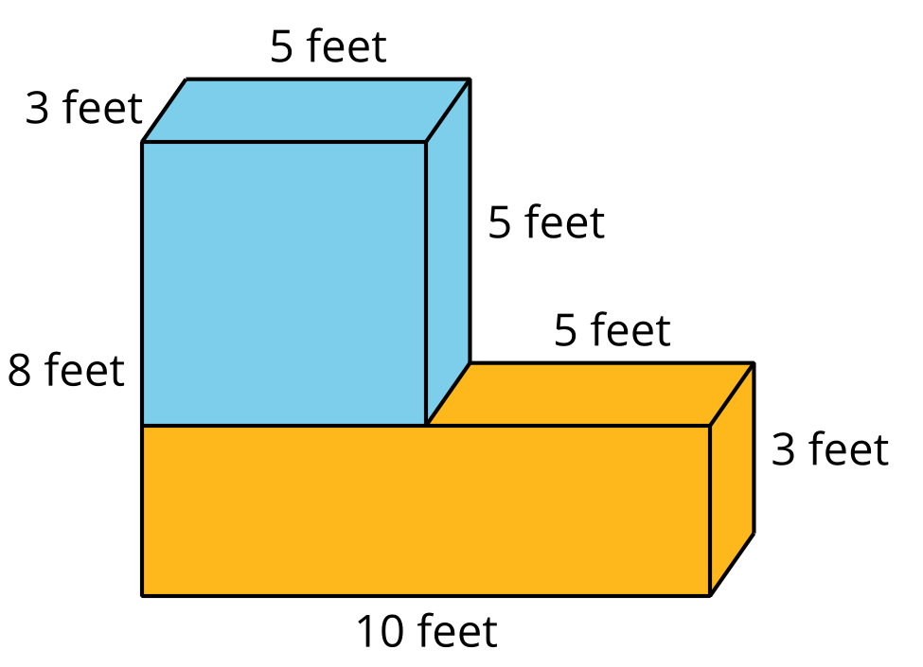
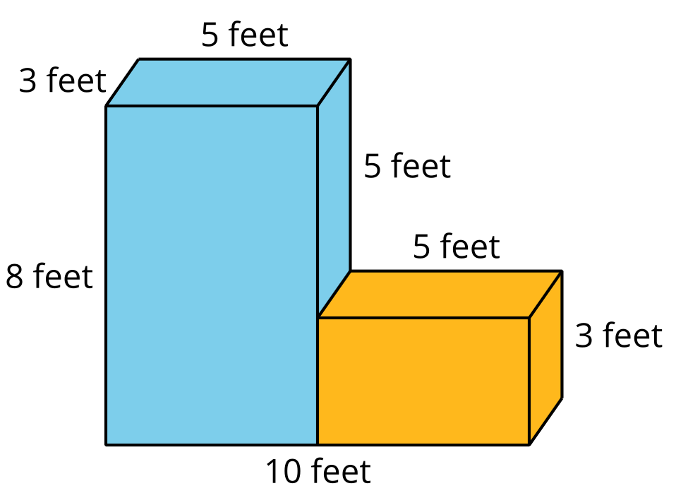

1 Compare Expressions

Student Task Statement
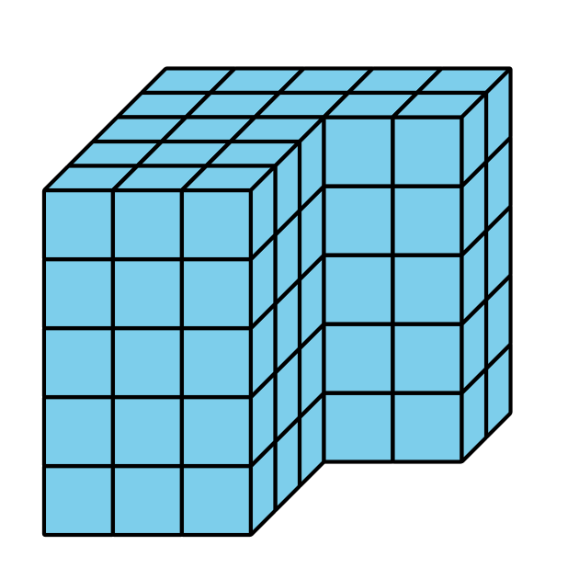
- Write an expression to represent the volume of the figure in unit cubes.
- Compare expressions with your partner.
  - How are they the same?
  - How are they different?
- If they are the same, try to find another way to represent the volume.

2 Find the Volume in Different Ways

Student Task Statement
- Find the volume of the figure by decomposing the figure 2 different ways. Show your thinking. Organize it so it can be followed by others.
- 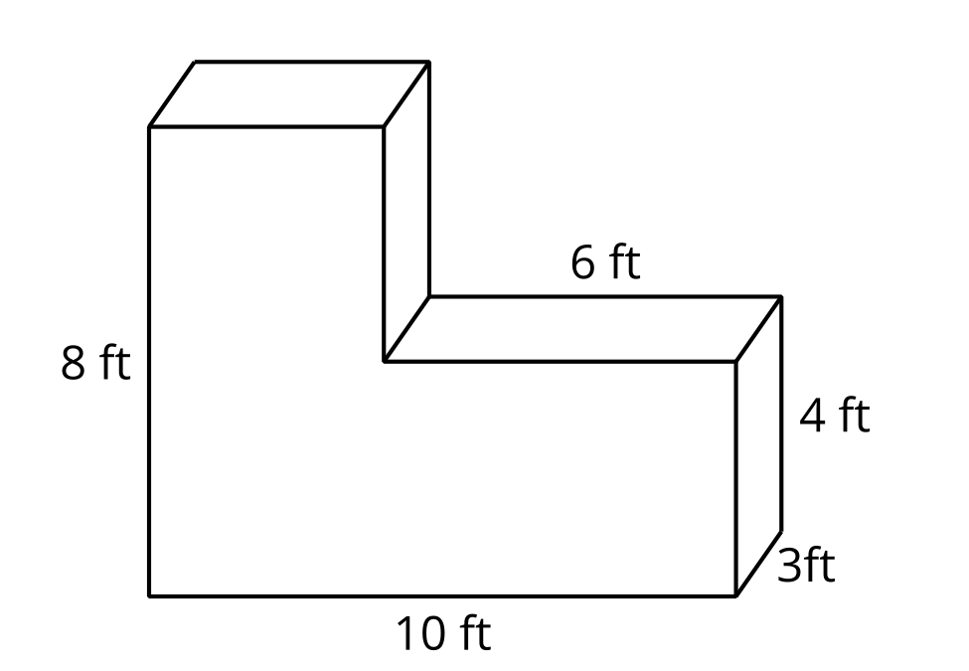
- For each way you decomposed the figure, write an expression that represents the volume.
- Mai used this expression to find the volume of the figure:
- $\left(10×8×3\right)−\left(6×4×3\right)$.
- Use the diagram to interpret Mai's expression. Show your thinking. Organize it so it can be followed by others.
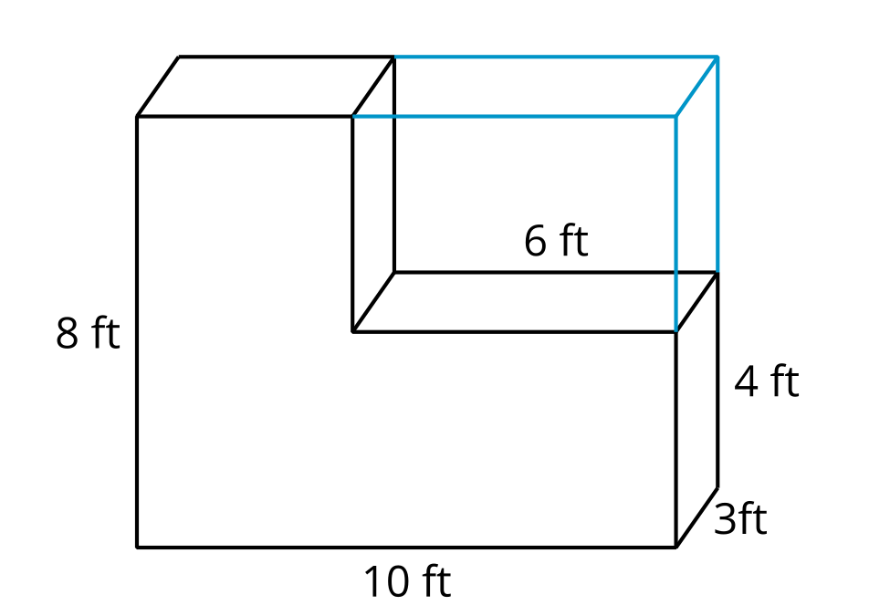
© CC BY 2021 Illustrative Mathematics®

