Unit 5 Lesson 8: Three-digit Numbers on the Number Line

WU Choral Count: Count by 10 and 100 (Warm up)

Student Task Statement

Activity Synthesis
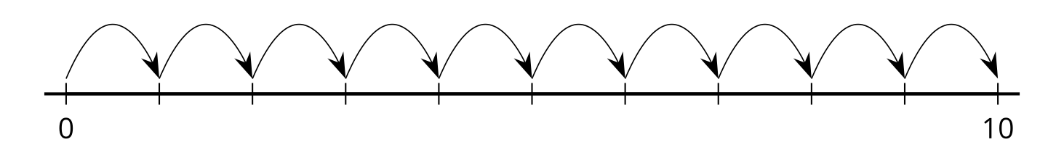
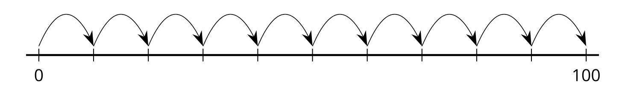
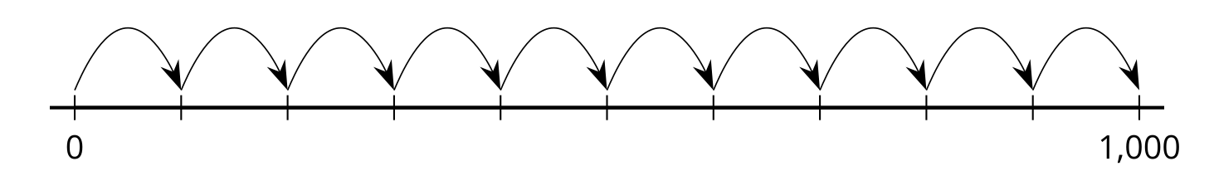

1 Label Three-digit Numbers

Student Task Statement
What do you notice? What do you wonder?
Locate and label 30, 300, and 3 on a number line.
Label each point with a number it represents.

2 Represent Three-digit Numbers on a Number Line

Student Task Statement
Locate and label each number on the number line. Label the tick marks with the numbers they represent if it helps.
- 700
- 472
- 940
- 356
- 590
© CC BY 2021 Illustrative Mathematics®

