Lesson 26: What’s the Story?
- Let’s solve story problems.

Warm-up: Number Talk: Subtract 10 or More
Find the value of each expression mentally.
- $15−10$
- $15−12$
- $16−10$
- $16−13$

26.1: Solve Related Story Problems
- Elena has 6 counters.
She gets some more counters.
Now she has 18 counters.
How many more counters did Elena get?
Show your thinking using drawings, numbers, or words.
- Equation: ________________________________
- Elena has 18 counters.
She gets rid of some counters.
Now she has 6 counters.
How many counters did Elena get rid of?
Show your thinking using drawings, numbers, or words.
- Equation: ________________________________

26.2: More Story Problems
Story Problem 1
Han has some pencils.
He gets 9 pencils from the art store.
Now he has 15 pencils.
How many pencils did Han have to start?
Story Problem 2
Han has 15 pencils.
He gives some pencils to his friends.
Now he has 9 pencils.
How many pencils did Han give to his friends?
Story Problem 3
Han has 9 pencils.
He gets some more pencils from the art store.
Now he has 15 pencils.
How many pencils did he get from the art store?
Story Problem 4
Han has 15 pencils.
He gives 9 pencils to his friends.
How many pencils does Han have now?
Show your thinking using drawings, words or numbers.
Equation: _________________________________

Section Summary
Section Summary
We used different methods to subtract within 20.
We used take away methods.
$15−8$

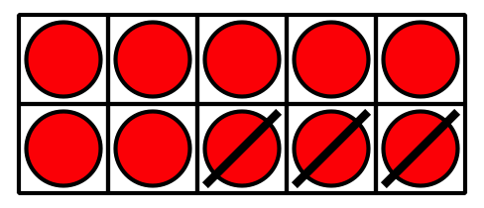
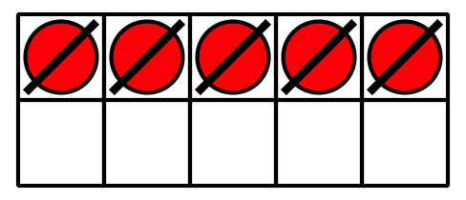
We used a ten to take away 8.

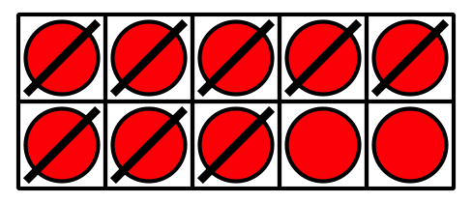

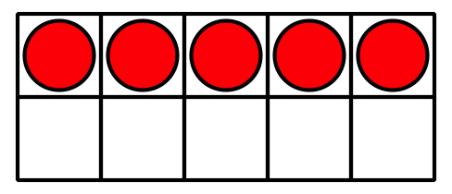
We used counting on methods.
$15−8$
8. . . 9, 10, 11, 12, 13, 14, 15
Use ten to help count on.
$8+2=10$
$10+5=15$
$2+5=7$
© CC BY 2021 Illustrative Mathematics®

