Unit 6 Lesson 10: Center Day 2

WU True or False: Adding within 100 (Warm up)

Student Task Statement
Is each statement true or false?
Be prepared to explain your reasoning.
- $24+30=44$
- $24+40=64$
- $30+45=75$
- $32+45=76$

1 Introduce Estimate and Measure, Choose Your Unit

Student Task Statement

2 Centers: Choice Time

Student Task Statement
Choose a center.
How Close?
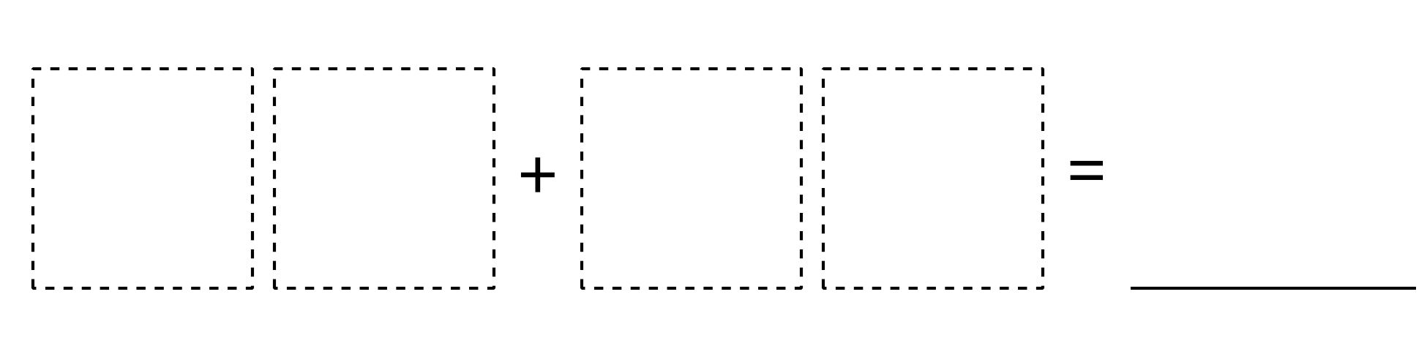
Target Numbers
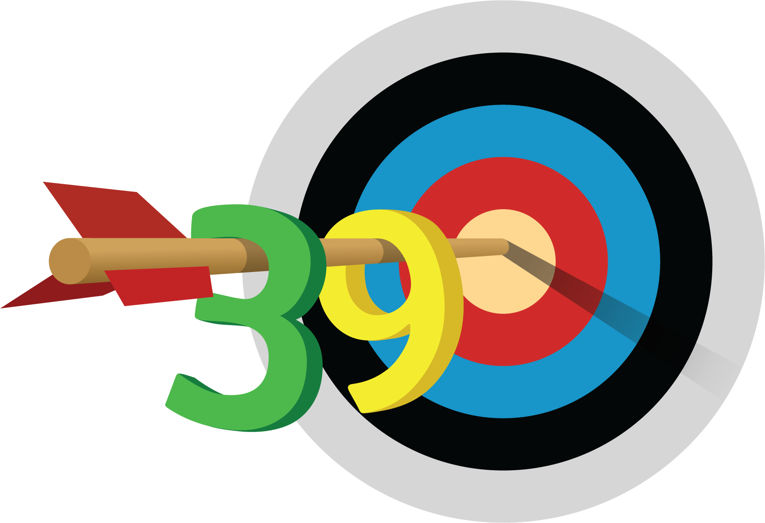
Five in a Row
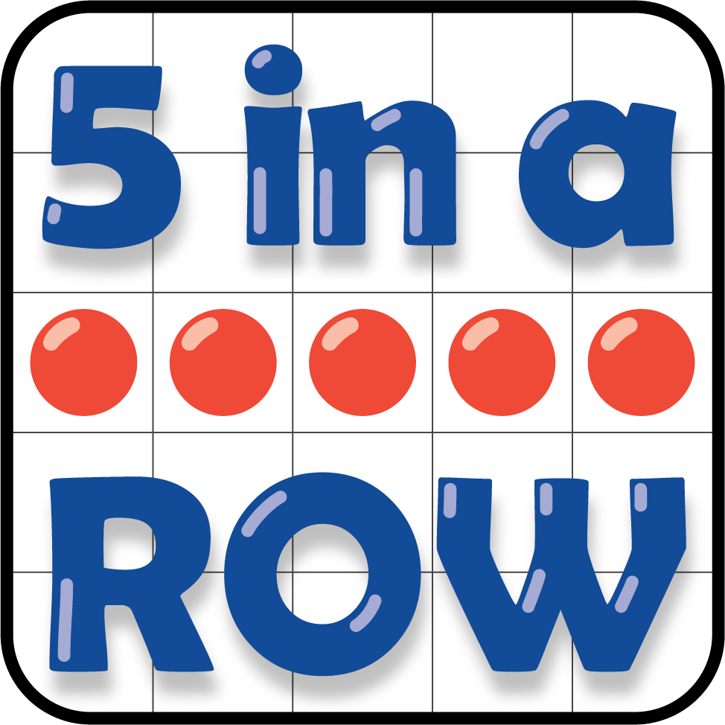
© CC BY 2021 Illustrative Mathematics®

