Lesson 17: Match and Draw Arrays

Standards Alignments
Addressing | 3.OA.A.1

Teacher-facing Learning Goals
- Relate arrays to drawings of equal groups and describe them in terms of multiplication.

Student-facing Learning Goals
- Let’s match arrays to equal groups and draw arrays.

Lesson Purpose
The purpose of this lesson is for students to relate arrays to drawings of equal groups and describe arrays in terms of multiplication.
Students first match arrays to drawings of equal groups. Then, they redraw drawings of equal groups as arrays. The work of this lesson connects to upcoming lessons when students represent arrays with expressions and equations. Make connecting cubes or counters available to students who need them.
Keep collecting ideas that arise about commutativity.

Access for:

Students with Disabilities
- Engagement (Activity 1)

English Learners
- MLR8 (Activity 2)

Instructional Routines
Card Sort (Activity 1), MLR1 Stronger and Clearer Each Time (Activity 1), Which One Doesn’t Belong? (Warm-up)

Materials to Gather
- Connecting cubes or counters: Activity 2

Materials to Copy
- Card Sort Arrays (groups of 2): Activity 1

Lesson Timeline
Warm-up | 10 min
Activity 1 | 20 min
Activity 2 | 15 min
Lesson Synthesis | 10 min
Cool-down | 5 min

Teacher Reflection Question
What question do you wish you had asked today? When and why should you have asked it?

Cool-down
(to be completed at the end of the lesson) 5min
Draw and Describe

Standards Alignments
Addressing | 3.OA.A.1

Student-facing Task Statement
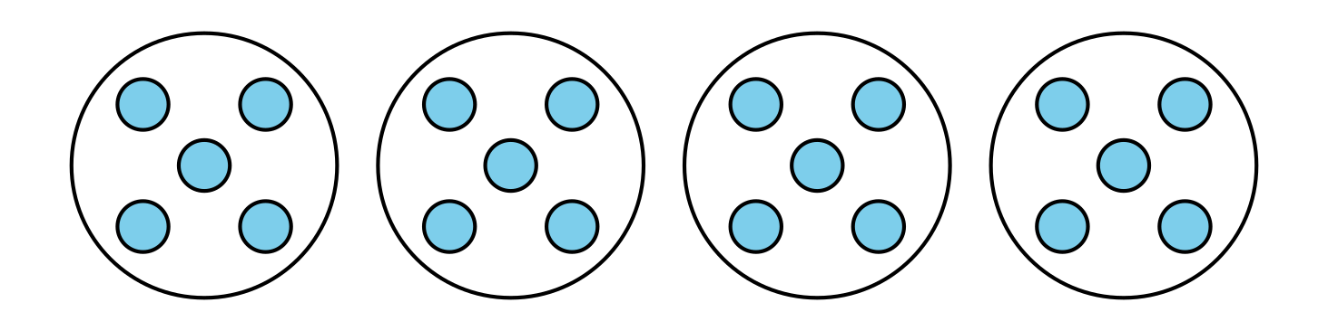
- Redraw the equal groups as an array.
- Describe how the diagram and the array are related.

Student Responses
- Sample response:Students create a $4×5$, $5×4$, $2×10$, or $10×2$ array.
- Sample response: There are 5 dots in each group and there are 5 dots in each row. There are 4 groups and there are 4 rows. They both have 20 dots.

