Lesson 20: Add and Subtract Within 1,000,000

Standards Alignments
Addressing | 4.NBT.B.4

Teacher-facing Learning Goals
- Add and subtract multi-digit numbers, with multiple compositions or decompositions, using the standard algorithm.

Student-facing Learning Goals
Let’s use the standard algorithm to add and subtract.

Lesson Purpose
The purpose of this lesson is for students to add and subtract within 1,000,000 with multiple compositions or decompositions.
In this lesson, students use the standard algorithm for addition and subtraction to the hundred-thousands place. They build their fluency with the algorithm as they encounter examples where more than one digit has to be decomposed in order to subtract. Students also look at errors that are commonly made when using the algorithm to find sums and differences.

Access for:

Students with Disabilities
- Action and Expression (Activity 1)

English Learners
- MLR8 (Activity 2)

Instructional Routines
Notice and Wonder (Warm-up)

Materials to Gather
- Grid paper: Activity 1, Activity 2

Lesson Timeline
Warm-up | 10 min
Activity 1 | 15 min
Activity 2 | 20 min
Lesson Synthesis | 10 min
Cool-down | 5 min

Teacher Reflection Question
What connections did students make between the decomposition of base-ten units using expanded form and using the standard algorithm when subtracting large numbers?

Cool-down
(to be completed at the end of the lesson) 5min
Subtract

Standards Alignments
Addressing | 4.NBT.B.4

Student-facing Task Statement
Use the standard algorithm to find the value of the difference.
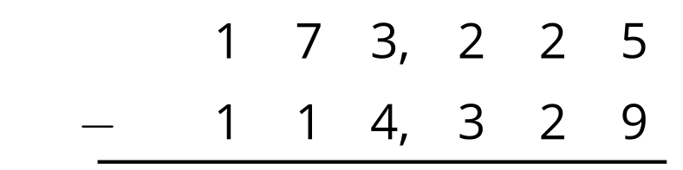

Student Responses
58,896
