Unit 9 Lesson 7: Solve Multiplicative Comparison Problems

WU Notice and Wonder: Two Cities (Warm up)

Student Task Statement
What do you notice? What do you wonder?
 | San Francisco, CA | Fort Wayne, IN
population | 805,235 | 253,691
milk (1 gallon) | $4.45 | $2.14
bread (1 loaf) | $3.54 | $1.82
gasoline (1 gallon) | $3.70 | $2.42
movie ticket | $15 | $12
internet connection (1 month) | $70 | $50
rent for a 3 bedroom apartment in the city center (1 month) | $6,000 | $1,500
cost of a house | $1,400,000 | $160,000

1 The Most and Least Expensive

Student Task Statement
Bermuda is the most expensive country in the world and India is one of the least expensive.
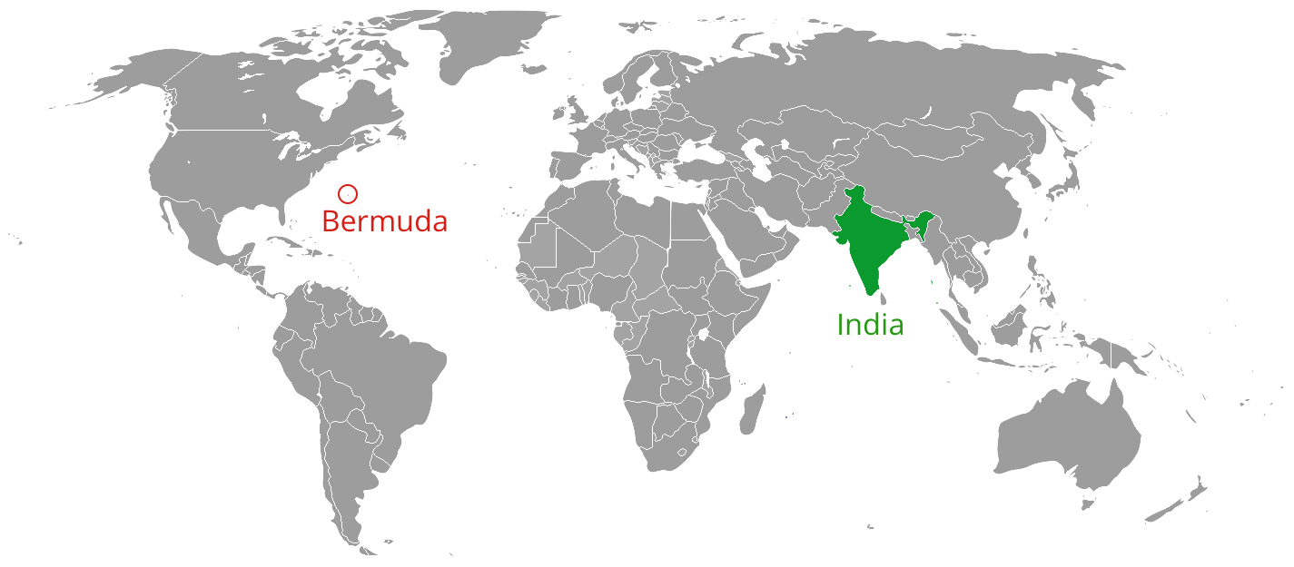
- The table shows how prices of some things in the two countries compare. Estimate or calculate the missing costs and complete the table.
- 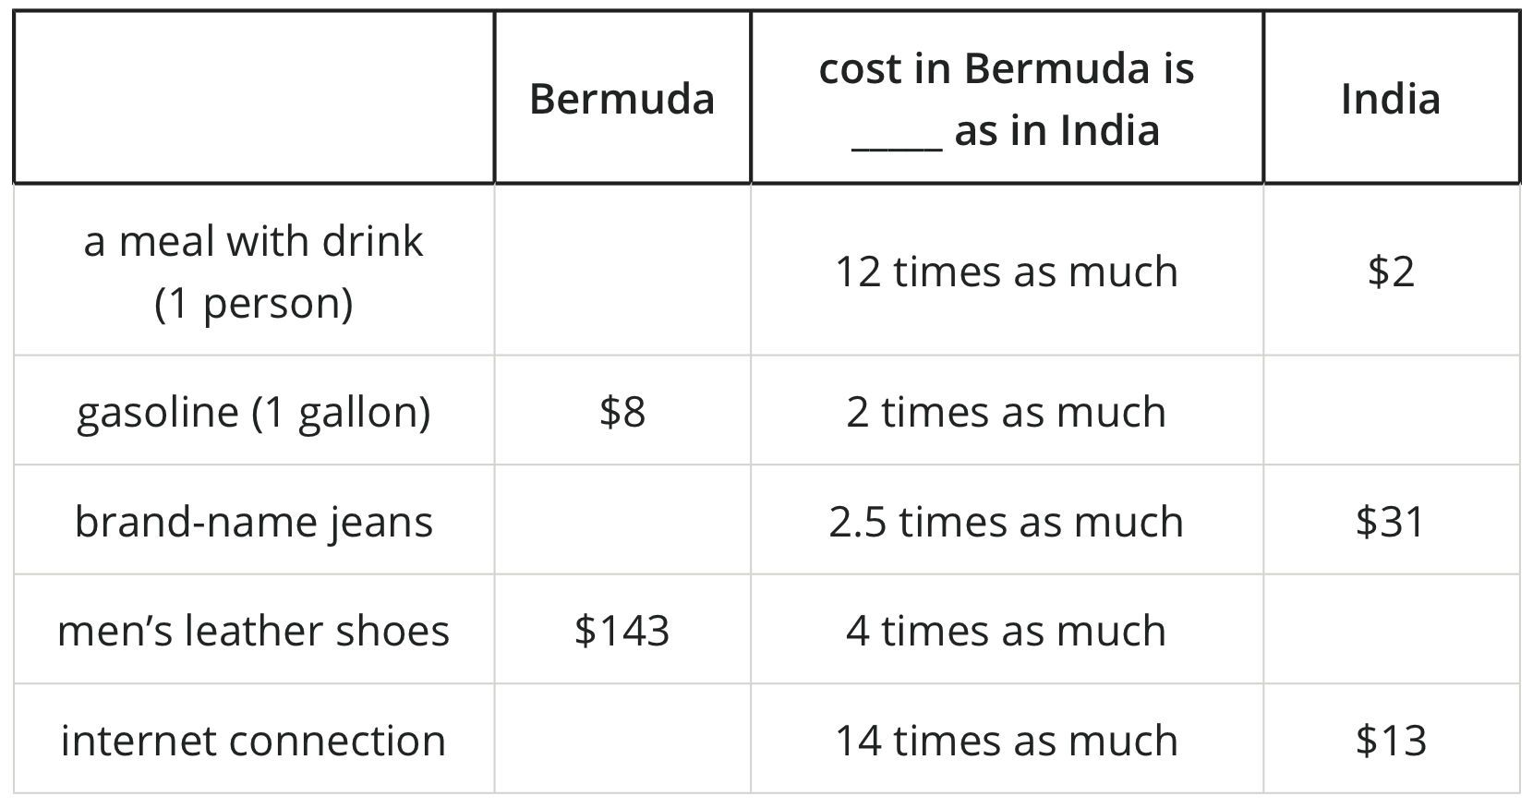
- In India, rent for a 1-bedroom apartment outside of a city center costs about $76 per month. A similar apartment in Bermuda costs 23 times as much.
- Utilities (electric, gas, water, and heating) for a small apartment costs about $27 per month in India and 7 times as much in Bermuda.
- If a person earns $2,000 per month, can they afford to pay rent and utilities in Bermuda?

2 The Cost of Living

Student Task Statement
The cost of living in the United States is higher than in Ghana.
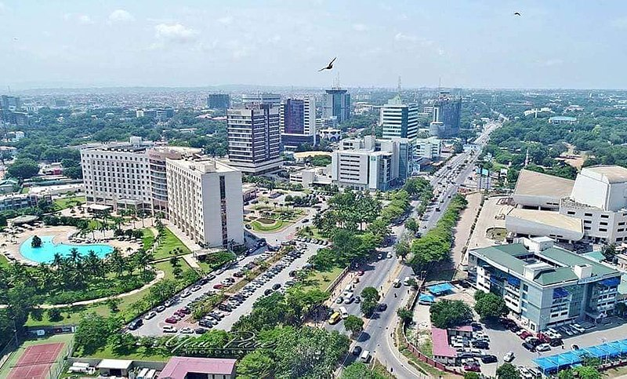
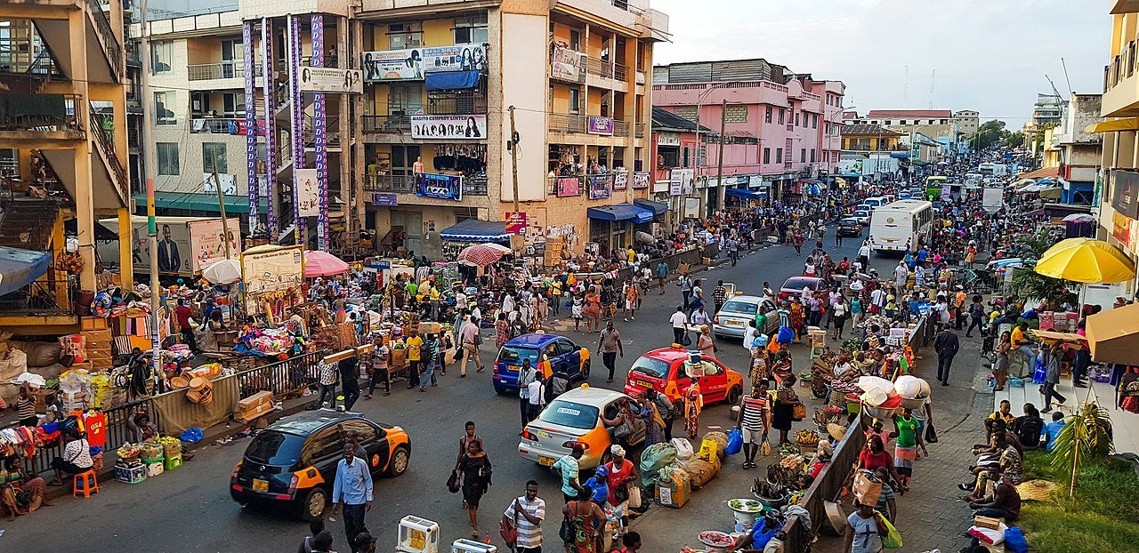
- The table shows how the prices of some other things in the two countries compare. Estimate or calculate the missing information in the table.
- 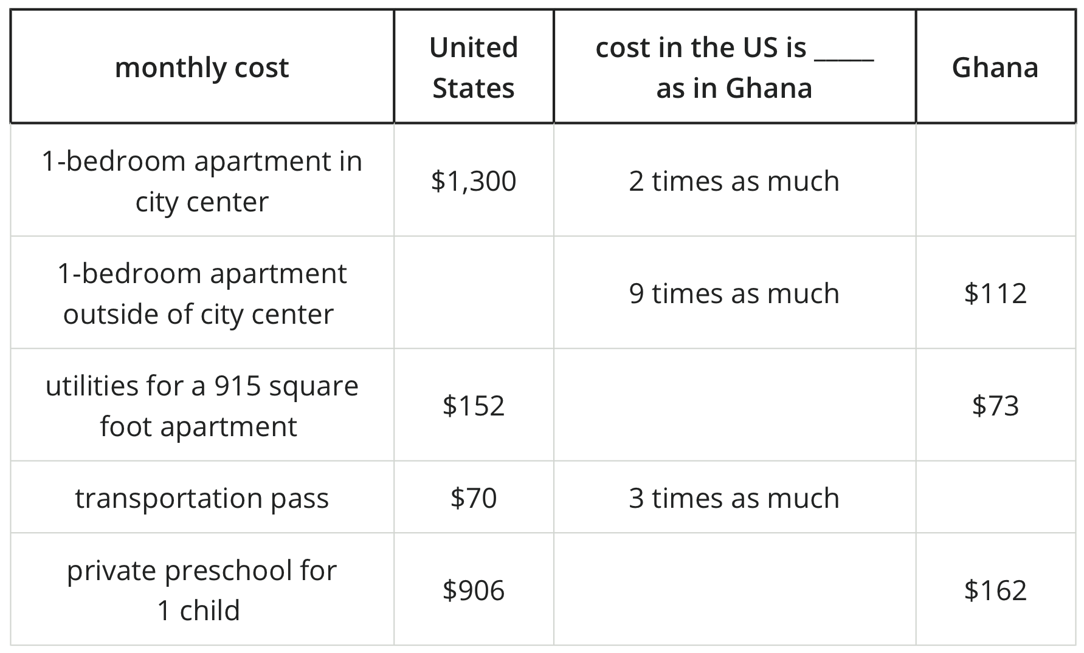
- Suppose a family has $3,000 for housing and wants a 1-bedroom apartment outside of a city center. With that amount of money, how many months of rent can they afford in:
  - the United States? Explain or show your reasoning.
  - Ghana? Explain or show your reasoning.
© CC BY 2021 Illustrative Mathematics®

