Lesson 1: Size of Divisor and Size of Quotient

1.1: Number Talk: Size of Dividend and Divisor
Find the value of each expression mentally.
$5,​000÷5$
$5,​000÷2,​500$
$5,​000÷10,​000$
$5,​000÷500,​000$

1.2: All Stacked Up
- Here are several types of objects. For each type of object, estimate how many are in a stack that is 5 feet high. Be prepared to explain your reasoning.
- Cardboard boxes
- 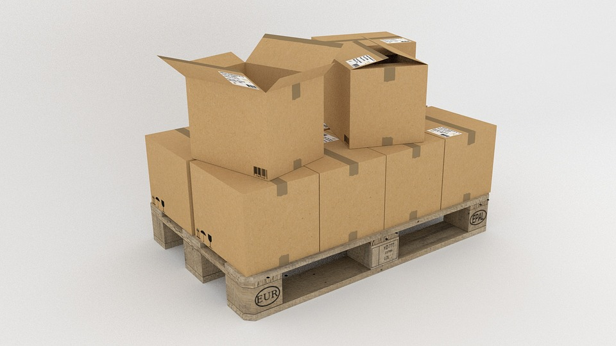
- Bricks
- 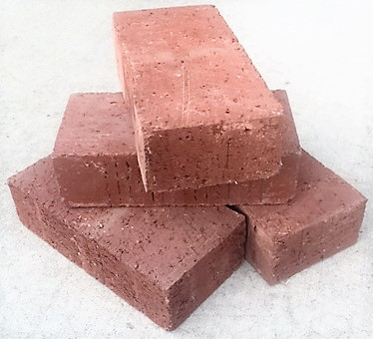
- Notebooks
- 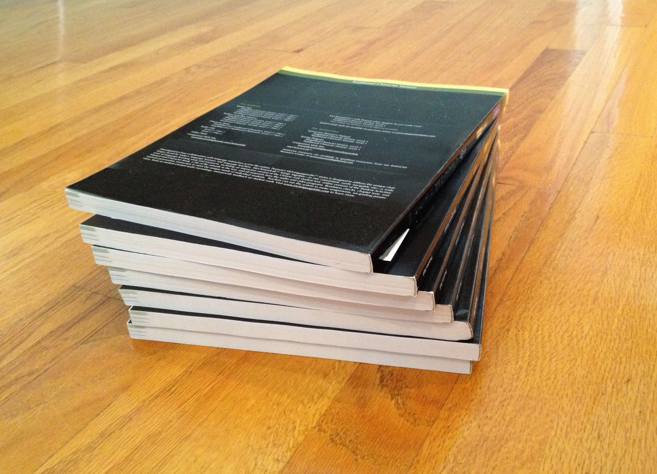
- Coins
- 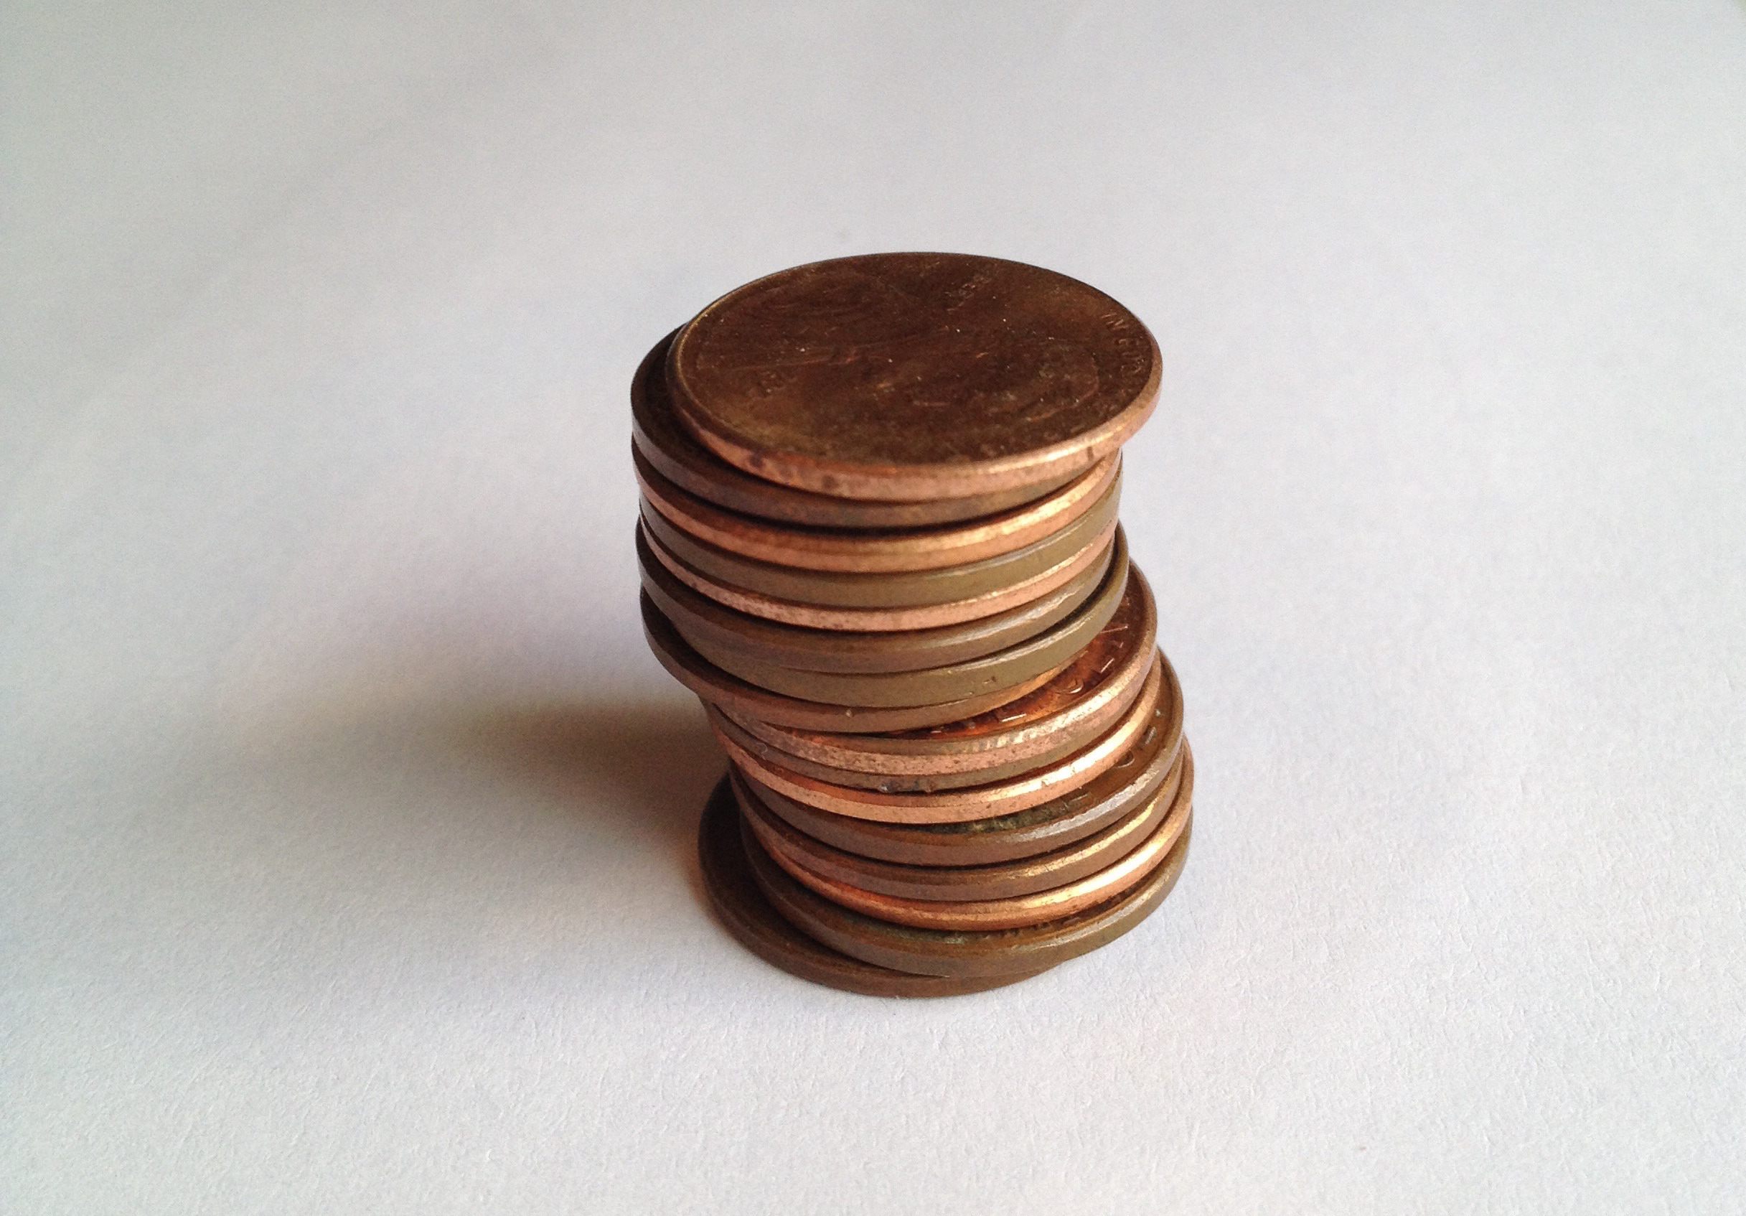
- A stack of books is 72 inches tall. Each book is 2 inches thick. Which expression tells us how many books are in the stack? Be prepared to explain your reasoning.
  - $72⋅2$
  - $72−2$
  - $2÷72$
  - $72÷2$
- Another stack of books is 43 inches tall. Each book is $\frac{1}{2}$-inch thick. Write an expression that represents the number of books in the stack.

1.3: All in Order
Your teacher will give you two sets of papers with division expressions.
- Without computing, estimate the quotients in each set and order them from greatest to least. Be prepared to explain your reasoning.
- Pause here for a class discussion.
- Record the expressions in each set in order from the greatest value to the least.
  - Set 1
  - Set 2
- Without computing, estimate the quotients and sort them into the following three groups. Be prepared to explain your reasoning.
- $30÷\frac{1}{2}$
- $30÷0.45$
- $9÷10$
- $9÷10,​000$
- $18÷19$
- $18÷0.18$
- $15,​000÷1,​500,​000$
- $15,​000÷14,​500$
  - Close to 0
  - Close to 1
  - Much larger than 1

Are you ready for more?
Write 10 expressions of the form $12÷?$ in a list ordered from least to greatest. Can you list expressions that have value near 1 without equaling 1? How close can you get to the value 1?

Lesson 1 Summary
Here is a division expression: $60÷4$. In this division, we call 60 the dividend and 4 the divisor. The result of the division is the quotient. In this example, the quotient is 15, because $60÷4=15$.
We don’t always have to make calculations to have a sense of what a quotient will be. We can reason about it by looking at the size of the dividend and the divisor. Let’s look at some examples.
- In $100÷11$ and in $18÷2.9$ the dividend is larger than the divisor. $100÷11$ is very close to $99÷11$, which is 9. The quotient $18÷2.9$ is close to $18÷3$ or 6.
- In general, when a larger number is divided by a smaller number, the quotient is greater than 1.
- In $99÷101$ and in $7.5÷7.4$ the dividend and divisor are very close to each other. $99÷101$ is very close to $99÷100$, which is $\frac{99}{100}$ or 0.99. The quotient $7.5÷7.4$ is close to $7.5÷7.5$, which is 1.
- In general, when we divide two numbers that are nearly equal to each other, the quotient is close to 1.
- In $10÷101$ and in $50÷198$ the dividend is smaller than the divisor. $10÷101$ is very close to $10÷100$, which is $\frac{10}{100}$ or 0.1. The division $50÷198$ is close to $50÷200$, which is $\frac{1}{4}$ or 0.25.
- In general, when a smaller number is divided by a larger number, the quotient is less than 1.
© CC BY Open Up Resources. Adaptations CC BY IM.

