Lesson 13 Practice Problems
- A group of ten friends played a number guessing game. They were asked to pick a number between 1 and 20. The person closest to the target number wins. The ten people made these guesses:
- guess | - 2 | - 15 | - 10 | - 8 | - 12 | - 19 | - 20 | - 5 | - 7 | - 9
- absolute guessing error
  - The actual number was 14. Complete the table with the absolute guessing errors.
  - Graph the guess and absolute guessing errors.
  - Is the absolute guessing error a function of the guess? Explain how you know.
- Bags of walnuts from a food producer are advertised to weigh 500 grams each. In a certain batch of 20 bags, most bags have an absolute error that is less than 4 grams.
- Could this scatter plot represent those 20 bags and their absolute errors? Explain your reasoning.
- The class guessed how many objects were placed in a mason jar. The graph displays the class results, with an actual number of 47.
- Suppose a mistake was made, and the actual number is 45.
- Explain how the graph would change, given the new actual number.
- Function $D$ gives the height of a drone $t$ seconds after it lifts off.
- Sketch a possible graph for this function given that:
  - $D(3)=4$
  - $D(10)=0$
  - $D(5)>D(3)$
- 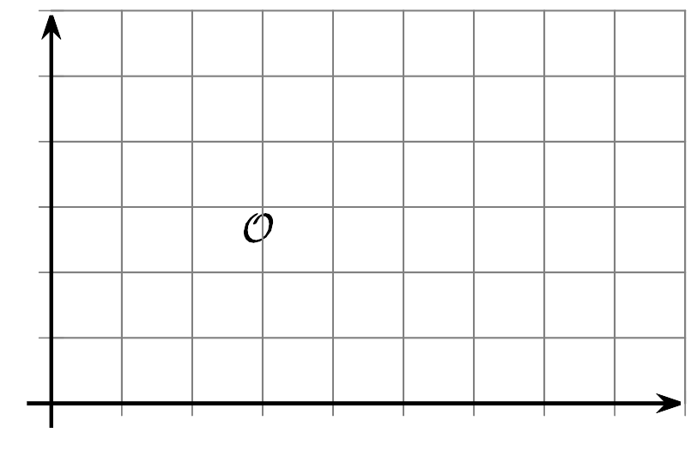
- (From Unit 4, Lesson 3.)
- The population of a city grew from 23,000 in 2010 to 25,000 in 2015.
  - What was the average rate of change during this time interval?
  - What does the average rate of change tell us about the population growth?
- (From Unit 4, Lesson 7.)
- Here is the graph of a function.
- Which time interval shows the largest rate of change?
  - From 0 to 2 seconds
  - From 0 to 3 seconds
  - From 4 to 5 seconds
  - From 6 to 8 seconds
- (From Unit 4, Lesson 7.)
- Here are the graphs of $L(x)$ and $R(x)$.

- $L(x)$
- 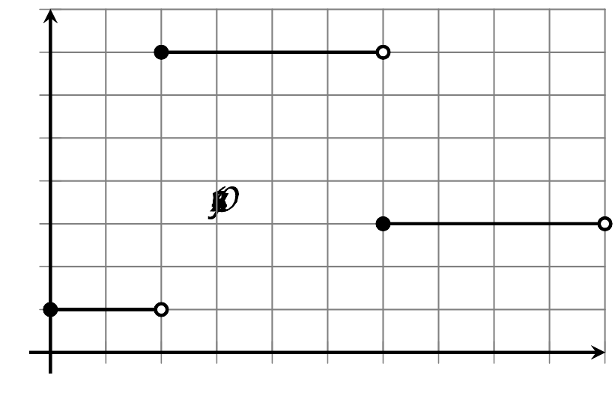

- $R(x)$
- 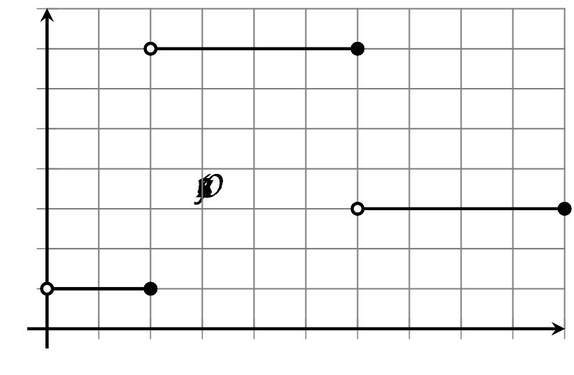
  - What are the values of $L(0)$ and $R(0)$?
  - What are the values of $L(2)$ and the $R(2)$?
  - For what $x$-values is $L(x)=7$?
  - For what $x$-values is $R(x)=7$?
- (From Unit 4, Lesson 12.)
- Select all systems that are equivalent to this system of equations: $\left\{\begin{matrix}\begin{matrix}4x+5y & =1 \\ x− y & =\frac{3}{8}\end{matrix}\end{matrix}\right.$
  - $\left\{\begin{matrix}\begin{matrix}4x+5y & =1 \\ 4x−4y & =\frac{3}{2}\end{matrix}\end{matrix}\right.$
  - $\left\{\begin{matrix}\begin{matrix}x+\frac{5}{4}y & =\frac{1}{4} \\ x− y & =\frac{3}{8}\end{matrix}\end{matrix}\right.$
  - $\left\{\begin{matrix}\begin{matrix}4x+5y & =1 \\ 5x−5y & =3\end{matrix}\end{matrix}\right.$
  - $\left\{\begin{matrix}\begin{matrix}8x+10y & =2 \\ 8x− 8y & =3\end{matrix}\end{matrix}\right.$
  - $\left\{\begin{matrix}\begin{matrix}x+y & =\frac{1}{5} \\ x−y & =\frac{3}{8}\end{matrix}\end{matrix}\right.$
- (From Unit 2, Lesson 16.)
© CC BY 2019 by Illustrative Mathematics®

