Unit 5 Lesson 6: Compare Decimals on the Number Line

WU Notice and Wonder: Nested Lines (Warm up)

Student Task Statement
What do you notice? What do you wonder?
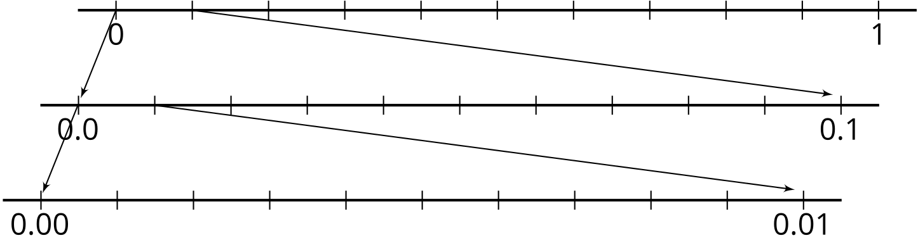

1 Locate 1 Thousandth

Student Task Statement
On each number line:
- Label all of the tick marks.
- Locate and label the number 0.001.

2 Label and Compare Decimals

Student Task Statement
- Label the tick marks on each number line.
- Which of the number lines would you use to compare 0.534 and 0.537? Explain or show your reasoning.

3 Locate and Compare With Symbols

Student Task Statement
- Use the symbol < or > to compare the decimals 0.2 and 0.02. Use the number line to explain or show your thinking.
- Use the symbol < or > to compare the decimals 0.3 and 0.14. Use the number line to explain or show your thinking.
- Use the symbol < or > to compare the decimals 0.23 and 0.216. Use the number line to explain or show your thinking.
© CC BY 2021 Illustrative Mathematics®

