Unit 1 Lesson 7: Cubic Units of Measure

WU Notice and Wonder: Two Prisms (Warm up)

Student Task Statement
What do you notice? What do you wonder?
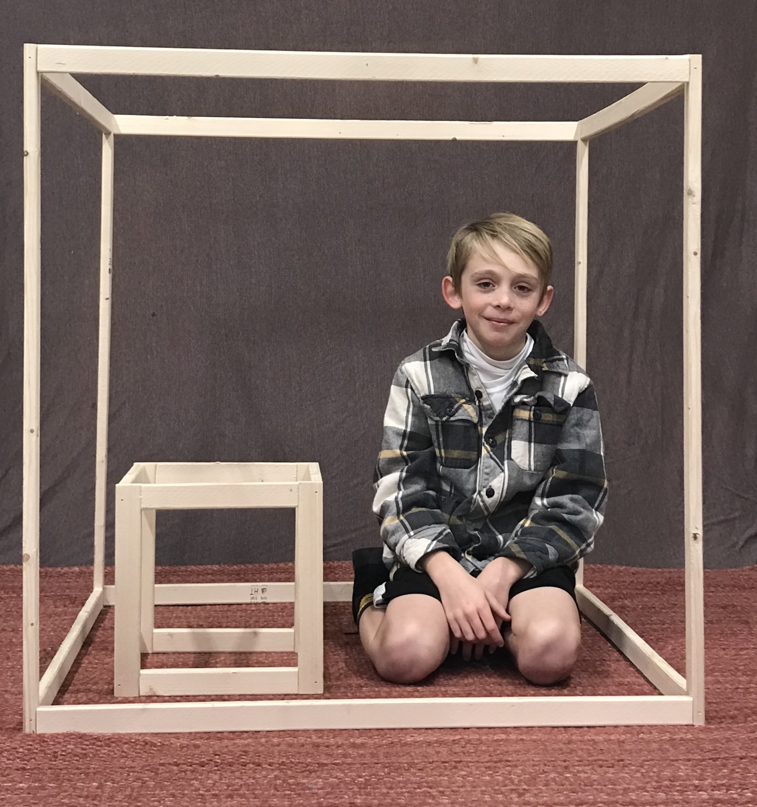

1 What are the Units?

Student Task Statement
For each object, choose the cubic unit you would use to measure the volume: cubic centimeter, cubic inch, or cubic foot.
object | unit you would use
the volume of a moving truck
the volume of a freezer
the volume of a juice box
the volume of a classroom
the volume of a dumpster
the volume of a lunch box
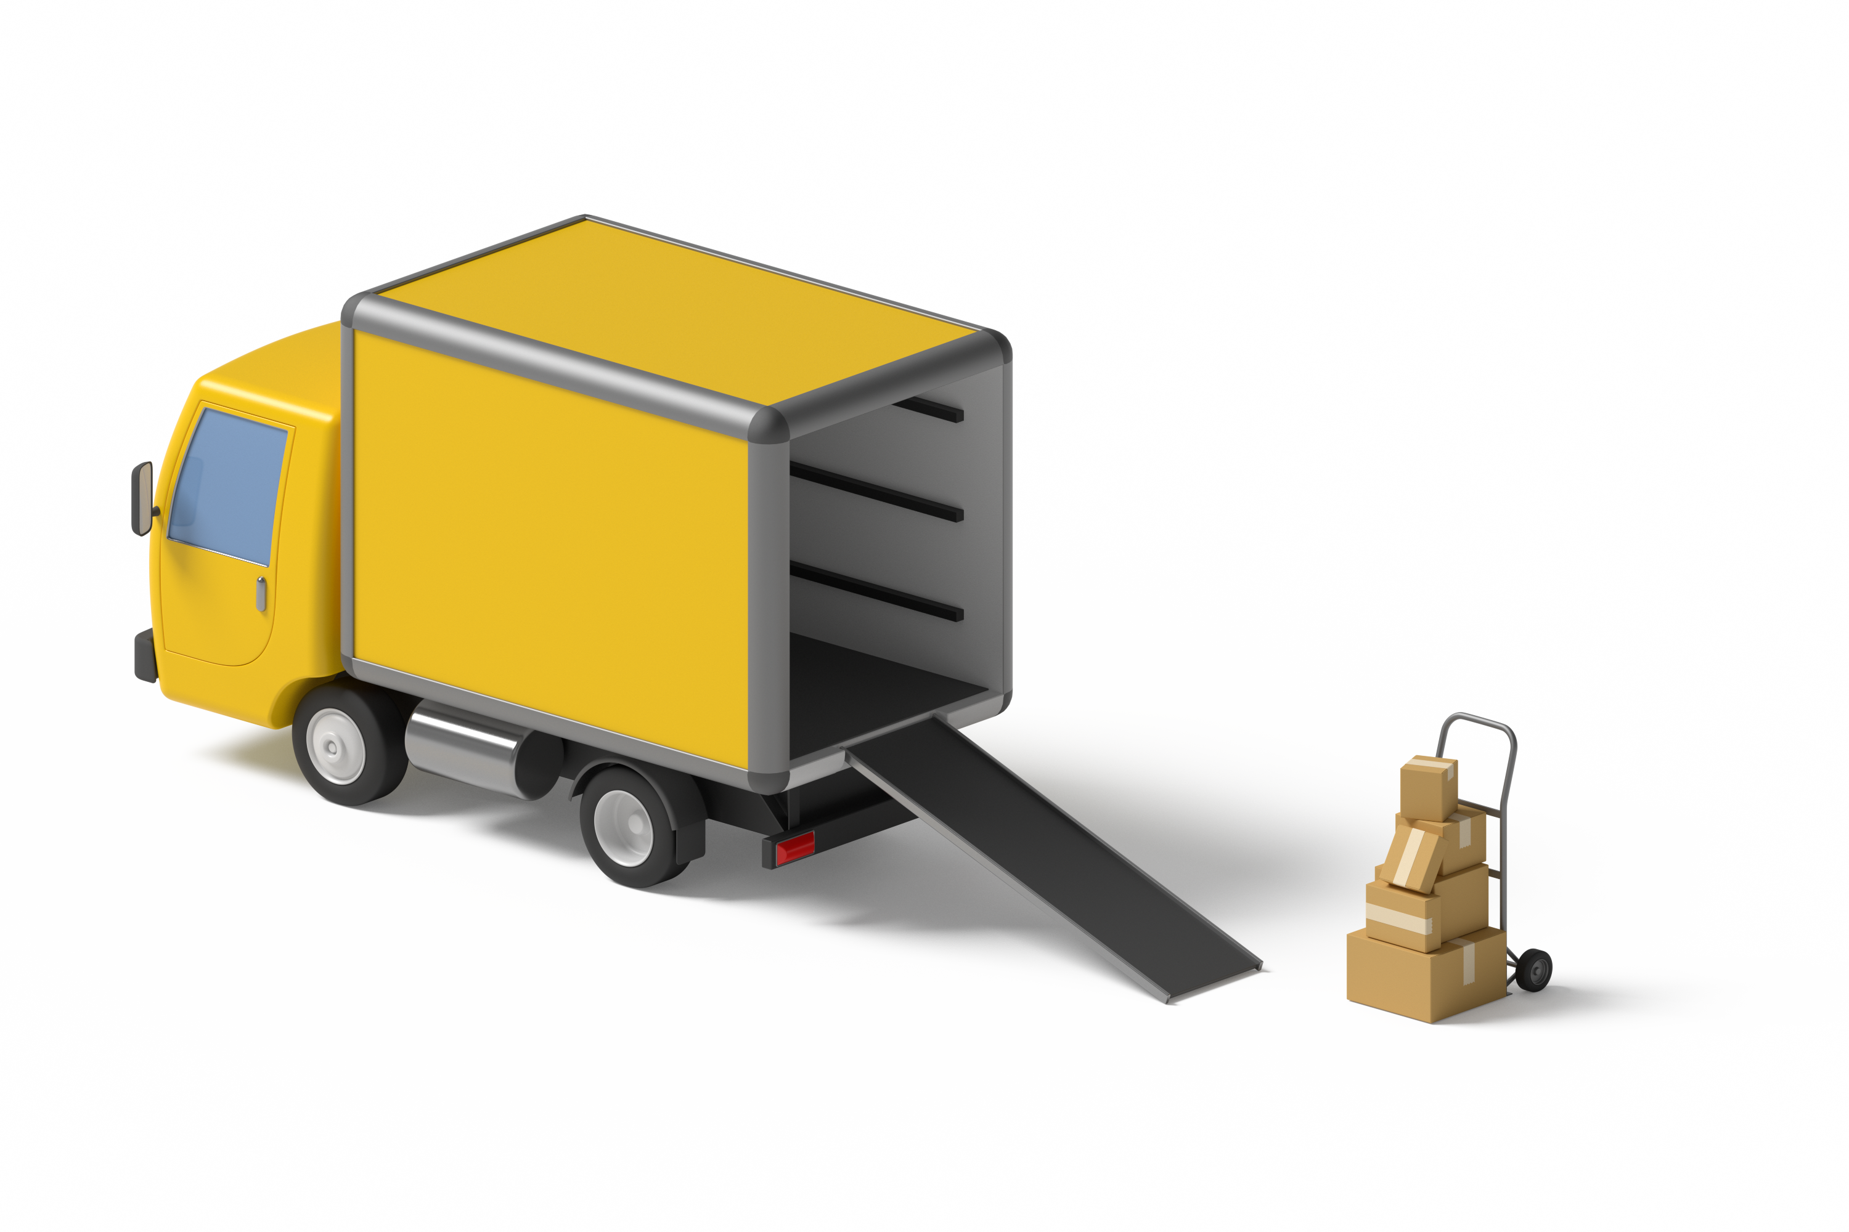

2 Info Gap: Sizing Up Cubic Units

Images for Launch
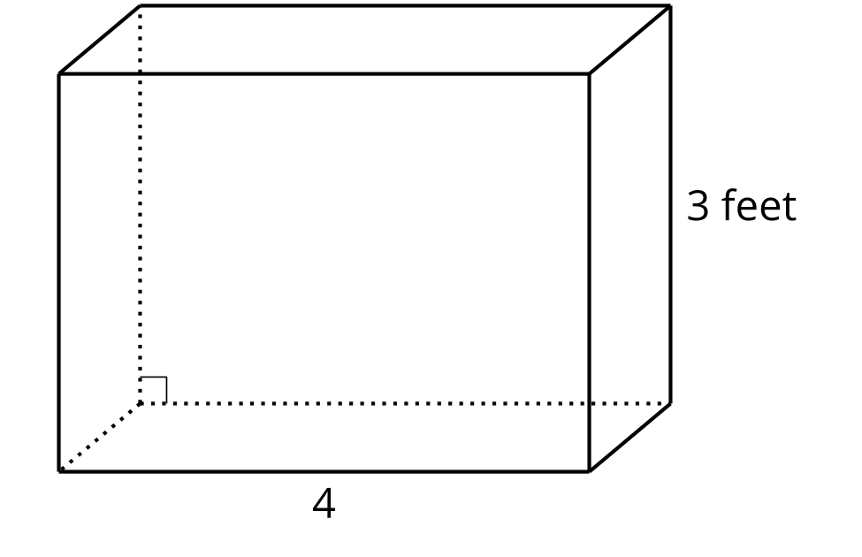

Student Task Statement
This is a diagram of a freezer. What is the volume of the freezer?
Problem 1:
- Partner A has the problem card.
- Partner B has the data card.
Problem 2:
- Partner B has the problem card.
- Partner A has the data card.
Your teacher will give you either a problem card or a data card. Do not show or read your card to your partner.
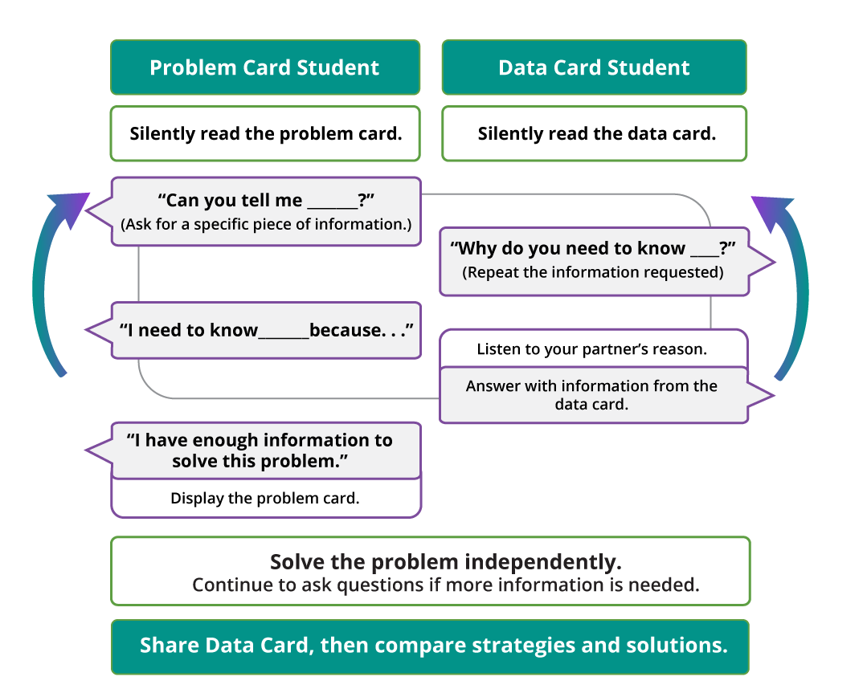
Pause here so your teacher can review your work. Ask your teacher for a new set of cards and repeat the activity, trading roles with your partner.

Images for Activity Synthesis
© CC BY 2021 Illustrative Mathematics®

