Unit 6 Lesson 7: Measure Length with Different Length Units

WU Notice and Wonder: Large Cubes and Small Cubes (Warm up)

Student Task Statement
What do you notice?
What do you wonder?
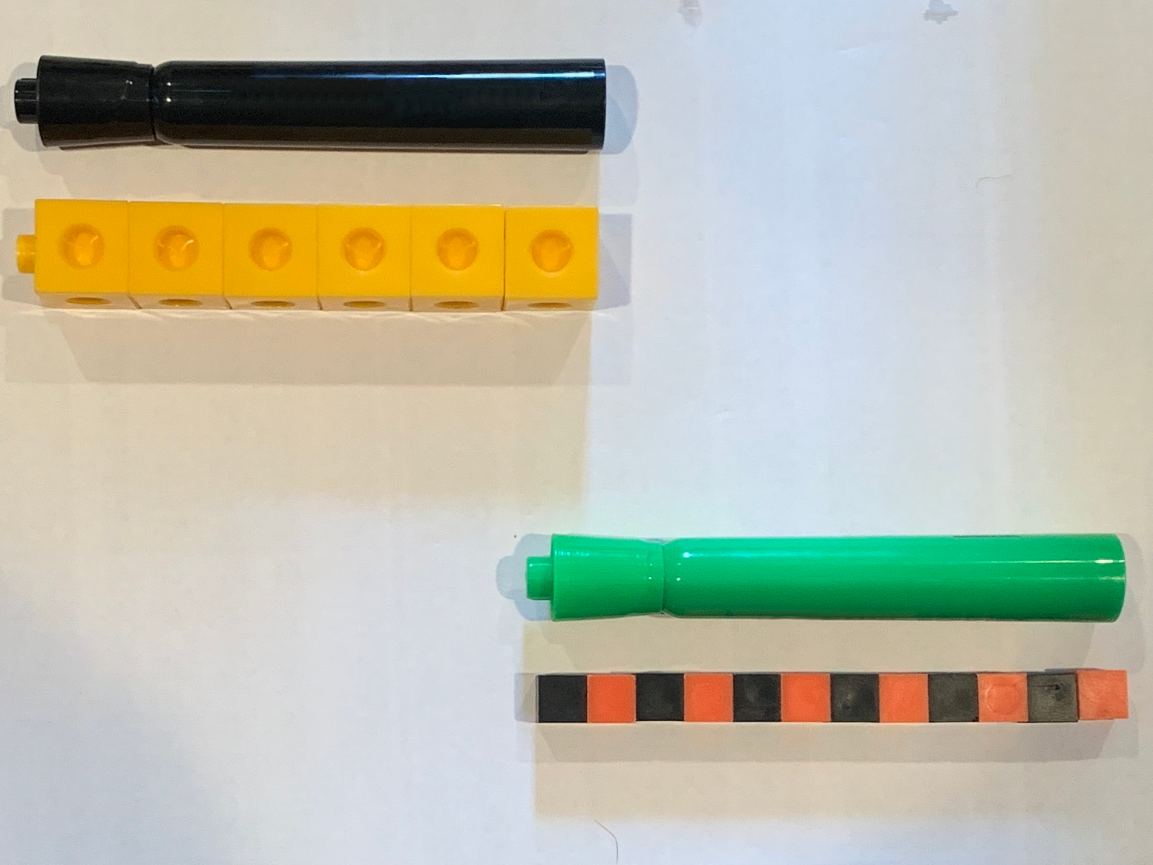

1 Measure With Different Objects

Student Task Statement
Circle the 3 objects you will use:
connecting cubes
small cubes
small paper clips
large paper clips
Measure the length of Jeison's foot with each object you chose and fill in the table.
object | length

2 Measure the Teacher’s Shoe

Student Task Statement
- Andre measured his teacher’s shoe and said it was 15 connecting cubes long.
- 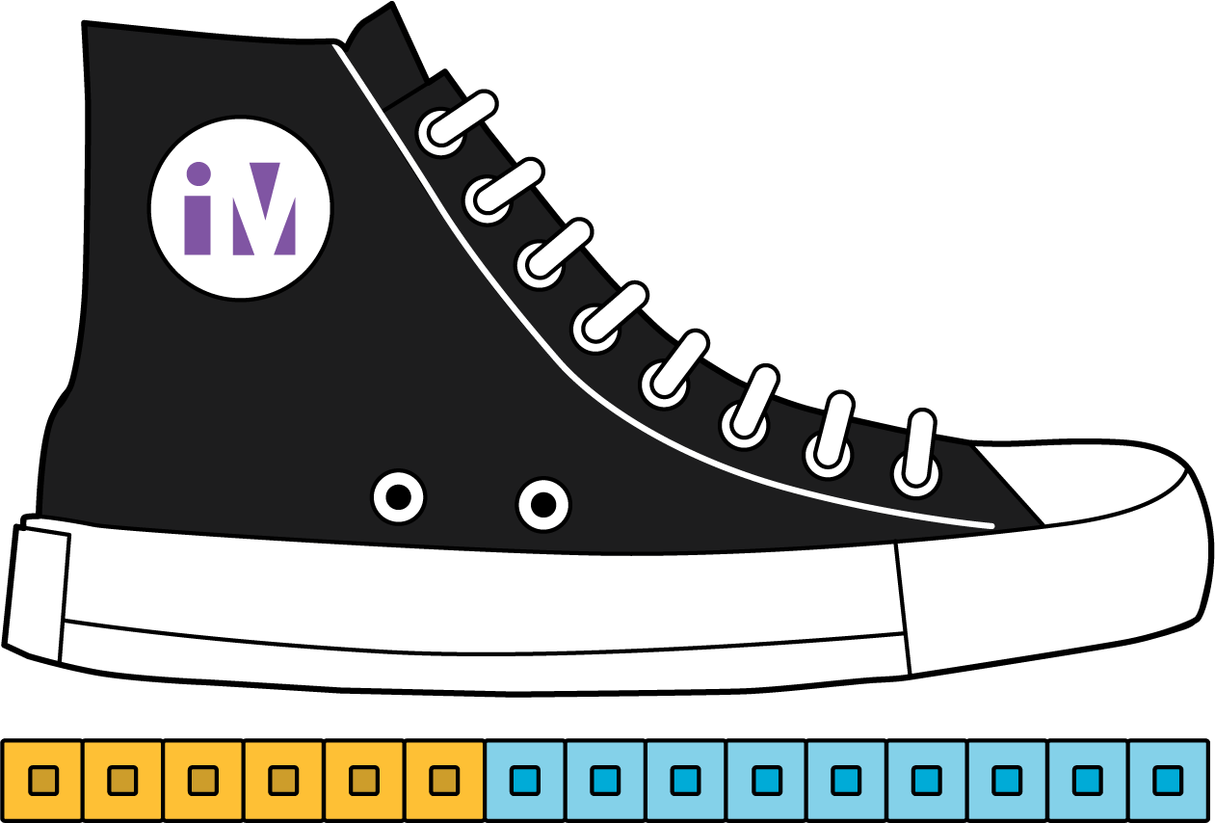
- Is his measurement accurate?
- Why or why not?
- Jada measured her teacher’s shoe and said it was 12 connecting cubes long.
- 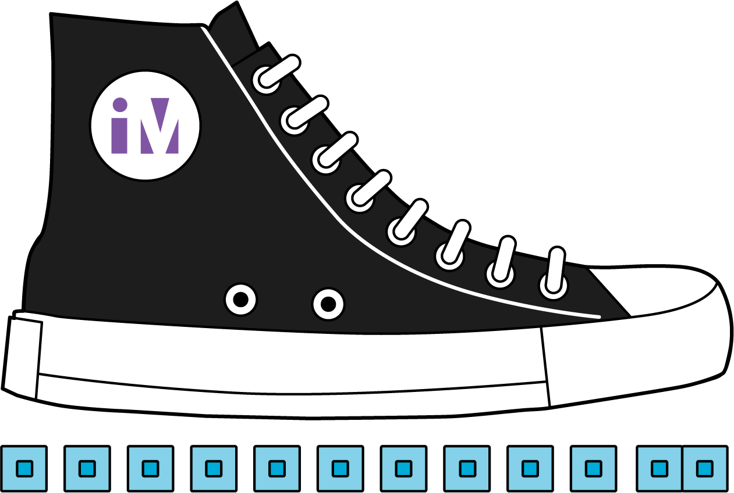
- Is her measurement accurate?
- Why or why not?
- Clare measured her teacher’s shoe and said it was 30 small cubes long.
- 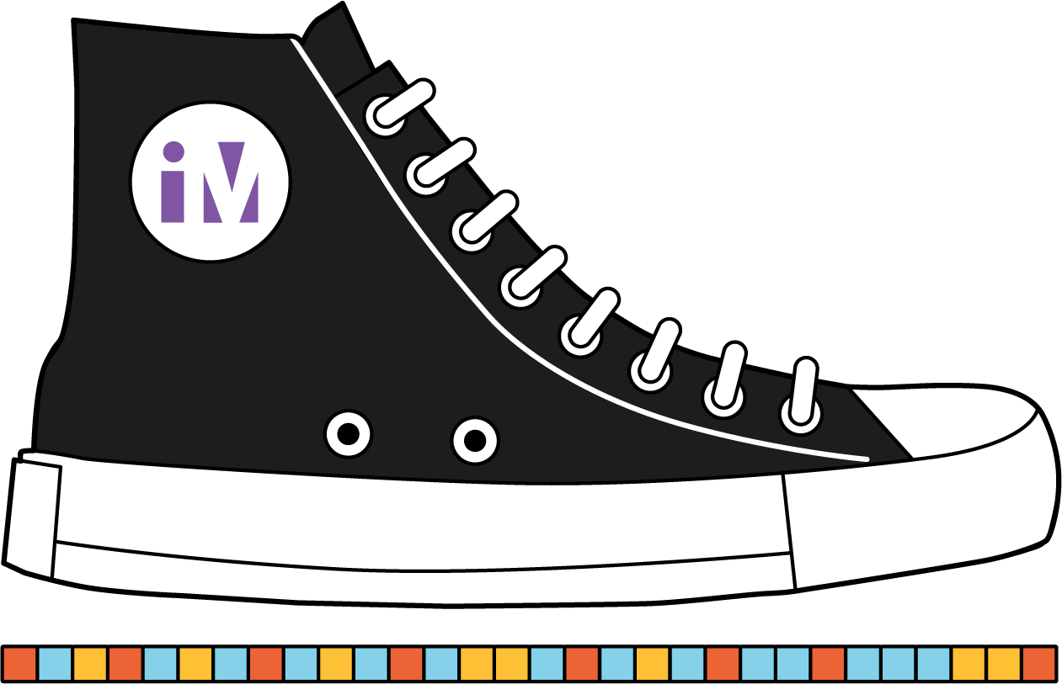
- Is her measurement accurate?
- Why or why not?
- Kiran measured his teacher’s shoe and said it was 19 cubes long.
- 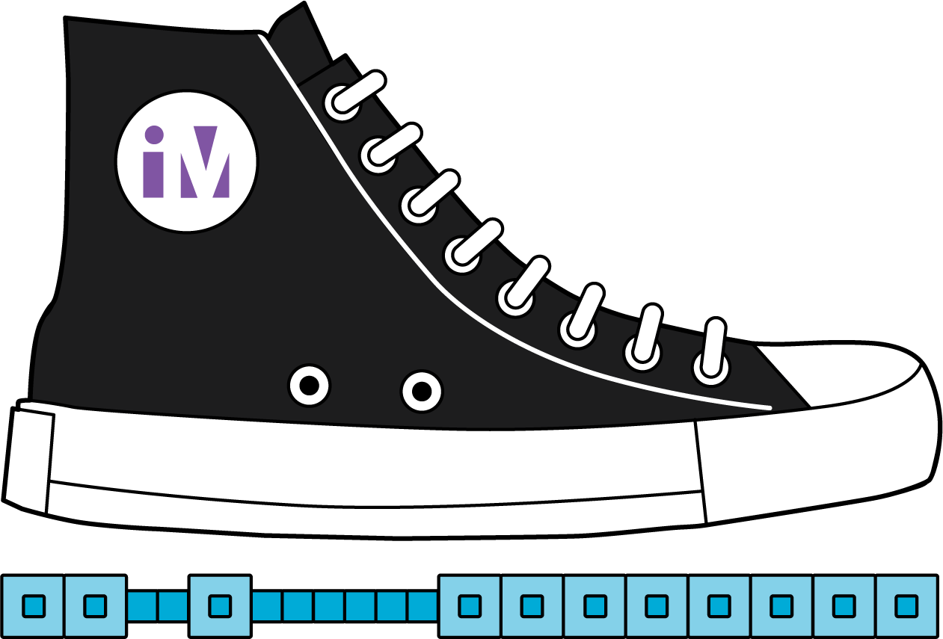
- Is his measurement accurate?
- Why or why not?
© CC BY 2021 Illustrative Mathematics®

