Lesson 14: Write and Solve Equations with Unknowns

Standards Alignments
Addressing | 3.OA.A.1, 3.OA.A.3, 3.OA.A.4, 3.OA.D.9
Building Towards | 3.OA.C.7

Teacher-facing Learning Goals
- Relate equations to multiplication situations and diagrams using a symbol for the unknown number.
- Write equations for multiplication situations and diagrams using a symbol for the unknown number.

Student-facing Learning Goals
- Let’s work with equations with unknown numbers.

Lesson Purpose
The purpose of this lesson is for students to relate equations to and write equations for multiplication situations and diagrams using a symbol for the unknown number.
Students have worked with addition and subtraction equations with a symbol to represent the unknown number in grades 1 and 2. Students build on that work and the work with multiplication equations in the previous lesson as they encounter multiplication equations that have a symbol for the unknown number for the first time.

Access for:

Students with Disabilities
- Representation (Activity 2)

English Learners
- MLR8 (Activity 1)

Instructional Routines
Card Sort (Activity 1), Number Talk (Warm-up)

Materials to Copy
- Card Sort Unknown Numbers (groups of 2): Activity 1

Lesson Timeline
Warm-up | 10 min
Activity 1 | 15 min
Activity 2 | 20 min
Lesson Synthesis | 10 min
Cool-down | 5 min

Teacher Reflection Question
How do tape diagrams help students make sense of equations in which the unknown number is in different positions?

Cool-down
(to be completed at the end of the lesson) 5min
Unknown and a Number

Standards Alignments
Addressing | 3.OA.A.1, 3.OA.A.4

Student-facing Task Statement
- Write an equation to match the diagram. Use a symbol for the unknown.
- 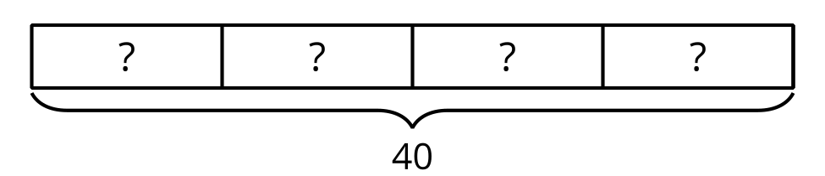
- Find the number that makes the equation true. Rewrite the equation with that number. Explain your reasoning.

Student Responses
- $4×?=40$ or $?×4=40$
- $4×10=40$ or $10×4=40$. Sample response: If I count by ten 4 times I get 40, so I know the missing number is 10.

