Unit 5 Lesson 2: Two Equations for Each Relationship

1 Missing Figures (Warm up)

Student Task Statement
Here are the second and fourth figures in a pattern.
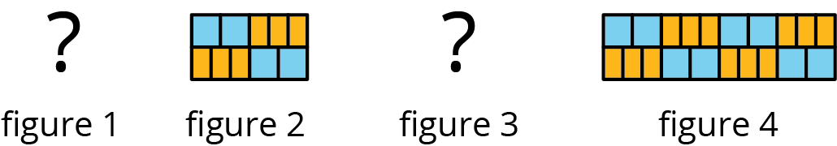
- What do you think the first and third figures in the pattern look like?
- Describe the 10th figure in the pattern.

2 Meters and Centimeters

Student Task Statement
There are 100 centimeters (cm) in every meter (m).
length (m) | length (cm)
1 | 100
0.94
1.67
57.24
$x$

length (cm) | length (m)
100 | 1
250
78.2
123.9
$y$
- Complete each of the tables.
- For each table, find the constant of proportionality.
- What is the relationship between these constants of proportionality?
- For each table, write an equation for the proportional relationship. Let $x$ represent a length measured in meters and $y$ represent the same length measured in centimeters.

3 Filling a Water Cooler

Student Task Statement
It took Priya 5 minutes to fill a cooler with 8 gallons of water from a faucet that was flowing at a steady rate. Let $w$ be the number of gallons of water in the cooler after $t$ minutes.
- Which of the following equations represent the relationship between $w$ and $t$? Select all that apply.
  - $w=1.6t$
  - $w=0.625t$
  - $t=1.6w$
  - $t=0.625w$
- What does 1.6 tell you about the situation?
- What does 0.625 tell you about the situation?
- Priya changed the rate at which water flowed through the faucet. Write an equation that represents the relationship of $w$ and $t$ when it takes 3 minutes to fill the cooler with 1 gallon of water.
- Was the cooler filling faster before or after Priya changed the rate of water flow? Explain how you know.

4 Feeding Shrimp (Optional)

Student Task Statement
At an aquarium, a shrimp is fed $\frac{1}{5}$ gram of food each feeding and is fed 3 times each day.
- How much food does a shrimp get fed in one day?
- Complete the table to show how many grams of food the shrimp is fed over different numbers of days.
- number of days | - food in grams
- 1
- 7
- 30
- 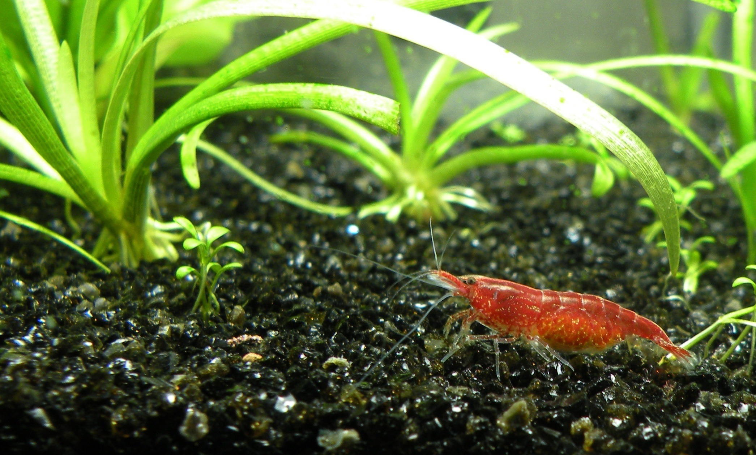
- What is the constant of proportionality? What does it tell us about the situation?
- If we switched the columns in the table, what would be the constant of proportionality? Explain your reasoning.
- Use $d$ for number of days and $f$ for amount of food in grams that a shrimp eats to write two equations that represent the relationship between $d$ and $f$.
- If a tank has 10 shrimp in it, how much food is added to the tank each day?
- If the aquarium manager has 300 grams of shrimp food for this tank of 10 shrimp, how many days will it last? Explain or show your reasoning.
© CC BY Open Up Resources. Adaptations CC BY IM.

