Lesson 21: Los ceros en el algoritmo estándar

Standards Alignments
Addressing | 4.NBT.A.2, 4.NBT.B.4

Teacher-facing Learning Goals
- Use the standard algorithm to subtract in the ten-thousands when the minuend has several zeros.

Student-facing Learning Goals
- Restémosle a números que tienen varios ceros.

Lesson Purpose
The purpose of this lesson is to use the standard algorithm when the minuend has several zeros.
These problems can be challenging for students because they require special attention to make sense of how the multiple regroupings work and how they are recorded in the standard algorithm.

Access for:

Students with Disabilities
- Representation (Activity 1)

English Learners
- MLR8 (Activity 1)

Instructional Routines
Which One Doesn’t Belong? (Warm-up)

Materials to Gather
- Grid paper: Activity 2

Lesson Timeline
Warm-up | 10 min
Activity 1 | 20 min
Activity 2 | 15 min
Lesson Synthesis | 10 min
Cool-down | 5 min

Teacher Reflection Question
Which parts of this lesson gave you insight into how students are subtracting across zero? What insights did you gain?

Cool-down
(to be completed at the end of the lesson) 5min
Encuentra algunas diferencias

Standards Alignments
Addressing | 4.NBT.B.4

Student-facing Task Statement
Usa el algoritmo estándar para encontrar cada diferencia.
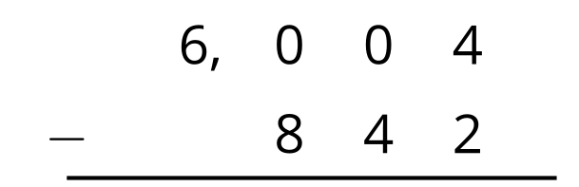
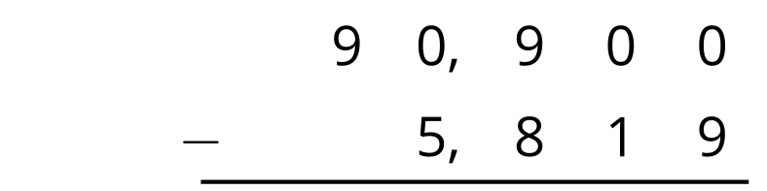

Student Responses
