## Unit 3 Lesson 6: Rectangles and Squares

### WU What Do You Know About Triangles? (Warm up)

#### Student Task Statement

What do you know about triangles?

#### Activity Synthesis

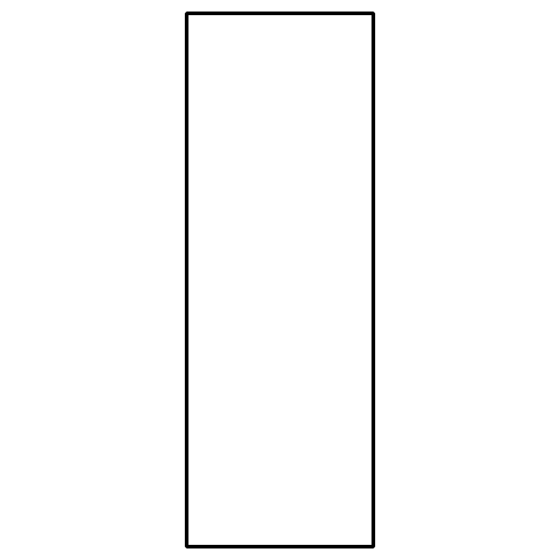

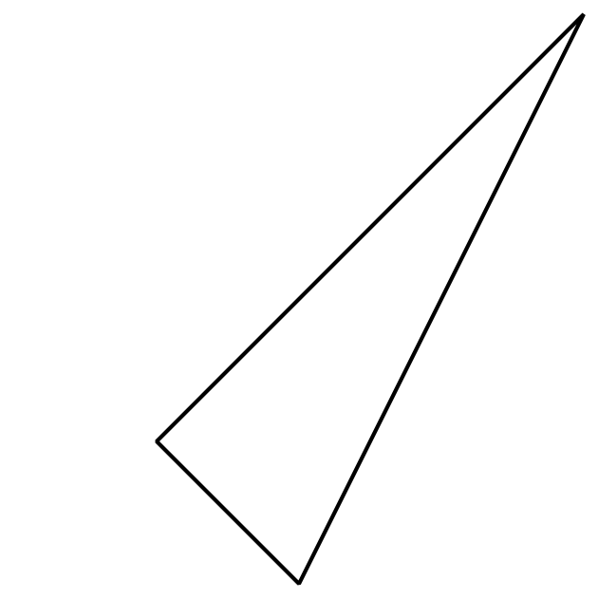

### 1 Sort Rectangles

#### Images for Launch

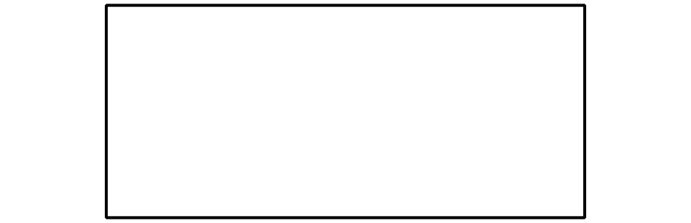

#### Student Task Statement

Let’s put the shapes into 2 groups.

Rectangle

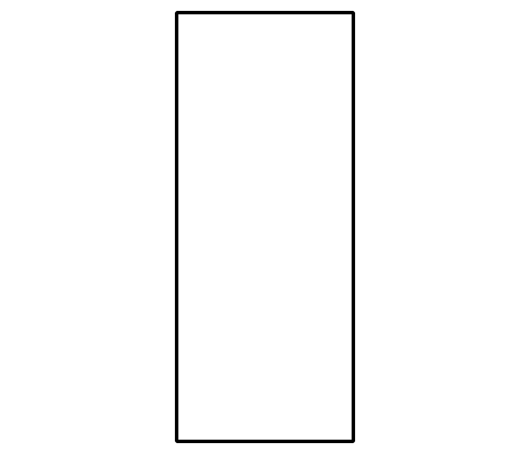

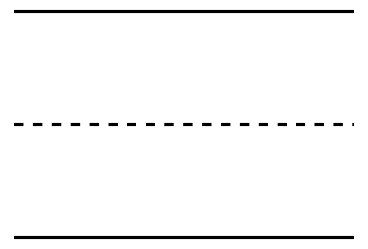

Line to separate the 2 groups.

Not a Rectangle

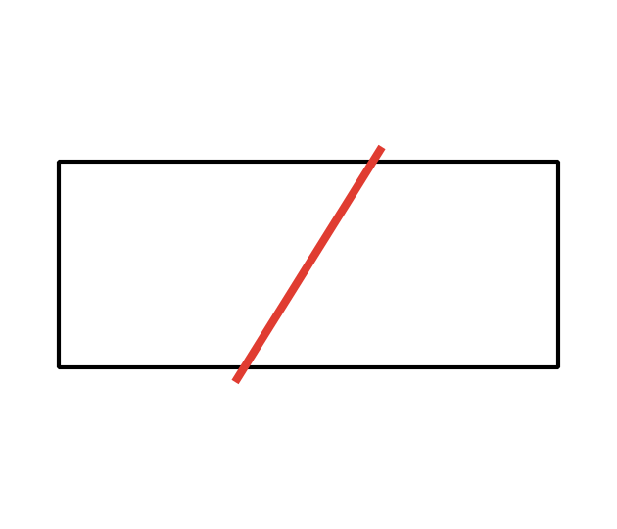



#### Activity Synthesis

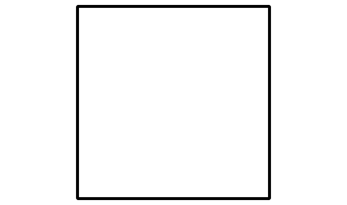

### 2 Compare Length of Rectangles

#### Images for Launch

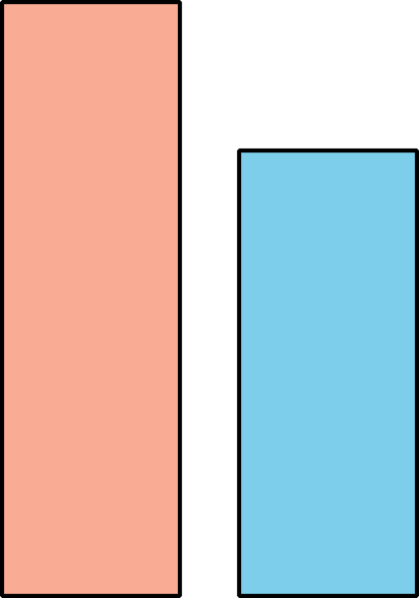

#### Student Task Statement





* 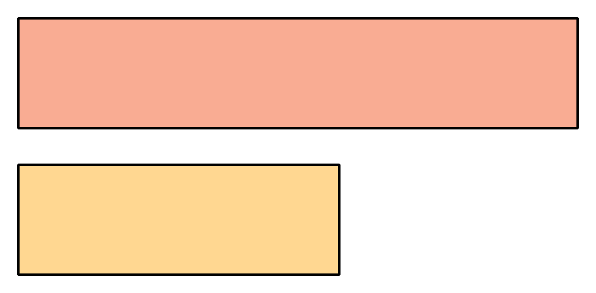



* 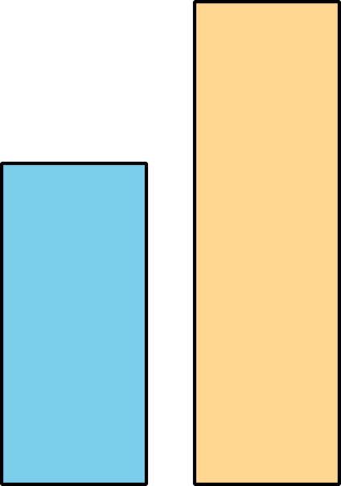



* 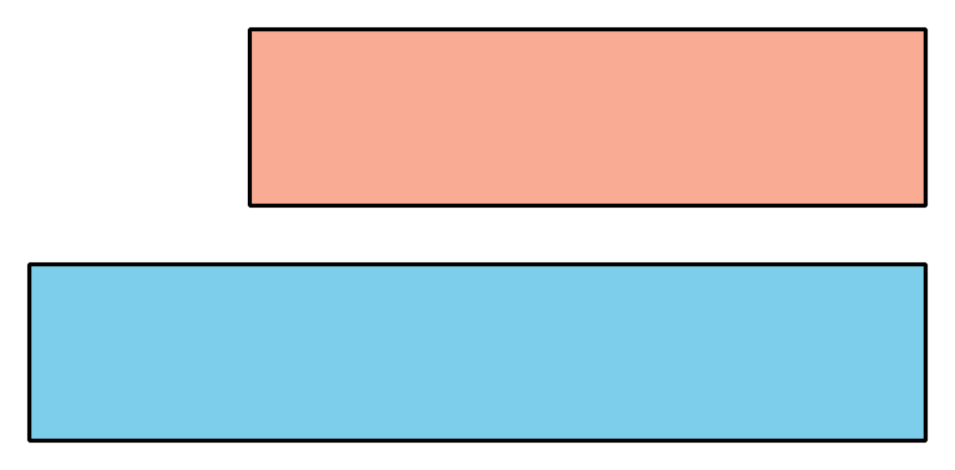



* 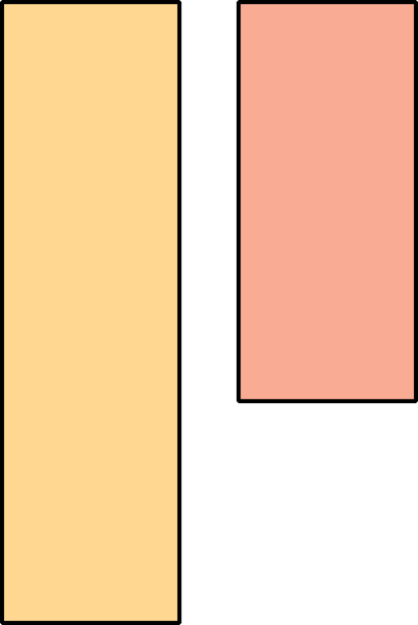

#### Activity Synthesis

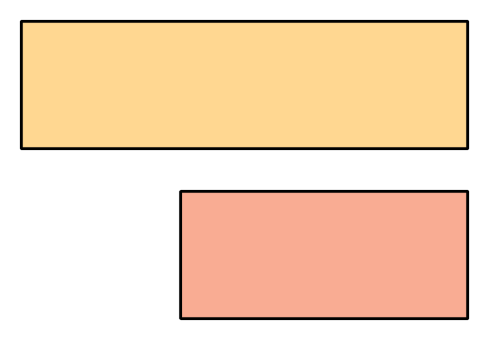

### 3 Centers: Choice Time

#### Student Task Statement

Choose a center.

Counting Collections

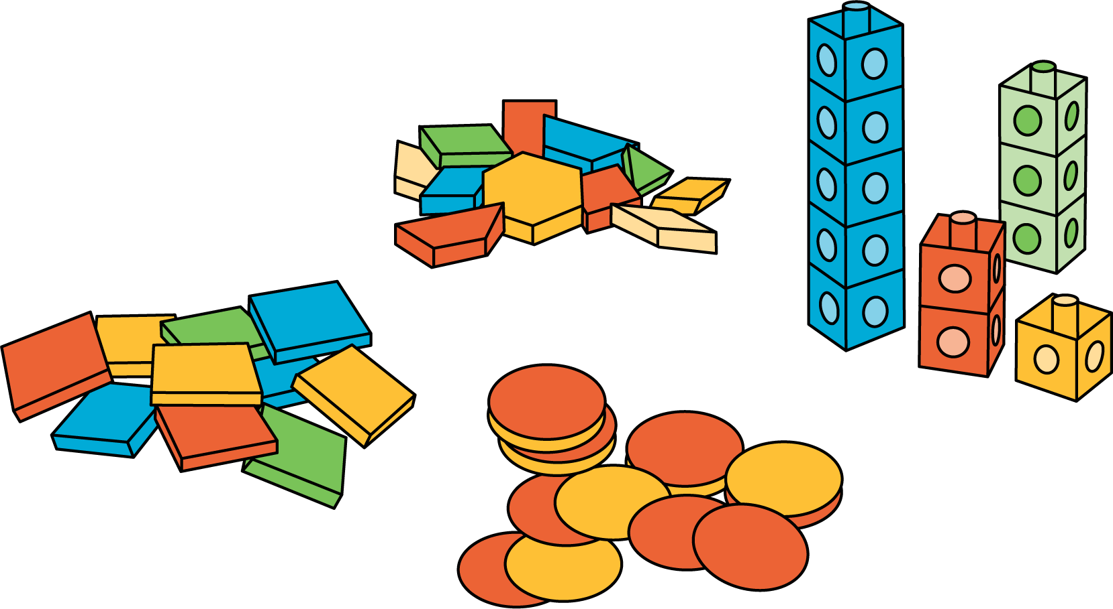

Which One

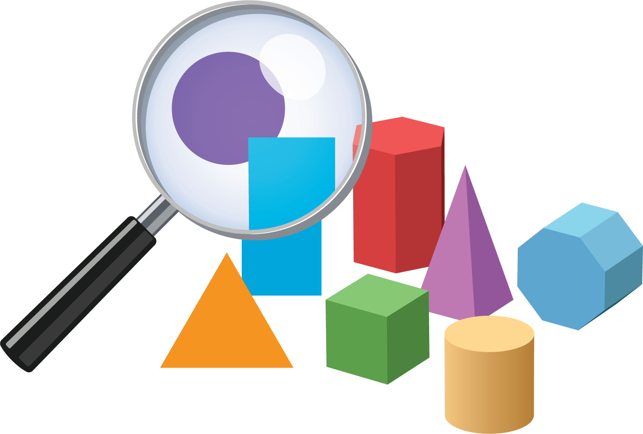

Picture Books

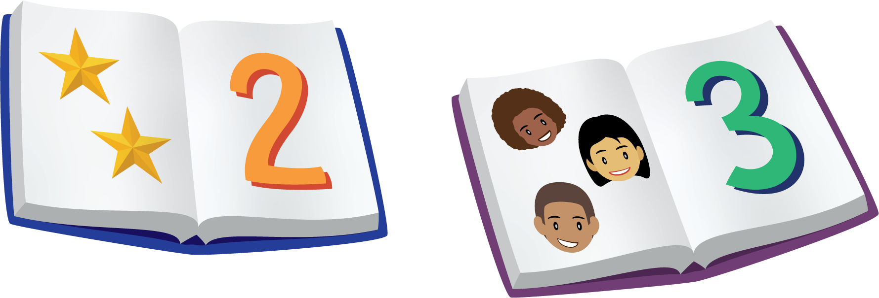

Bingo

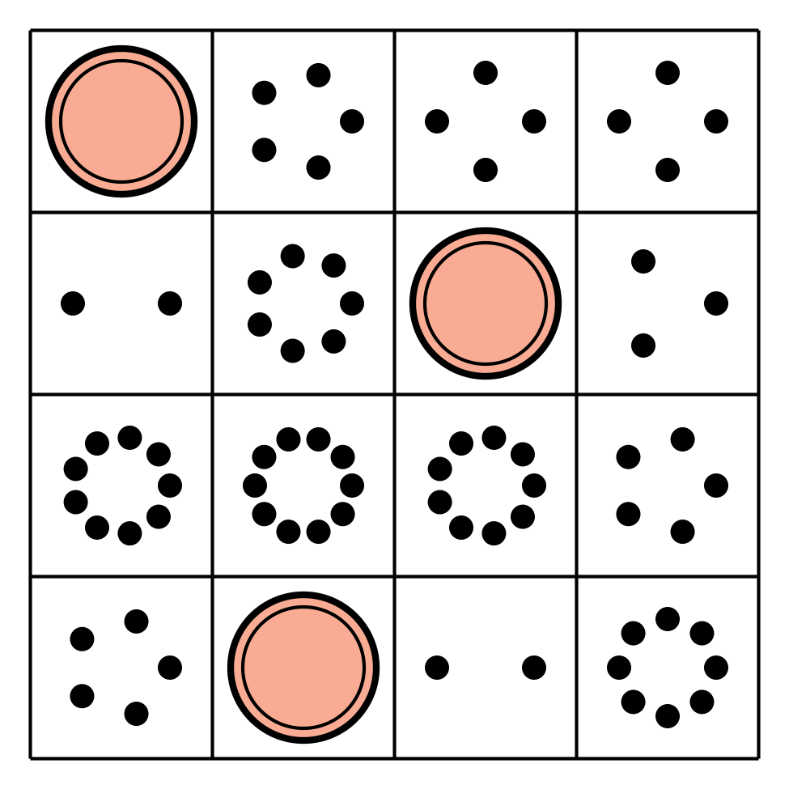

Shake and Spill

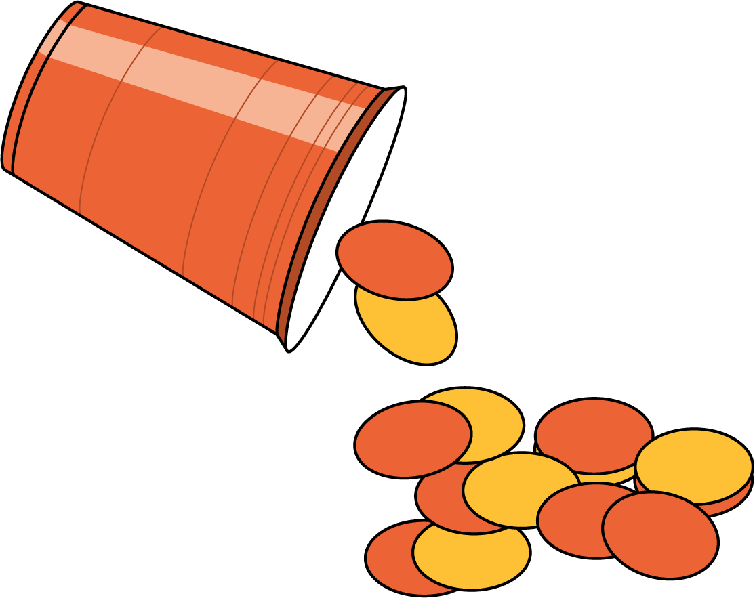

#### Images for Activity Synthesis

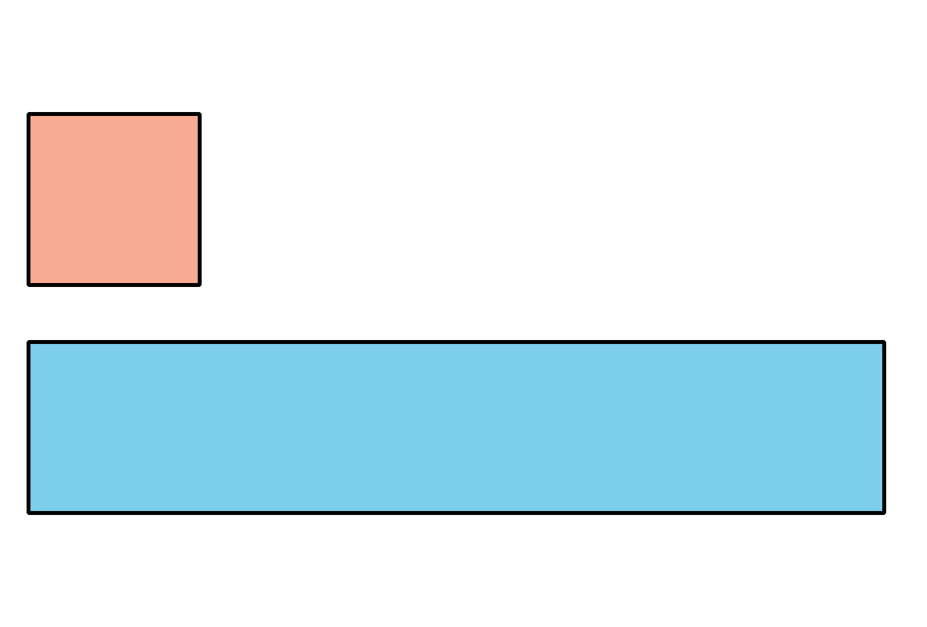



© CC BY 2021 Illustrative Mathematics®