Lesson 7 Practice Problems
- The center of a clock is at $\left(0,0\right)$ in a coordinate system, and the minute hand is 10 inches long. Find the approximate coordinates of the tip of the minute hand at:
  - 12:05 p.m.
  - 12:45 p.m.
  - 12:55 p.m.
- The center of a Ferris wheel is 100 feet off the ground and its radius is 85 feet. The point $A$ is at the 0 radian position, $B$ is rotated $\frac{7π}{12}$ radians from $A$, and $C$ is rotated $\frac{5π}{4}$ radians from $A$.
- 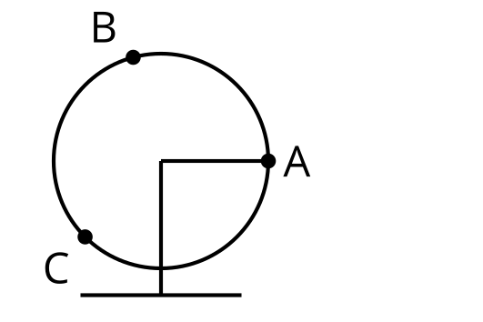
- For each point $A$, $B$, and $C$, find how high the position on the Ferris wheel is off the ground. Write an expression using the sine or cosine function and estimate the value.
- A Ferris wheel has a radius of 50 feet, and its center is 60 feet off the ground. How many points on the Ferris wheel are:
  - 30 feet off the ground?
  - 110 feet off the ground?
  - 5 feet off the ground?
- The minute hand on a clock tower is 6 feet long. At 10 minutes after the hour, the tip of the minute hand is 55 feet above the ground. How high above the ground is the center of the clock face? Explain how you know.
- A wheel has a radius of 1 foot. The center of the wheel is point $O$.
- 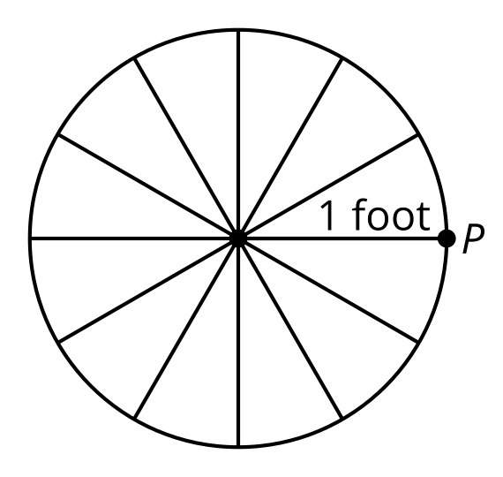
  - Indicate where the point $P$ will be after the wheel rotates counterclockwise around its center 1 foot. Label this point $Q$.
  - What is the measure of angle $POQ$ in radians?
  - Indicate where the point $P$ will be after the wheel rotates counterclockwise around its center $\frac{3π}{2}$ feet. Label this point $R$.
  - What is the measure of angle $POR$ in radians?
- (From Unit 6, Lesson 3.)
- Angle $θ$ corresponds to a point $\left(x,y\right)$ on the unit circle in quadrant 1.
  - Which quadrant does $θ+π$ lie in?
  - In terms of $x$ and $y$, what are the coordinates of $θ+π$?
- (From Unit 6, Lesson 4.)
- Using a unit circle display, give an example of an angle satisfying each inequality.
  - $A$ so that $cos\left(A\right)>0$ and $sin\left(A\right)<0$
  - $B$ so that $cos\left(B\right)<0$ and $sin\left(B\right)>0$
  - $C$ so that $cos\left(C\right)<0$ and $sin\left(C\right)<0$
- (From Unit 6, Lesson 6.)
- Suppose angle $θ$, in radians, is in quadrant 3 of the unit circle. If $sin\left(θ\right)=\text{-}0.45$, what are the values of $cos\left(θ\right)$ and $tan\left(θ\right)$?
- (From Unit 6, Lesson 6.)
© CC BY 2019 by Illustrative Mathematics®

