Lesson 14: Proving the Pythagorean Theorem
- Let’s prove the Pythagorean Theorem.

14.1: Notice and Wonder: Variable Version
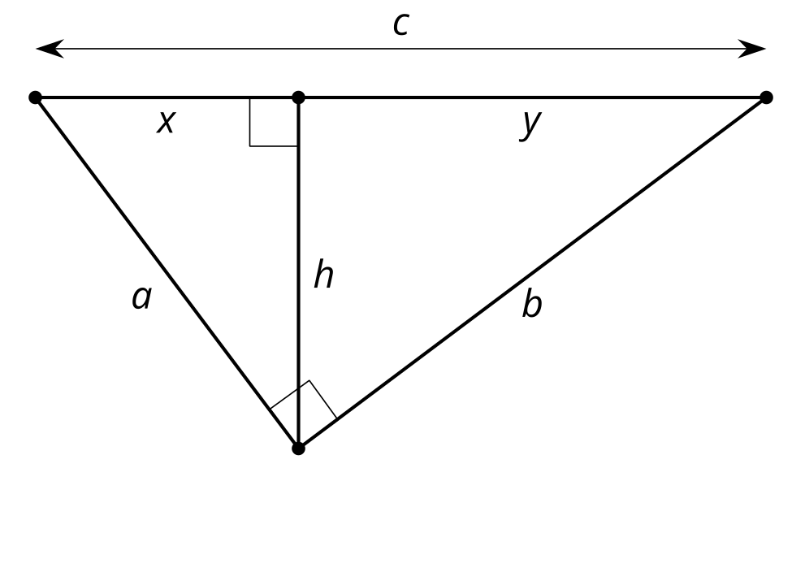
What do you notice? What do you wonder?

14.2: Prove Pythagoras Right
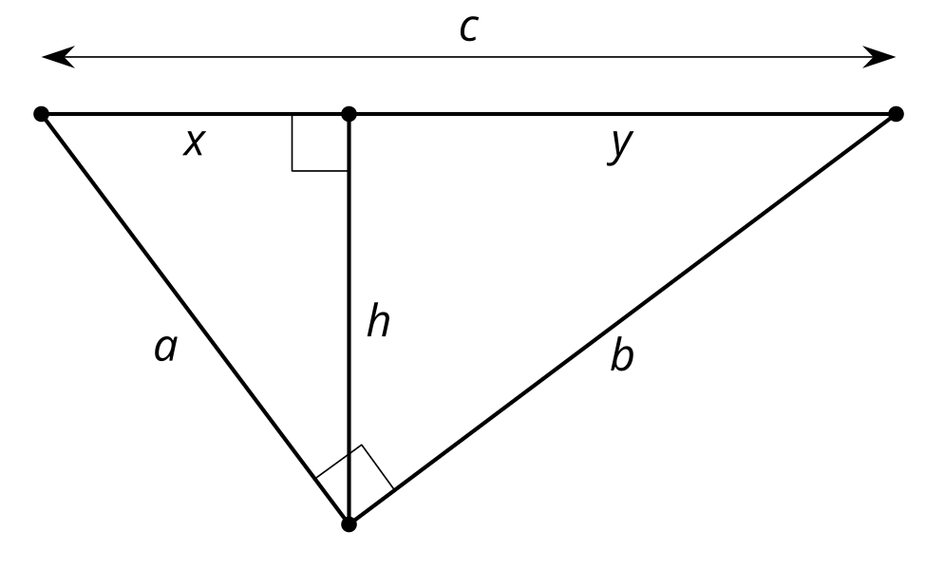
Elena is playing with the equivalent ratios she wrote in the warm-up. She rewrites $\frac{a}{x}=\frac{c}{a}\text{ as }a^{2}=xc$. Diego notices and comments, “I got $b^{2}=yc$. The $a^{2}$ and $b^{2}$ remind me of the Pythagorean Theorem.” Elena says, “The Pythagorean Theorem says that $a^{2}+b^{2}=c^{2}$. I bet we could figure out how to show that.”
- How did Elena get from $\frac{a}{x}=\frac{c}{a}\text{ to }a^{2}=xc$?
- What equivalent ratios of side lengths did Diego use to get $b^{2}=yc$?
- Prove $a^{2}+b^{2}=c^{2}$ in a right triangle with legs length $a$ and $b$ and hypotenuse length $c$.

14.3: An Alternate Approach
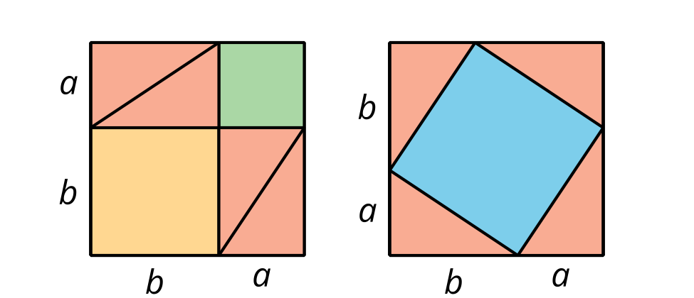
When Pythagoras proved his theorem he used the 2 images shown here. Can you figure out how he used these diagrams to prove $a^{2}+b^{2}=c^{2}$ in a right triangle with hypotenuse length $c$?

Are you ready for more?
James Garfield, the 20th president, proved the Pythagorean Theorem in a different way.
- Cut out 2 congruent right triangles
- Label the long sides $b$, the short sides $a$ and the hypotenuses $c$.
- Align the triangles on a piece of paper, with one long side and one short side in a line. Draw the line connecting the other acute angles.
How does this diagram prove the Pythagorean Theorem?
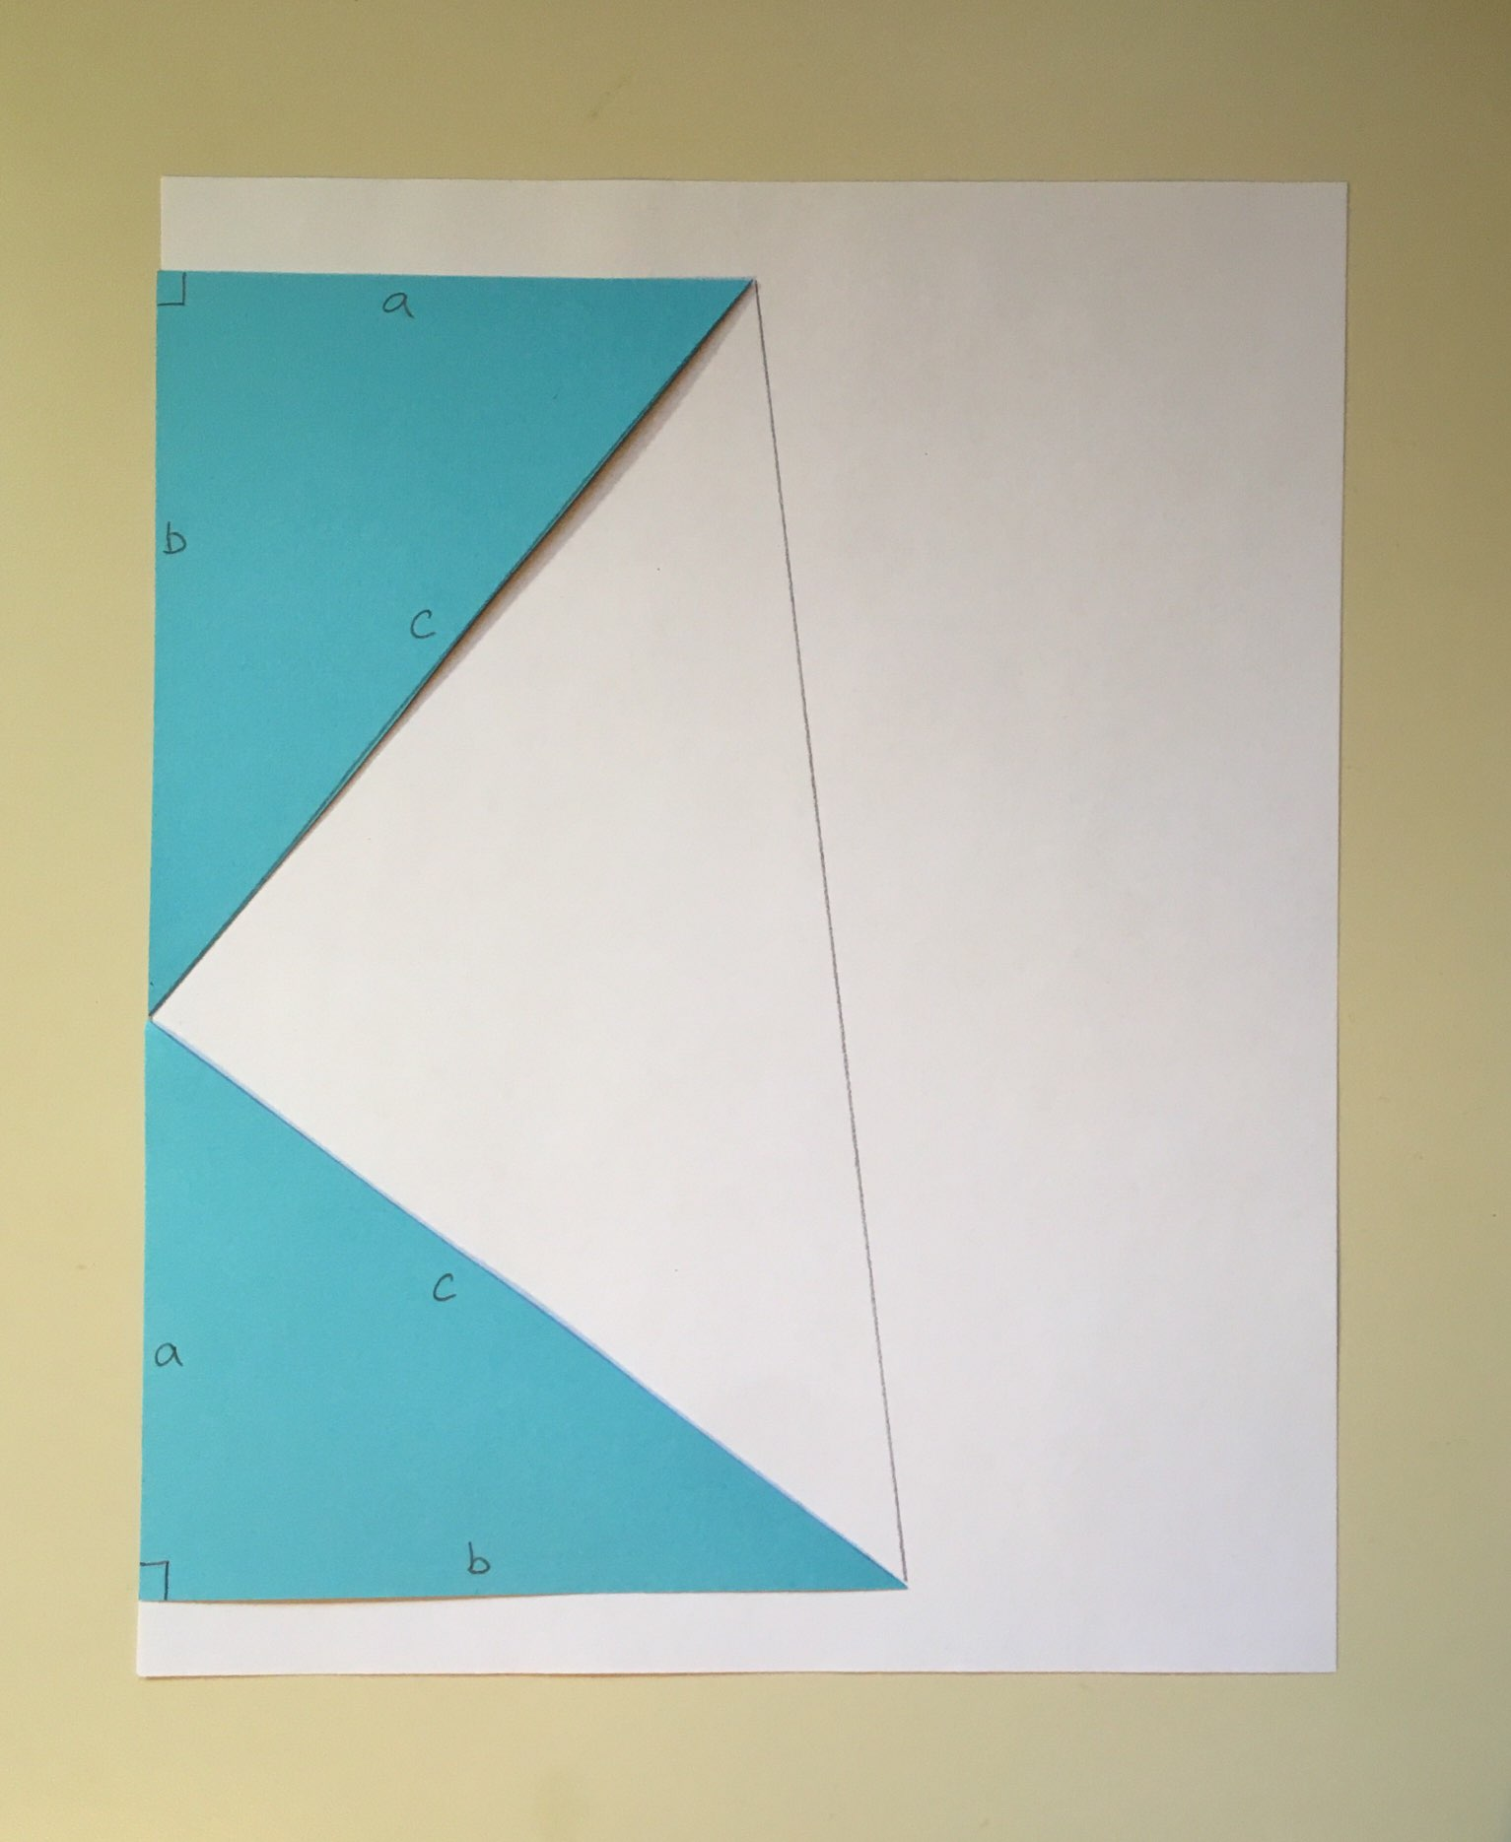

Lesson 14 Summary
In any right triangle with legs $a$ and $b$ and hypotenuse $c$, we know that $a^{2}+b^{2}=c^{2}$. We call this the Pythagorean Theorem. But why does it work?
We can use an altitude drawn to the hypotenuse of a right triangle to prove the Pythagorean Theorem.
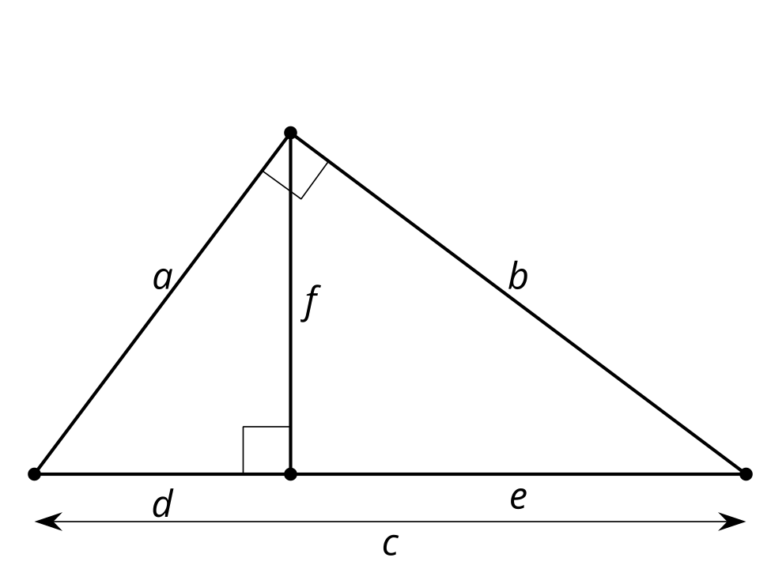
We can use the Angle-Angle Triangle Similarity Theorem to show that all 3 triangles are similar. Because the triangles are similar, corresponding side lengths are in the same proportion.
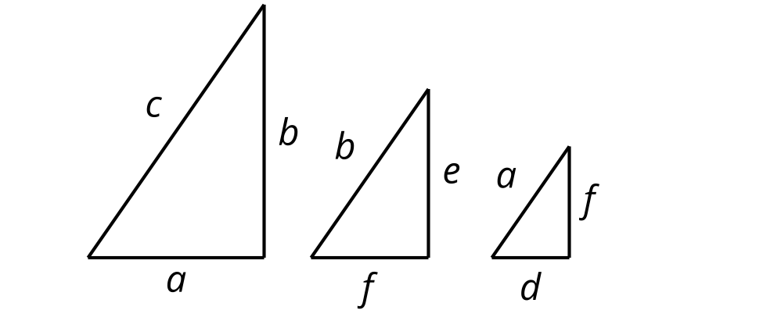
Because the largest triangle is similar to the smaller triangle, $\frac{c}{a}=\frac{a}{d}$. Because the largest triangle is similar to the middle triangle, $\frac{c}{b}=\frac{b}{e}$. We can rewrite these equations as $a^{2}=cd$ and $b^{2}=ce$.
We can add the 2 equations to get that $a^{2}+b^{2}=cd+ce$ or $a^{2}+b^{2}=c\left(d+e\right)$. From the original diagram we can see that $d+e=c$, so $a^{2}+b^{2}=c\left(c\right)$ or $a^{2}+b^{2}=c^{2}$.
Using the Pythagorean Theorem we can describe a triangle's angles without ever drawing it. For example, a triangle with side lengths 8, 15, and 17 is right because ${17}^{2}=8^{2}+{15}^{2}$. A triangle with side lengths 8, 15, and 18 is obtuse because ${18}^{2}>8^{2}+{15}^{2}$. A triangle with side lengths 8, 15, and 16 is acute because ${16}^{2}<8^{2}+{15}^{2}$.
© CC BY 2019 by Illustrative Mathematics®

