Lesson 3: Sample Spaces
- Let’s look closer at sample spaces.

3.1: Rolling Cubes
When rolling two standard number cubes, one of the possible outcomes is 1 and 1.
- What are the other possible outcomes?
- How many outcomes are in the sample space?

3.2: Spinner Sample Space
Each of the spinners is spun once.
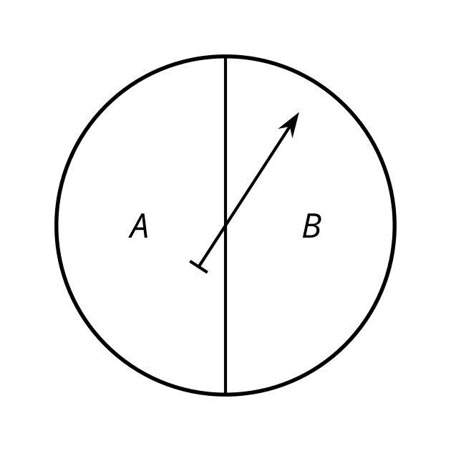
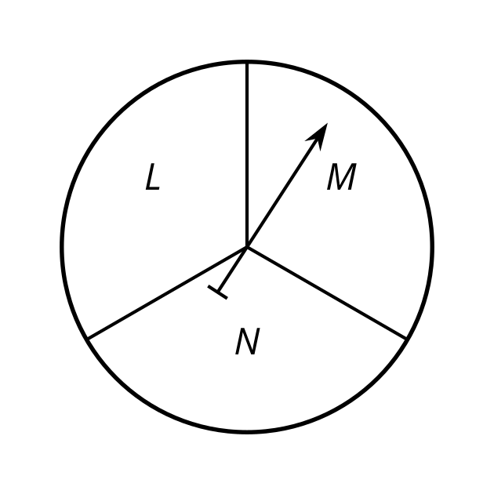
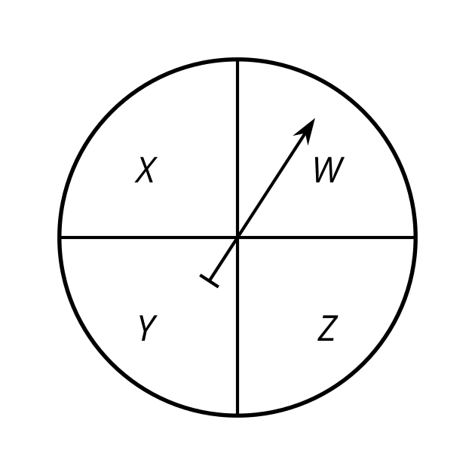
- Diego makes a list of the possible outcomes: ALW, ALX, ALY, ALZ, AMW, AMX, AMY, AMZ, ANW, ANX, ANY, ANZ, BLW, BLX, BLY, BLZ, BMW, BMX, BMY, BMZ, BNW, BNX, BNY, BNZ
- Tyler makes a table for the first two spinners.
 | - L | - M | - N
- A | - AL | - AM | - AN
- B | - BL | - BM | - BN
- Then he uses the outcomes from the table to include the third spinner.
 | - W | - X | - Y | - Z
- AL | - ALW | - ALX | - ALY | - ALZ
- AM | - AMW | - AMX | - AMY | - AMZ
- AN | - ANW | - ANX | - ANY | - ANZ
- BL | - BLW | - BLX | - BLY | - BLZ
- BM | - BMW | - BMX | - BMY | - BMX
- BN | - BNW | - BNX | - BNY | - BNZ
- Lin creates a tree to keep track of the outcomes.
- 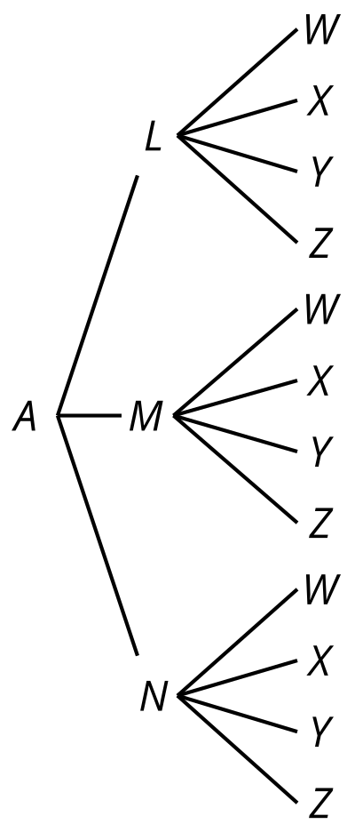
- 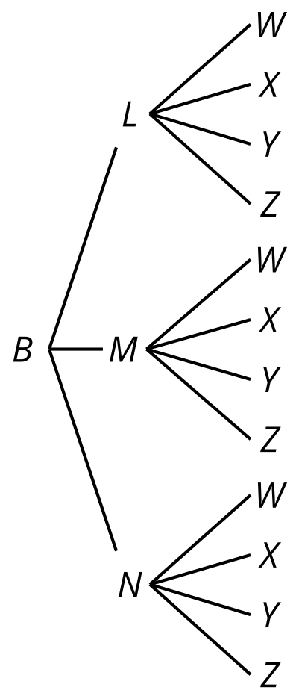
- How many outcomes are in the sample space for this experiment?
- One of the outcomes from Diego’s list is BLX. Where does this show up in Tyler's method? Where is it in Lin’s method?
- When spinning all three spinners, what is the probability that:
  - they point to the letters ANY? Explain your reasoning.
  - they point to the letters AMW, ANZ, or BNW? Explain your reasoning.
- If a fourth spinner that has 2 equal sections labeled S and T is added, how would each of the methods need to adjust?

3.3: Sample Space Practice
List all the possible outcomes for each experiment.
- A standard number cube is rolled, then a coin is flipped.
- Four coins are flipped.
- The two spinners are spun.
- 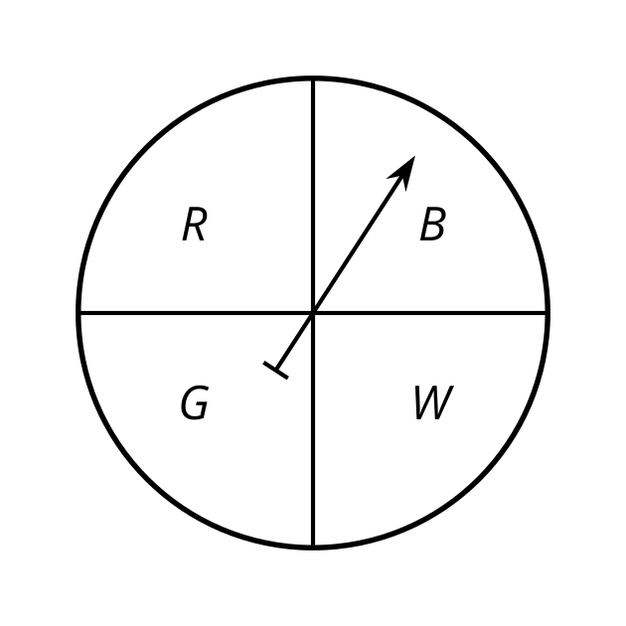
- 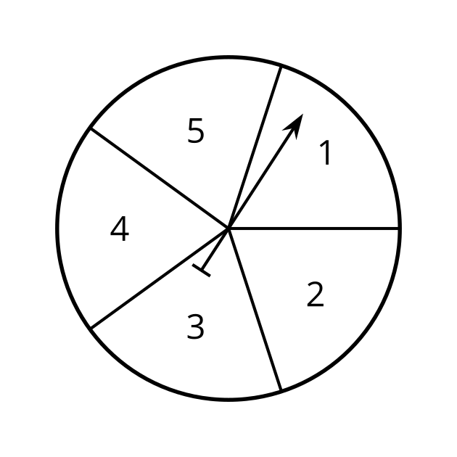
- A class block is chosen from 1, 2, 3, 4, or 5, then a subject is chosen from English or math.

Are you ready for more?
Elena is answering a matching practice problem where she has to match each of 4 items in a left column (A, B, C, D) to 4 items on the right (1, 2, 3, 4) so that each item is used exactly once. For example one way to answer this problem is A4, B2, C1, D3.
- What are all the possible ways she could answer this problem?
- The actual solution is A1, B2, C3, D4. If Elena was equally likely to guess any answer, use the sample space to find:
  - The probability of getting exactly 0 items matched correctly.
  - The probability of getting exactly 1 item matched correctly.
  - The probability of getting exactly 2 items matched correctly.
  - The probability of getting exactly 3 items matched correctly.
  - The probability of getting exactly 4 items matched correctly.

Lesson 3 Summary
Probability represents the proportion of the time an event will occur when repeating an experiment many, many times. For complex experiments, the sample space can get very large very quickly, so it is helpful to have some methods for keeping track of the outcomes in the sample space.
In some cases, it makes sense to list all the outcomes in the sample space. For example, when flipping 3 coins, the 8 outcomes in the sample space are:
HHH, HHT, HTH, THH, HTT, THT, TTH, TTT
where H represents heads and T represents tails.
With more outcomes possible, it can be difficult to make sure all the outcomes are represented and none are repeated, so other methods may be helpful.
Another option is to use tables. When a complex experiment is broken down into parts, tables can be used to find the outcomes of two parts at a time. For example, when flipping 3 coins, we determine the outcomes for flipping just 2 coins.
 | H | T
H | HH | HT
T | TH | TT
The possible outcomes are represented by the 4 options in the middle of the table: HH, HT, TH, and TT. These outcomes can then be combined with the third coin flip in another table.
 | H | T
HH | HHH | HHT
HT | HTH | HTT
TH | THH | THT
TT | TTH | TTT
Again, we see that the outcomes are HHH, HHT, HTH, HTT, THH, THT, TTH, and TTT.
Another way to keep track of the outcomes is to draw a tree structure. Each column represents another part of an experiment, with branches connecting each possible result from one part of the experiment to the possible results for the next part. By following the branches from left to right, each path represents an outcome for the sample space. The tree for flipping 3 coins would look like this:
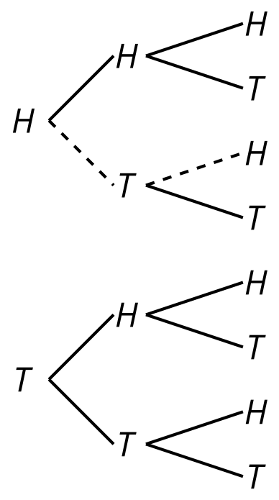
The path shown with the dashed line represents the HTH outcome. By following the other paths, the other 7 outcomes can be seen.
© CC BY 2019 by Illustrative Mathematics®

