Unit 5 Lesson 7: Round Doubloons

WU Notice and Wonder: A Digital Scale (Warm up)

Student Task Statement
What do you notice? What do you wonder?
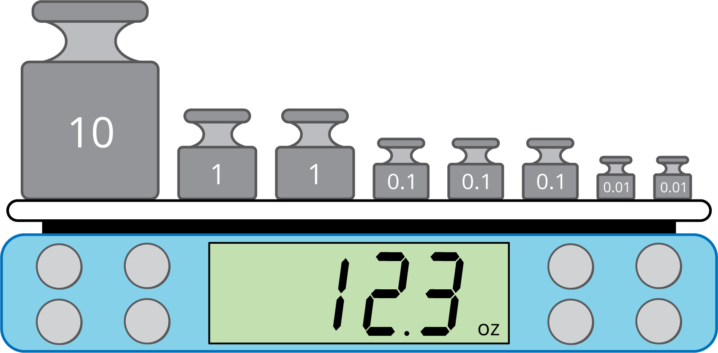

1 Gold Doubloons

Student Task Statement
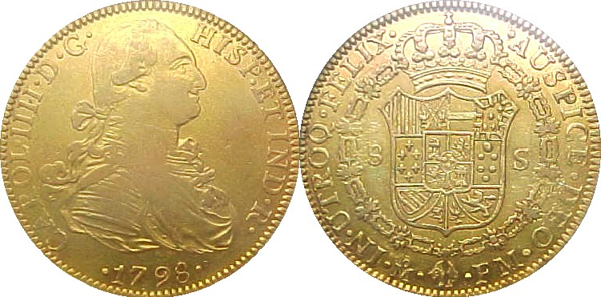
- Until 1728, doubloons weighed 6.867 grams.
- After 1728, they weighed 6.766 grams.
- You have a scale that measures weight to the nearest tenth of a gram.
- Was the doubloon on the scale made before or after 1728?
- 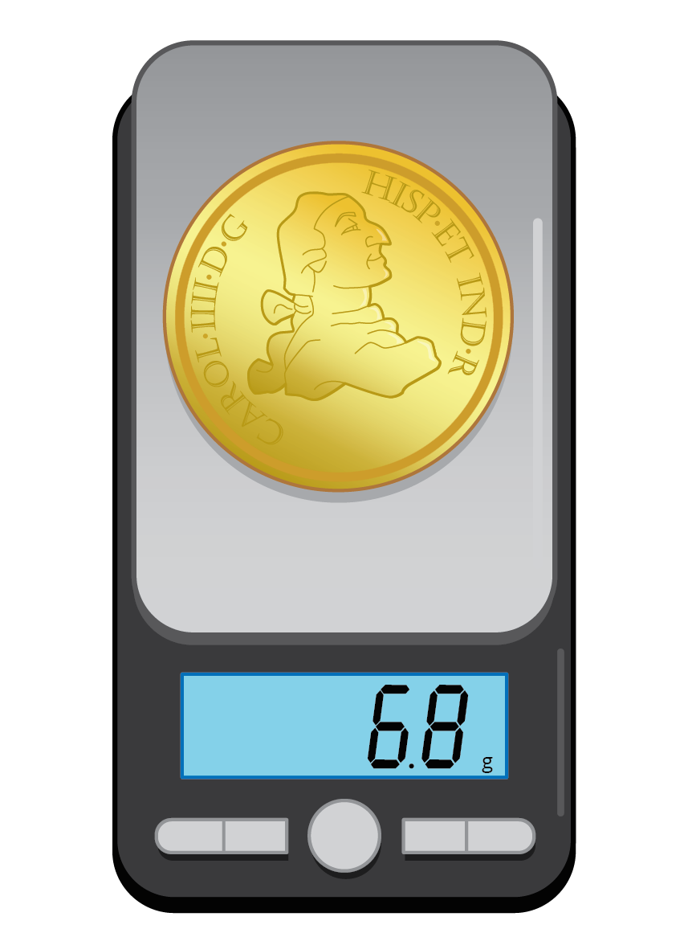
- If you had a scale that measured to the nearest gram, explain why you would not be able to tell what year the doubloon was made based on the weight listed on the scale.

  - Which doubloons weigh more, the ones made before 1728 or the ones made after 1728? Explain or show your reasoning.
  - Show the weights of the doubloons on the number line.
- Use the number lines to find which hundredth of a gram the doubloon weights are each closest to.

2 Exact or Approximate?

Student Task Statement
Decide if each quantity is exact or an estimate. Be prepared to explain your reasoning.
- There are 14 pencils on the desk.
- The population of Los Angeles is 12,400,000.
- It's 2.4 miles from the school to the park.
- The runner finished the race in 19.78 seconds.
© CC BY 2021 Illustrative Mathematics®

