Unit 1 Lesson 8: Figures Made of Prisms

WU Which One Doesn’t Belong: Different Figures (Warm up)

Student Task Statement
Which one doesn’t belong?
A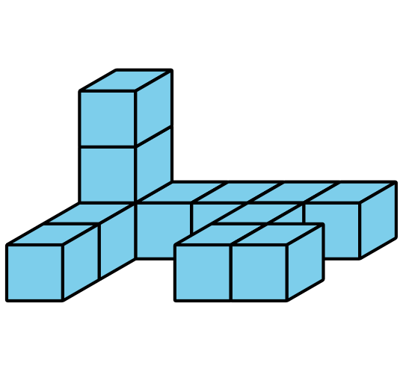
B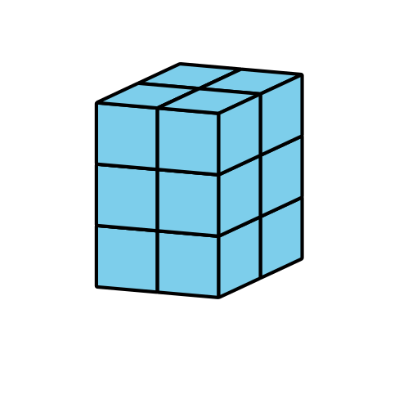
C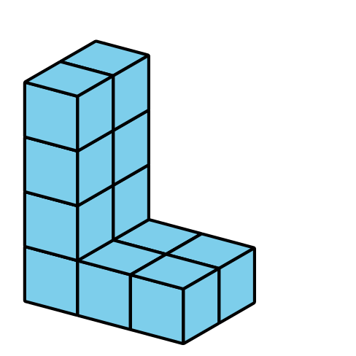
D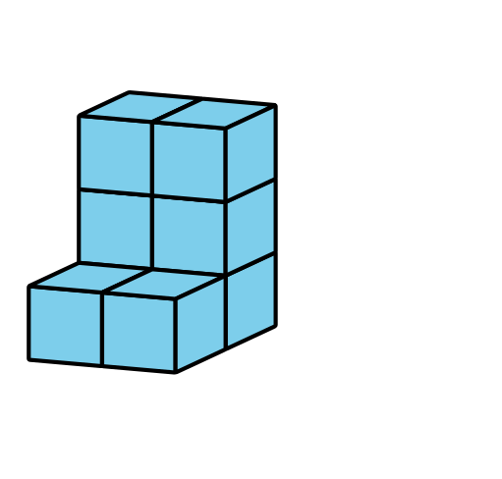

1 Put It Together

Student Task Statement
- Partner A, build a rectangular prism with 12 cubes.
- Partner B, build a rectangular prism with 10 cubes.
- Put your two rectangular prisms together to make one figure. What is the volume of the new figure? Explain or show your thinking.
- Diego and Jada put together two rectangular prisms to make this figure:
- 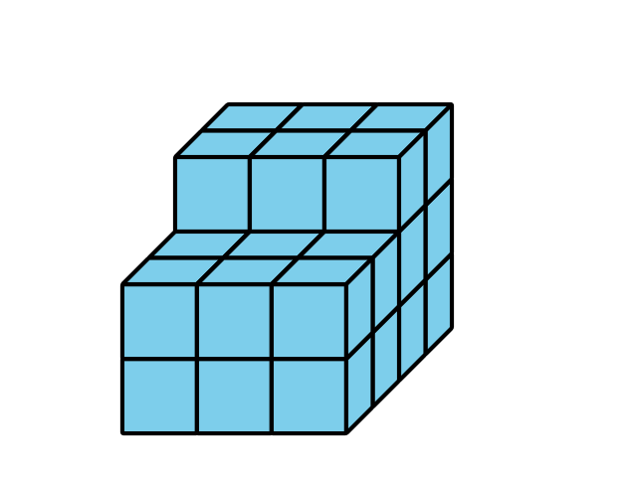
  - What is the volume of the figure Diego and Jada made?
  - Which rectangular prisms could Diego and Jada each have built? Explain or show your thinking. Organize it so it can be followed by others.

2 I See Two Prisms

Student Task Statement
Find the volume of each figure. Explain or show your reasoning.
a.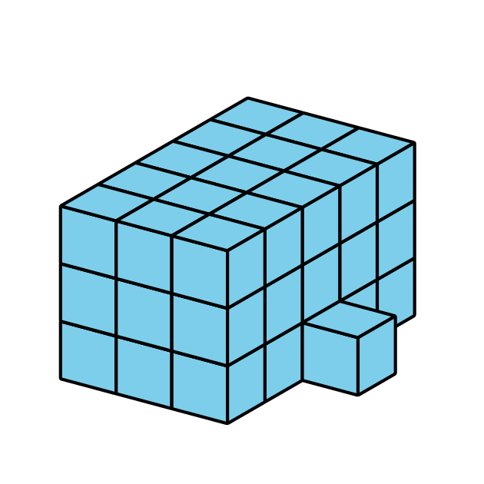
b.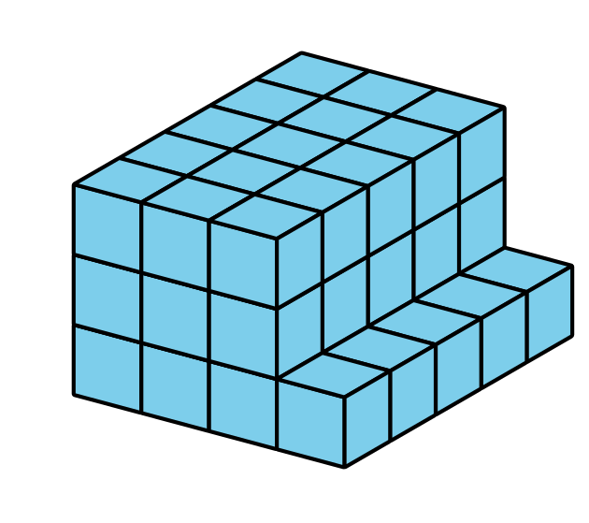
c.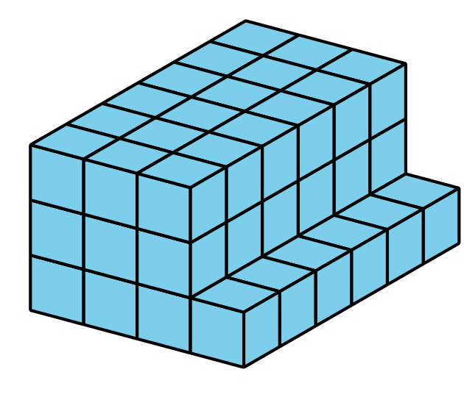
d.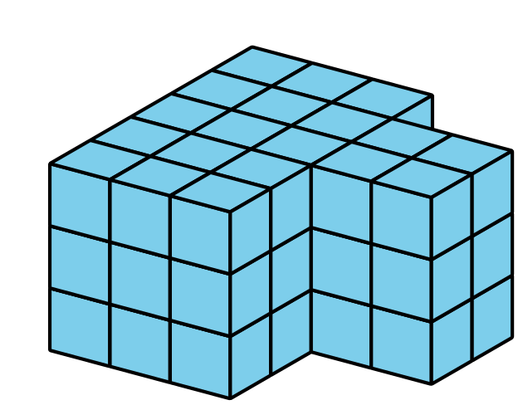
© CC BY 2021 Illustrative Mathematics®

