Unit 5 Lesson 6: Represent Numbers in Different Ways

WU Which One Doesn’t Belong: Numbers in Different Ways (Warm up)

Student Task Statement
Which one doesn’t belong?
A
B
C
D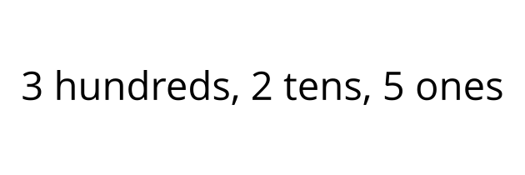

1 Numbers as Words

Student Task Statement
- Fill in the blanks to represent 248 with words.
- two ___________________ forty-________________
- Fill in the blanks to represent 562 with words.
- ______________ hundred _____________- _______
- Represent this number with words.
- 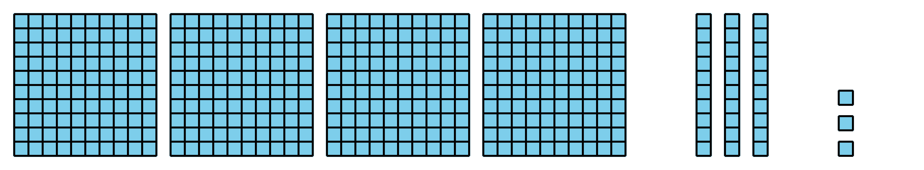
- Represent 627 with words.
- Represent $900+50+1$ with words.
- Represent three hundred eighteen in two different ways.

2 Represent the Numbers

Student Task Statement
Represent the number on your poster. Be sure to represent the number using:
- a three-digit number
- a base-ten diagram
- expanded form
- words
If you have time: Represent the number using only tens and ones. Represent the number composed in a different way.
© CC BY 2021 Illustrative Mathematics®

