Unit 6 Lesson 8: Groups Up to 110

WU Choral Count: Above 100 (Warm up)

Student Task Statement

1 Long Lengths with Small Cubes

Student Task Statement
Represent your measurement using drawings, numbers, or words.

2 Representations of Large Numbers

Student Task Statement
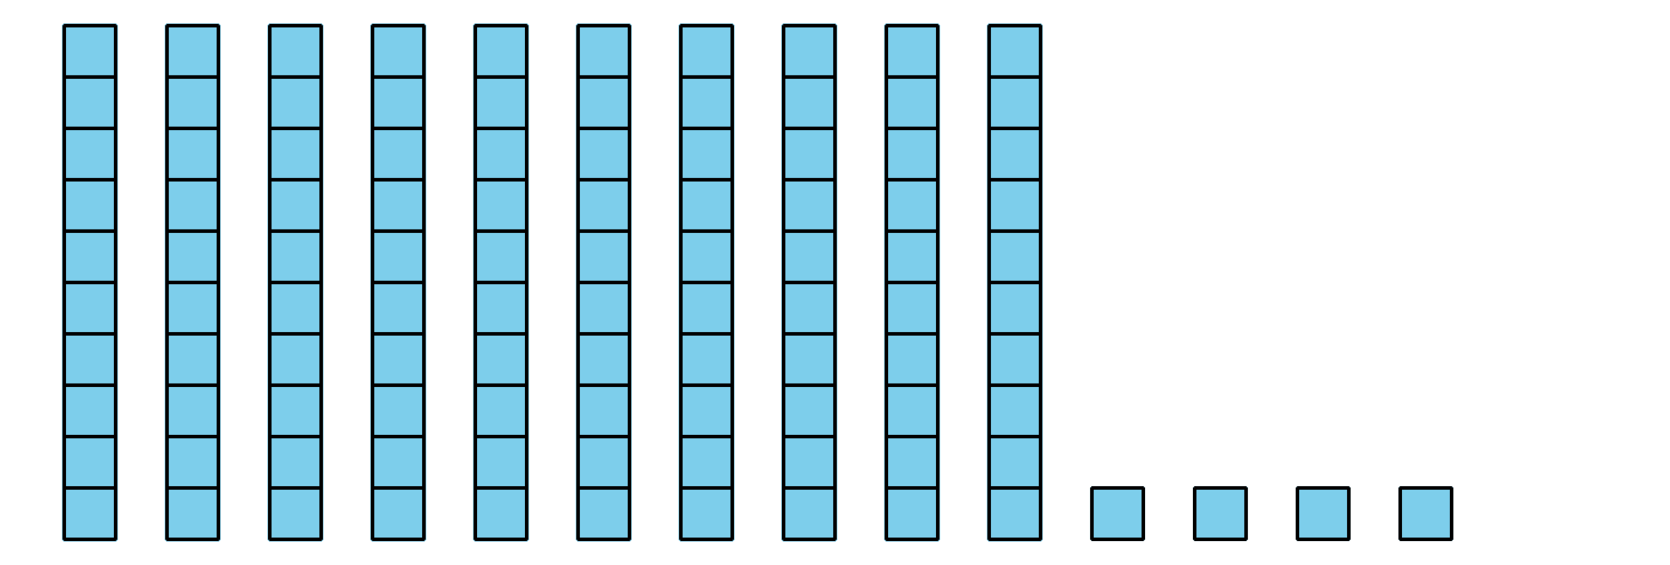
© CC BY 2021 Illustrative Mathematics®

