Unit 3 Lesson 6: Problems with Equal Groups of Fractions

WU True or False: Two and Three Factors (Warm up)

Student Task Statement
Decide whether each statement is true or false. Be prepared to explain your reasoning.
- $\frac{10}{12}=5×\frac{2}{12}$
- $1×\frac{10}{12}=5×\frac{2}{12}$
- $\frac{24}{4}=6×3×\frac{1}{4}$
- $12×2×\frac{1}{4}=8×3×\frac{1}{4}$

1 Banana Bread Recipe

Student Task Statement
A bakery is making banana bread. Here is the recipe for 1 batch.
Recipe:
- 1 banana
- $\frac{2}{3}$ cup butter
- $\frac{3}{2}$ teaspoons baking soda
- $\frac{5}{8}$ cup sugar
- 2 large eggs
- $\frac{5}{2}$ cups of all-purpose flour
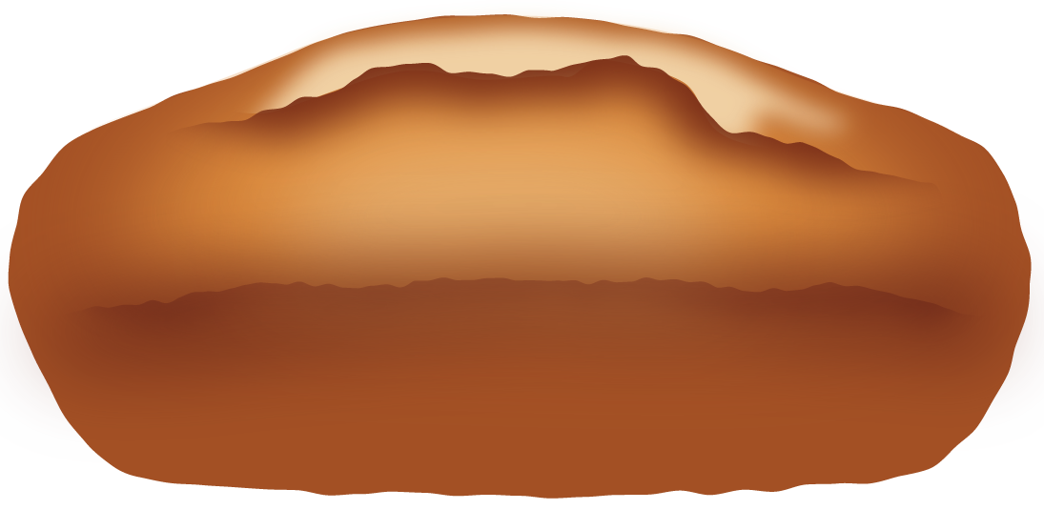
- The bakery makes 2 batches of banana bread on Monday. Complete the table to show how much of each ingredient is used.
- Monday’s banana bread
- ingredient | - expression | - amount of ingredient
- bananas |  | - _______
- butter |  | - _______ cup(s)
- baking soda |  | - _______ teaspoon(s)
- sugar |  | - _______ cup(s)
- eggs |  | - _______
- flour |  | - _______ cup(s)
- On Tuesday, the bakery needs $\frac{8}{3}$ cups of butter to make enough banana bread for the day. How many batches were made? Explain or show your reasoning.
- Recipe:
  - 1 banana
  - $\frac{2}{3}$ cup butter
  - $\frac{3}{2}$ teaspoons baking soda
  - $\frac{5}{8}$ cup sugar
  - 2 large eggs
  - $\frac{5}{2}$ cups of all-purpose flour
- Based on the number of the batches made on Tuesday, complete the table for each ingredient.
- Tuesday’s banana bread
- ingredient | - expression | - amount of ingredient
- bananas |  | - _______
- butter |  | - $\frac{8}{3}$ cups
- baking soda |  | - _______ teaspoon(s)
- sugar |  | - _______ cup(s)
- eggs |  | - _______
- flour |  | - _______ cup(s)

2 How Much Milk Was Used?

Student Task Statement
The bakery that sells banana bread also sells fresh milkshakes. Each serving uses $\frac{1}{10}$ liter of milk.
Here are five descriptions of the milkshakes sold in a week and five expressions that represent the liters of milk used.
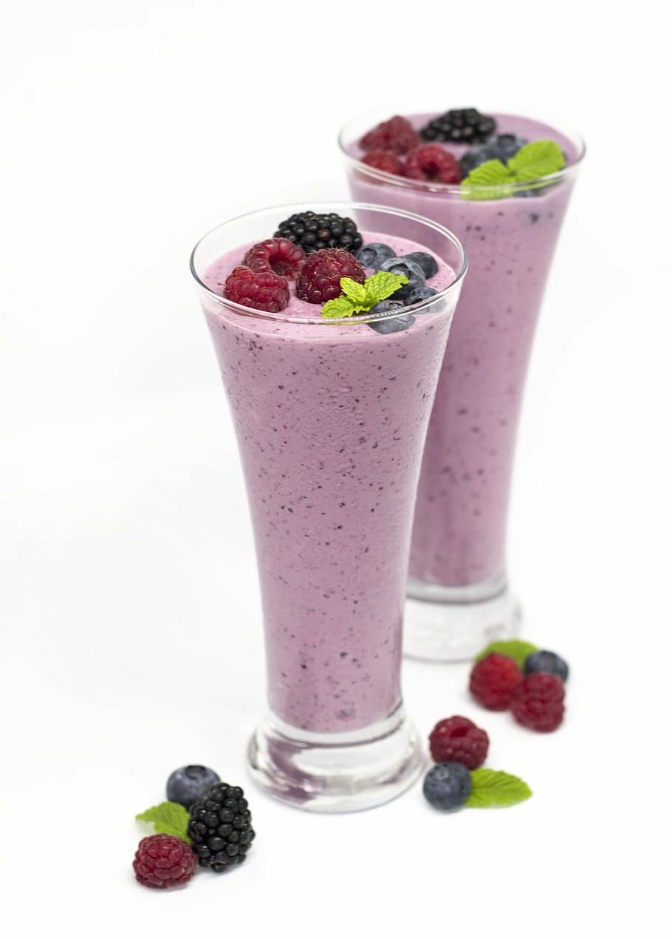
Match each description to an expression that represents it.
- On Monday, the bakery sold 8 servings of milkshake. How much milk was used?
- On Tuesday, two customers bought 4 servings of milkshake each. How much milk was used?
- On Wednesday, four customers bought 2 servings of milkshake each. How much milk was used?
- On Thursday, two customers each bought a serving of milkshake. They placed the same order three more times for their friends that day. How much milk was used?
- On Saturday, four friends each purchased a serving of milkshake for breakfast. They came back for the same after dinner. How much milk was used?
$4×\left(2×\frac{1}{10}\right)$
$4×\frac{2}{10}$
$8×\frac{1}{10}$
$2×\left(4×\frac{1}{10}\right)$
$2×\frac{4}{10}$
© CC BY 2021 Illustrative Mathematics®

