Lesson 18: Standard Algorithm to Add and Subtract

Standards Alignments
Addressing | 4.NBT.B.4

Teacher-facing Learning Goals
- Add multi-digit numbers, with composing, using the standard algorithm.
- Subtract multi-digit numbers, without decomposing, using the standard algorithm.

Student-facing Learning Goals
- Let’s find sums and differences of large numbers.

Lesson Purpose
The purpose of this lesson is to add and subtract large numbers within 100,000 using the standard algorithm.
In grade 3, students found sums and differences within 1,000. Students analyzed and used different algorithms based on place value, including the standard algorithm. As students work with larger numbers in grade 4, they recognize that the standard algorithm is a reliable and efficient way to add and subtract within 1,000,000.
Grid paper should be made available but not required, as a tool to support aligning digits when adding and subtracting in each activity.

Access for:

Students with Disabilities
- Representation (Activity 1)

English Learners
- MLR2 (Activity 1)

Instructional Routines
Estimation Exploration (Warm-up)

Materials to Gather
- Grid paper: Activity 1, Activity 2

Lesson Timeline
Warm-up | 10 min
Activity 1 | 15 min
Activity 2 | 20 min
Lesson Synthesis | 10 min
Cool-down | 5 min

Teacher Reflection Question
What strategies from earlier grades did students rely on to find sums and differences in the warm-up and first activity, before the standard algorithm was explicitly mentioned? How can you support students in connecting these strategies to the standard algorithm?

Cool-down
(to be completed at the end of the lesson) 5min
Andre's Steps

Standards Alignments
Addressing | 4.NBT.B.4

Student-facing Task Statement
Andre started tracking his steps. He walked 14,687 steps on Monday and 10,512 steps on Tuesday.
- How many steps did he walk in those two days? Show your reasoning.
- How many more steps did he walk on Monday than on Tuesday?

Student Responses
- 25,199 steps. Sample response:
- 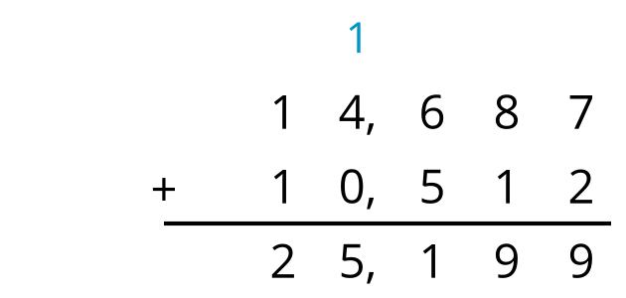
- 4,175 steps. Sample response:
- 
 

