Unit 9 Lesson 5: Multiplication of Multi-digit Numbers

WU Estimation Exploration: A Silly Riddle (Warm up)

Student Task Statement
- Seven teachers are going to the park.
- Each teacher is taking 7 students.
- Each student is bringing 7 fishbowls.
- Each fishbowl has 7 fish.
How many are going to the park?
Record an estimate that is:
too low | about right | too high

1 Two Methods Revisited

Student Task Statement
- Earlier in the course, we used these two ways to multiply numbers:
- A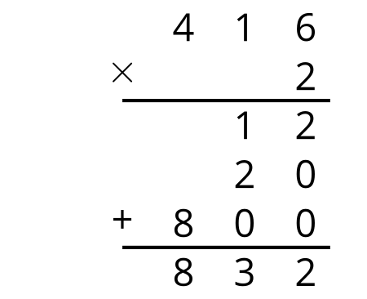
- B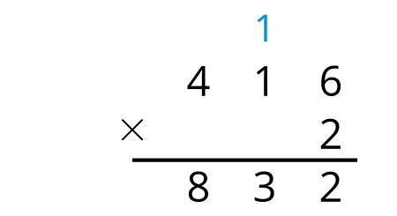
  - In method A, where do the 12, 20, and 800 come from?
  - In method B, where does the 1 above 416 come from?
- Diego used both methods to find the value of $215×3$ but ended up with very different results.
- 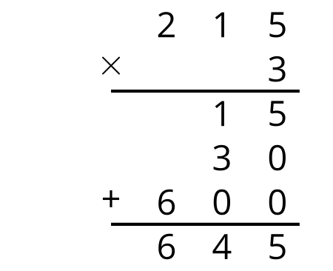
- 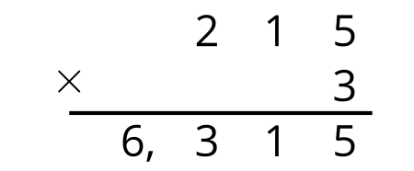
  - Without calculating anything, can you tell which method shows the correct product? How do you know the other one is not correct?
  - For the incorrect result, explain what was correct and what was incorrect in his steps. Then, show the correct calculation using method B.
- Use either way to find the value of each product. Show your reasoning.
  - $521×3$
  - $6,​121×4$
  - $305×9$

2 Two by Two

Student Task Statement
Here are two ways to find the value of $34×21$.
A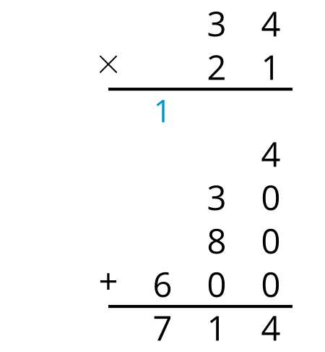
B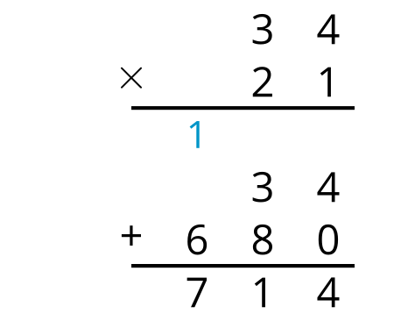
- In method A, where do the 4, 30, 80, and 600 come from?
- In method B, which two numbers are multiplied to get:
  - 34?
  - 680?
- Use the two methods to show that each equation is true.
- a. $44×12=528$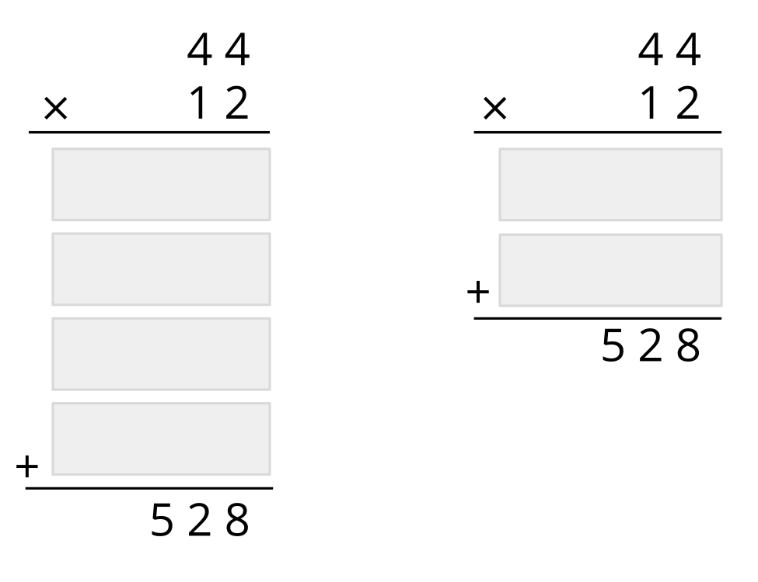
- b. $63×21=1,​323$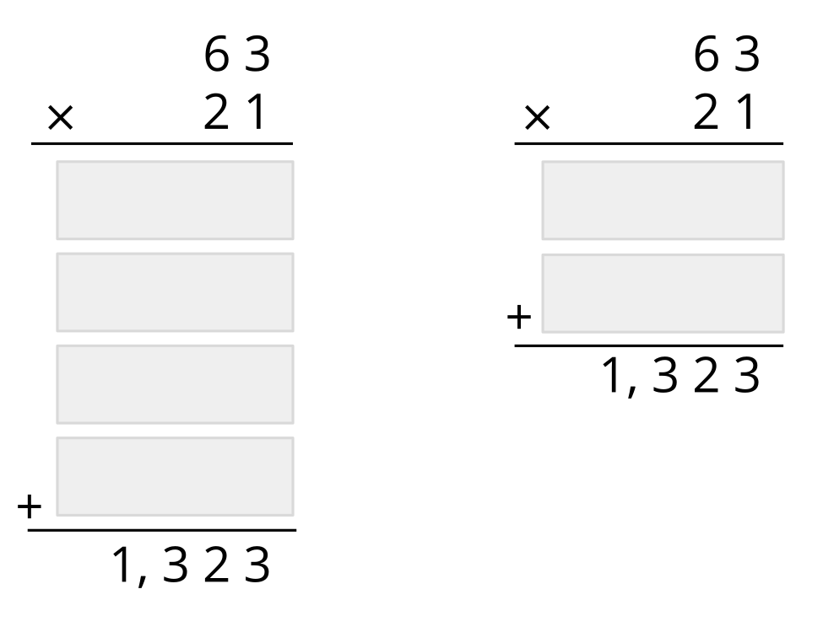

Images for Activity Synthesis
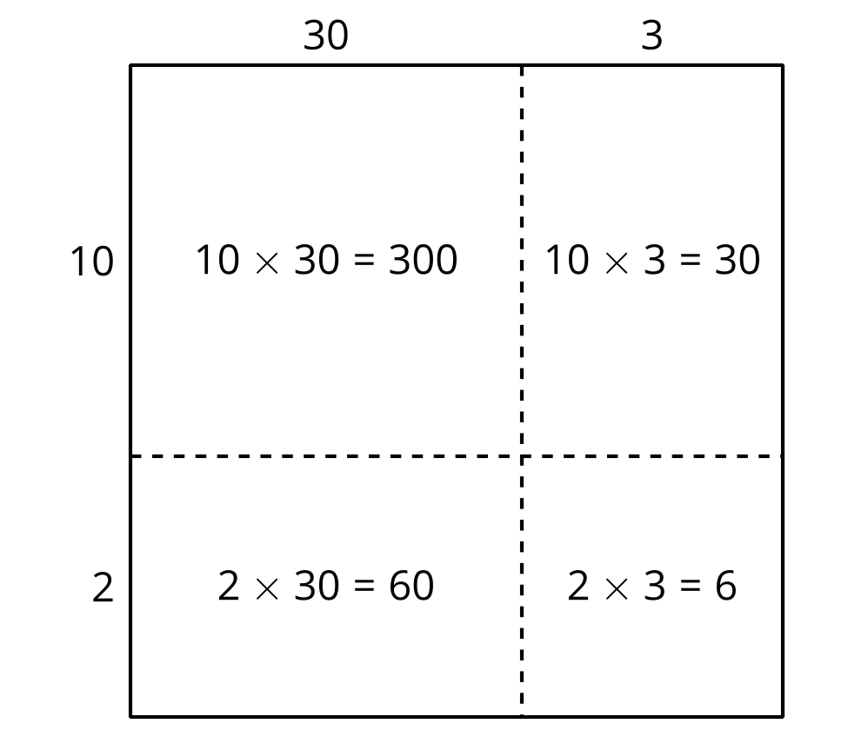
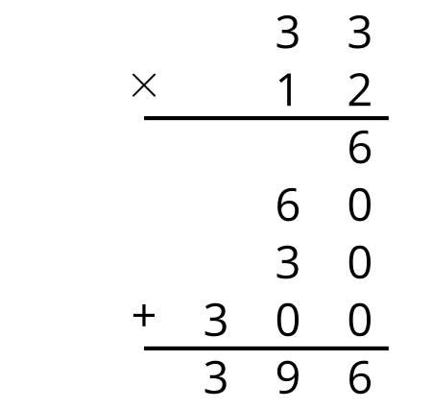
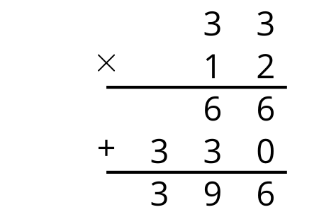
© CC BY 2021 Illustrative Mathematics®

