Unit 8 Lesson 8: Describing Distributions on Histograms

1 Which One Doesn’t Belong: Histograms (Warm up)

Student Task Statement
Which histogram does not belong? Be prepared to explain your reasoning.
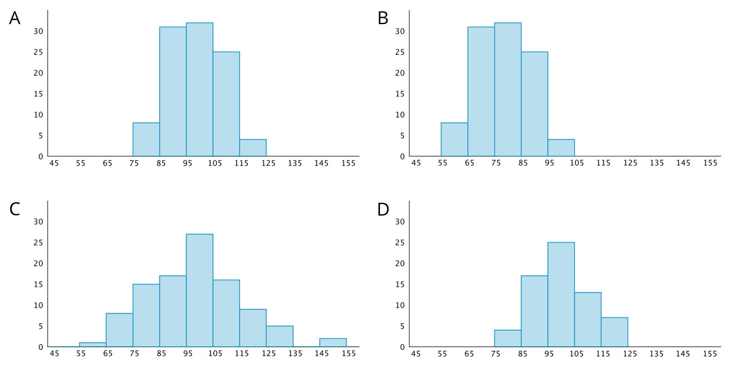

2 Sorting Histograms

Images for Launch
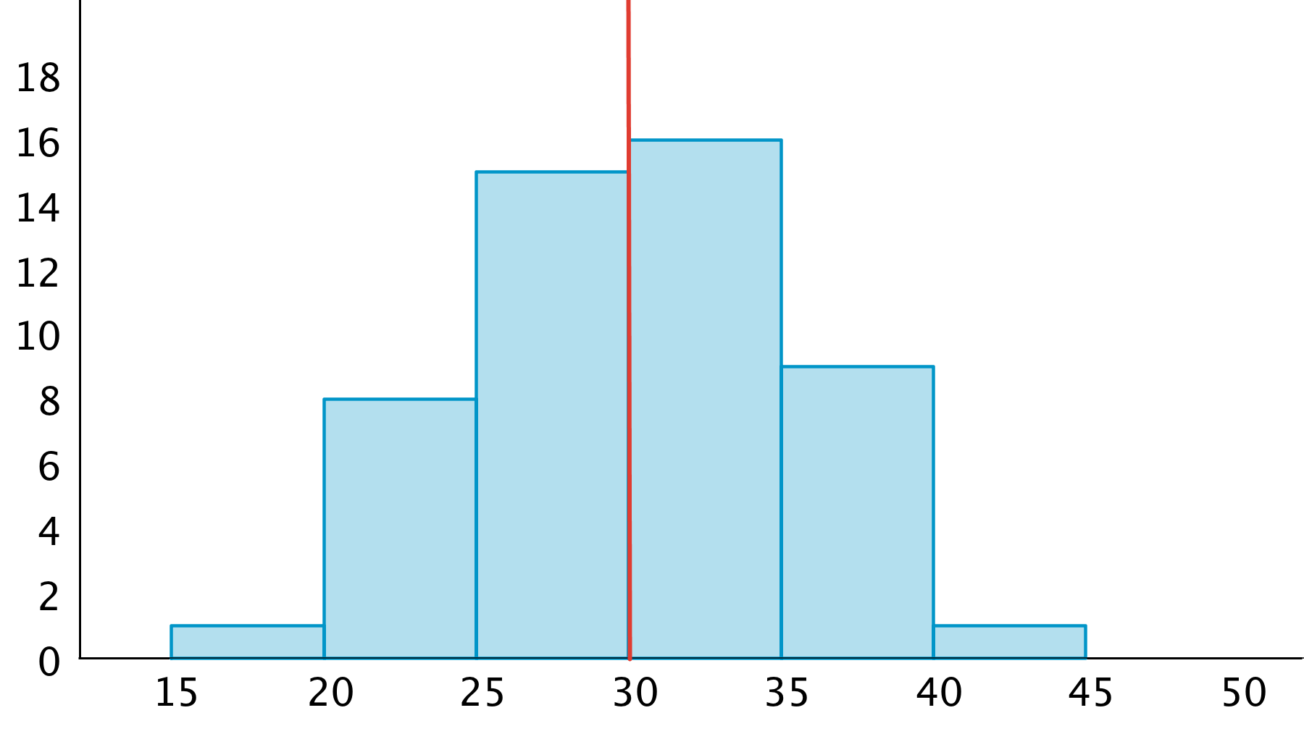

Student Task Statement
- Your teacher will give your group a set of histogram cards. Sort them into two piles—one for histograms that are approximately symmetrical, and another for those that are not.
- Discuss your sorting decisions with another group. Do both groups agree which cards should go in each pile? If not, discuss the reasons behind the differences and see if you can reach agreement. Record your final decisions.
  - Histograms that are approximately symmetrical:
  - Histograms that are not approximately symmetrical:
- Histograms are also described by how many major peaks they have. Histogram A is an example of a distribution with a single peak that is not symmetrical.
- Which other histograms have this feature?
- Some histograms have a gap, a space between two bars where there are no data points. For example, if some students in a class have 7 or more siblings, but the rest of the students have 0, 1, or 2 siblings, the histogram for this data set would show gaps between the bars because no students have 3, 4, 5, or 6 siblings.
- Which histograms do you think show one or more gaps?
- Sometimes there are a few data points in a data set that are far from the center. Histogram A is an example of a distribution with this feature.
- Which other histograms have this feature?

3 Getting to School

Student Task Statement
Your teacher will provide you with some data that your class collected the other day.
- Use the data to draw a histogram that shows your class’s travel times.
- 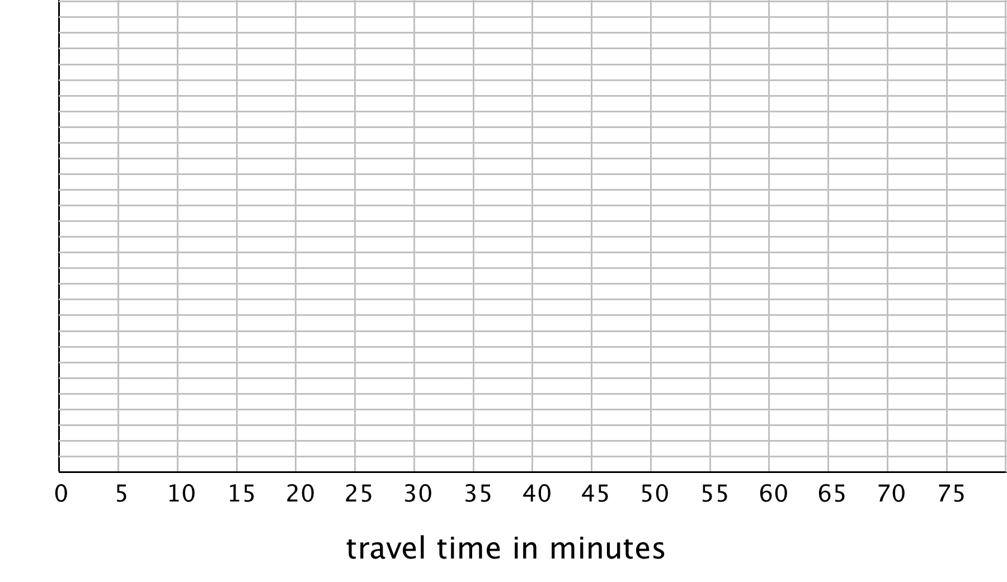
- Describe the distribution of travel times. Comment on the center and spread of the data, as well as the shape and features.
- Use the data on methods of travel to draw a bar graph. Include labels for the horizontal axis.
- Describe what you learned about your class’s methods of transportation to school. Comment on any patterns you noticed.
- Compare the histogram and the bar graph that you drew. How are they the same? How are they different?
© CC BY Open Up Resources. Adaptations CC BY IM.

