Unit 5 Lesson 18: Scaling Two Dimensions

1 Tripling Statements (Warm up)

Student Task Statement
$m$, $n$, $a$, $b$, and $c$ all represent positive integers. Consider these two equations: $m=a+b+c$ $n=abc$
- Which of these statements are true? Select all that apply.
  - If $a$ is tripled, $m$ is tripled.
  - If $a$, $b$, and $c$ are all tripled, then $m$ is tripled.
  - If $a$ is tripled, $n$ is tripled.
  - If $a$, $b$, and $c$ are all tripled, then $n$ is tripled.
- Create a true statement of your own about one of the equations.

2 A Square Base (Optional)

Student Task Statement
Clare sketches a rectangular prism with a height of 11 and a square base and labels the edges of the base $s$. She asks Han what he thinks will happen to the volume of the rectangular prism if she triples $s$.
Han says the volume will be 9 times bigger. Is he right? Explain or show your reasoning.

3 Playing with Cones (Optional)

Student Task Statement
There are many cones with a height of 7 units. Let $r$ represent the radius and $V$ represent the volume of these cones.
- Write an equation that expresses the relationship between $V$ and $r$. Use 3.14 as an approximation for $π$.
- Predict what happens to the volume if you triple the value of $r$.
- Graph this equation.

- What happens to the volume if you triple $r$? Where do you see this in the graph? How can you see it algebraically?

Images for Activity Synthesis
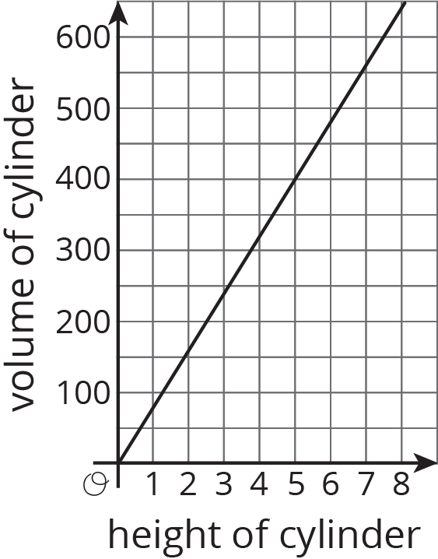
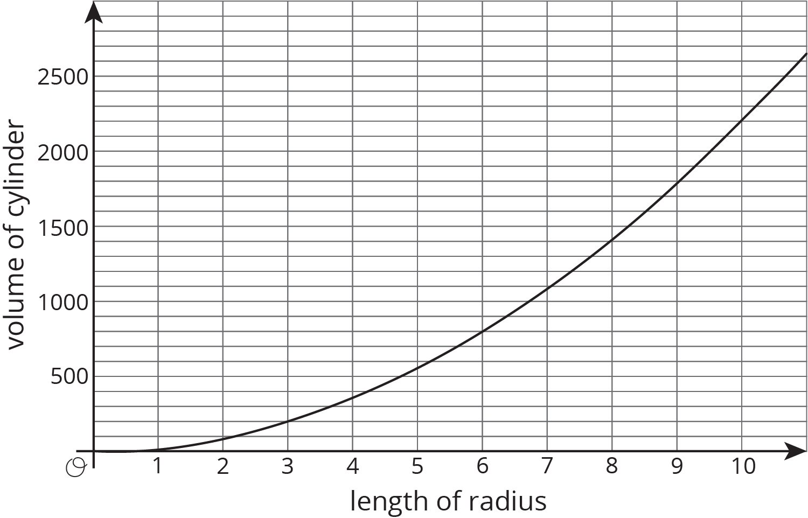
© CC BY Open Up Resources. Adaptations CC BY IM.

