Unit 3 Lesson 1: The Burj Khalifa

1 Estimating Height (Warm up)

Student Task Statement
Use the picture to estimate the height of Hyperion, the tallest known tree.
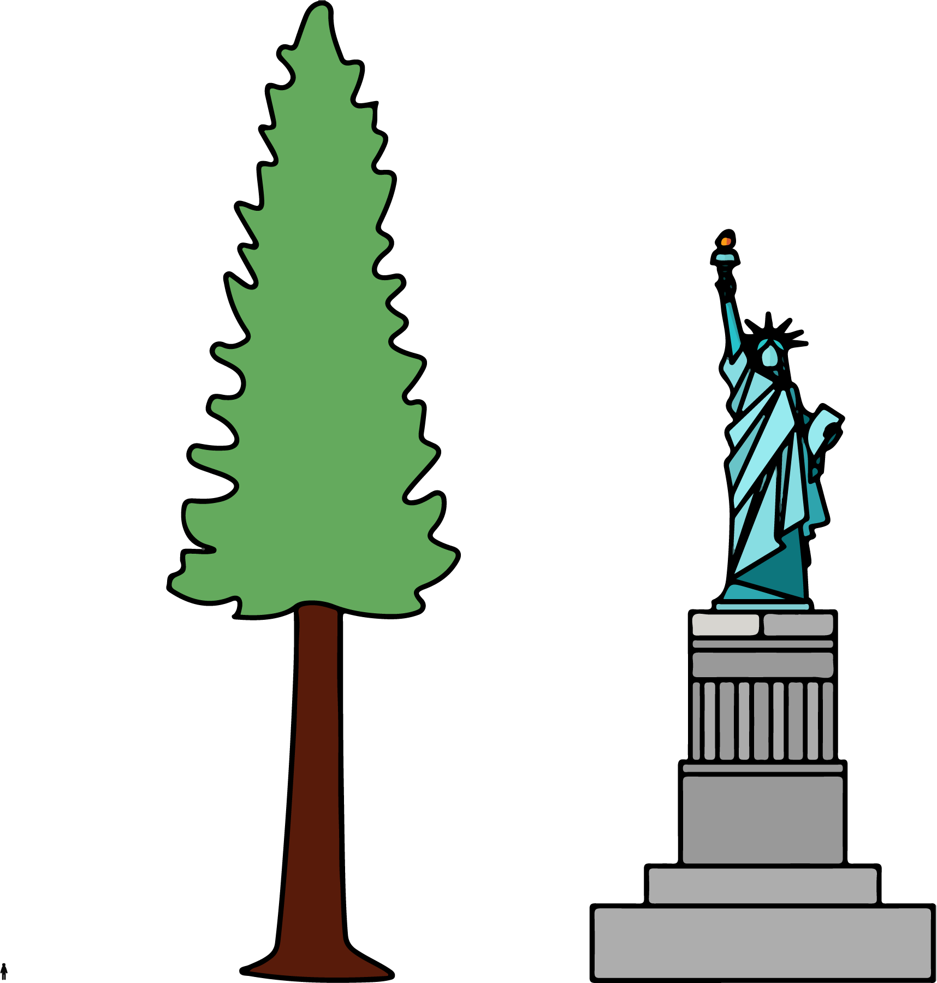

2 Window Washing

Images for Launch
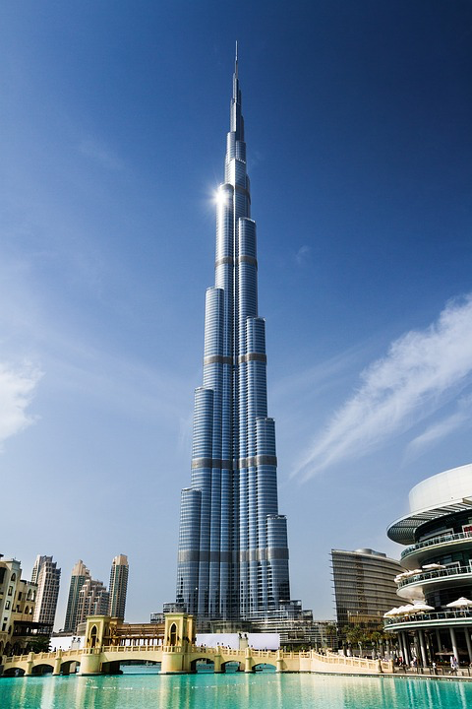

Student Task Statement
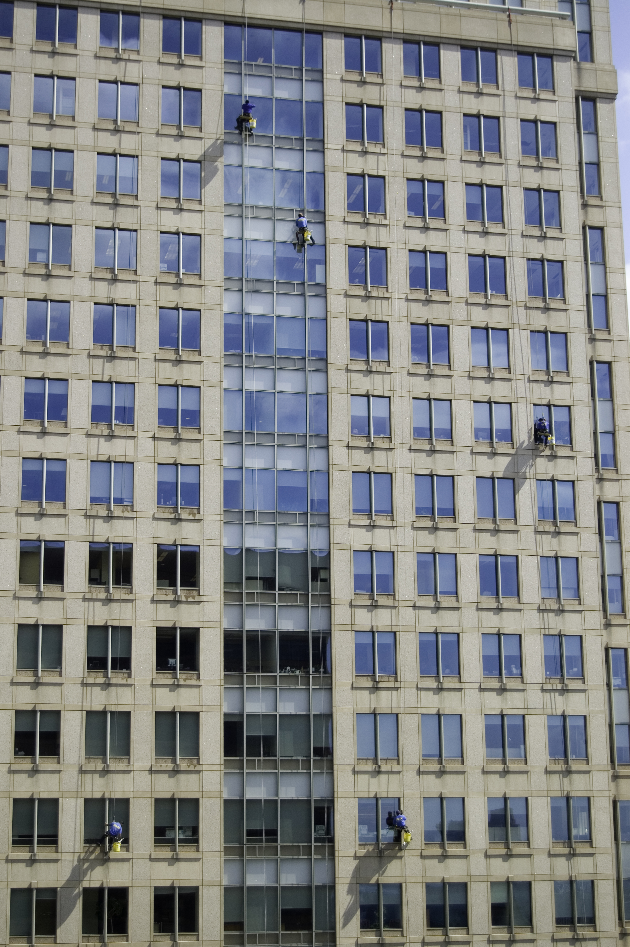
A window-washing crew can finish 15 windows in 18 minutes.
If this crew was assigned to wash all the windows on the outside of the Burj Khalifa, how long will the crew be washing at this rate?

3 Climbing the Burj Khalifa

Student Task Statement
In 2011, a professional climber scaled the outside of the Burj Khalifa, making it all the way to 828 meters (the highest point on which a person can stand) in 6 hours.
Assuming they climbed at the same rate the whole way:
- How far did they climb in the first 2 hours?
- How far did they climb in 5 hours?
- How far did they climb in the final 15 minutes?
© CC BY Open Up Resources. Adaptations CC BY IM.

