Unit 3 Lesson 6: Residuals

1 Math Talk: Differences in Expectations (Warm up)

Student Task Statement
Mentally calculate how close the estimate is to the actual value using the difference: $\text{actual value}−\text{estimated value}$.
Actual value: 24.8 grams. Estimated value: 19.6 grams
Actual value: $112.11. Estimated value: $109.30
Actual value: 41.5 centimeters. Estimated value: 45.90 centimeters
Actual value: -1.34 degrees Celsius. Estimated value: -2.45 degrees Celsius

2 Oranges Return

Student Task Statement
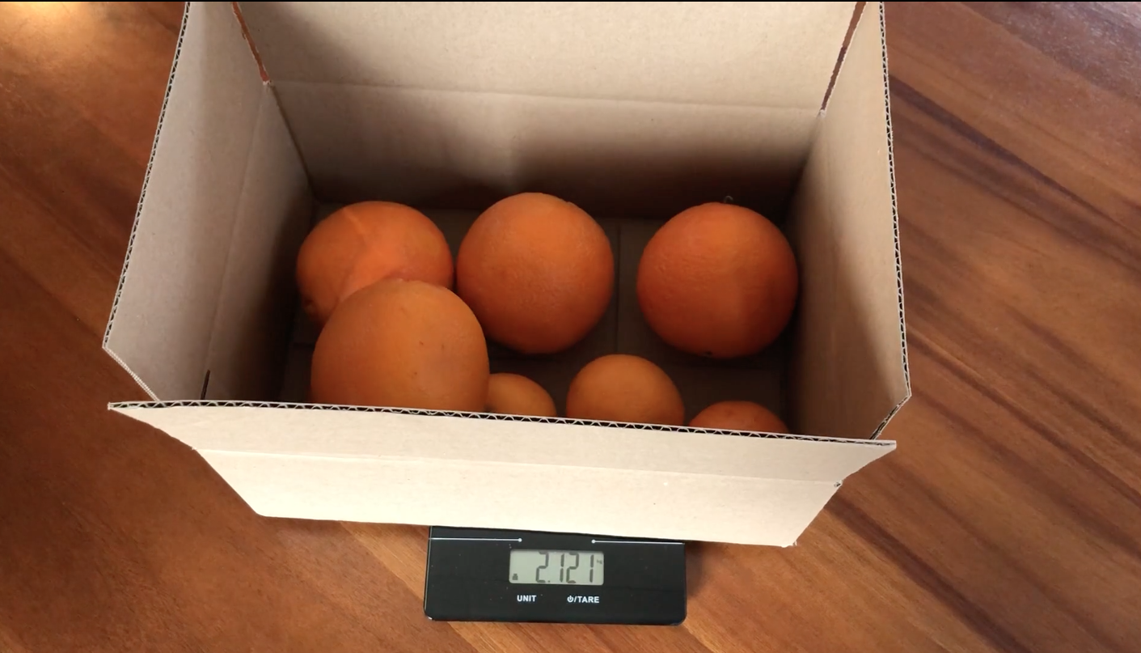
- For the scatter plot of orange weights from a previous lesson, use technology to find the line of best fit.
- What level of accuracy makes sense for the slope and intercept values? Explain your reasoning.
- What does the linear model estimate for the weight of the box of oranges for each of the number of oranges?
- number of oranges
- Compare the weights of the box with 3 oranges in it to the estimated weight of the box with 3 oranges in it. Explain or show your reasoning.
- How many oranges are in the box when the linear model estimates the weight best? Explain or show your reasoning.
- How many oranges are in the box when the linear model estimates the weight least well? Explain or show your reasoning.
- The difference between the actual value and the value estimated by a linear model is called the residual. If the actual value is greater than the estimated value, the residual is positive. If the actual value is less than the estimated value, the residual is negative. For the orange weight data set, what is the residual for the best fit line when there are 3 oranges? On the same axes as the scatter plot, plot this residual at the point where $x=3$ and $y$ has the value of the residual.
- Find the residuals for each of the other points in the scatter plot and graph them.
- 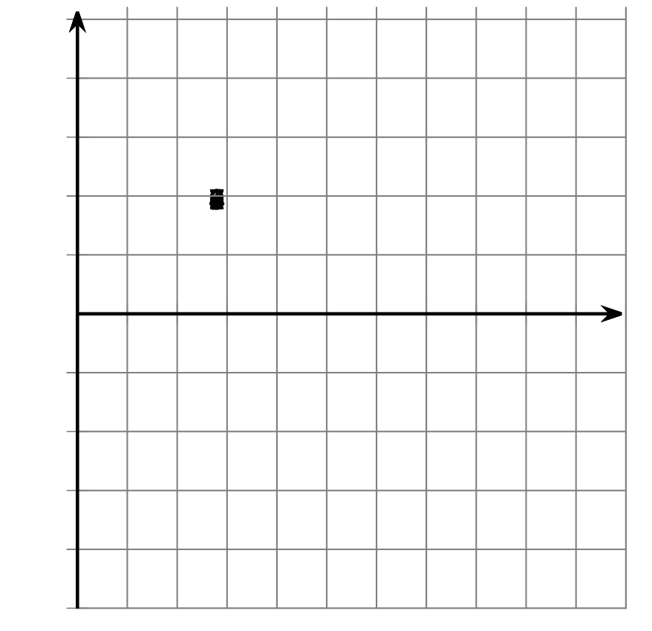
- Which point on the scatter plot has the residual closest to zero? What does this mean about the weight of the box with that many oranges in it?
- How can you use the residuals to decide how well a line fits the data?

Activity Synthesis

3 Best Residuals

Student Task Statement
- Match the scatter plots and given linear models to the graph of the residuals.
- Turn the scatter plots over so that only the residuals are visible. Based on the residuals, which line would produce the most accurate estimates? Which line fits its data worst?
© CC BY 2019 by Illustrative Mathematics®

