Lesson 16 Practice Problems
- Find the quotients:
  - $24÷\text{-}6$
  - $\text{-}15÷0.3$
  - $\text{-}4÷\text{-}20$
- Find the quotients.
  - $\frac{2}{5}÷\frac{3}{4}$
  - $\frac{9}{4}÷\frac{\text{-}3}{4}$
  - $\frac{\text{-}5}{7}÷\frac{\text{-}1}{3}$
  - $\frac{\text{-}5}{3}÷\frac{1}{6}$
- Is the solution positive or negative?
  - $2⋅x=6$
  - $\text{-}2⋅x=6.1$
  - $2.9⋅x=\text{-}6.04$
  - $\text{-}2.473⋅x=\text{-}6.859$
- Find the solution mentally.
  - $3⋅\text{-}4=a$
  - $b⋅\left(\text{-}3\right)=\text{-}12$
  - $\text{-}12⋅c=12$
  - $d⋅24=\text{-}12$
- Find the products.
  - $\left(100\right)⋅\left(\text{-}0.09\right)$
  - $\left(\text{-}7\right)⋅\left(\text{-}1.1\right)$
  - $\left(\text{-}7.3\right)⋅\left(5\right)$
  - $\left(\text{-}0.2\right)⋅\left(\text{-}0.3\right)$
- (From Unit 7, Lesson 14.)
- Which graphs could not represent a proportional relationship? Explain how you decided.
- 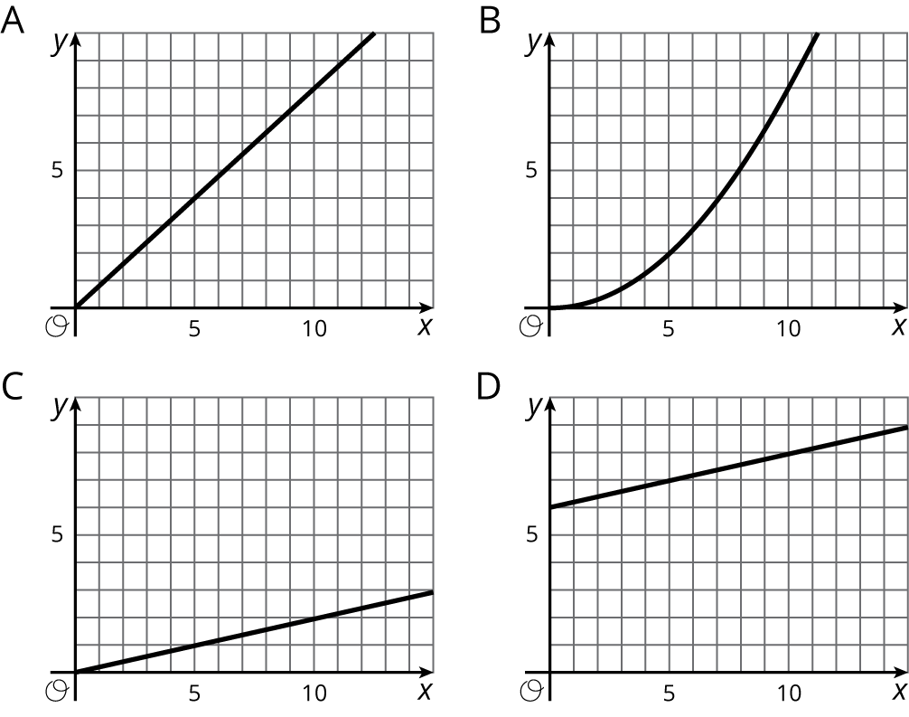
- (From Unit 5, Lesson 7.)
© CC BY Open Up Resources. Adaptations CC BY IM.

