Unit 3 Lesson 7: Build with Straws

WU Choral Count: Count to 30 (Warm up)

Student Task Statement

1 Compare Length of Straws

Student Task Statement
Let’s put the straws into 2 groups.
shorter than
longer than

Activity Synthesis
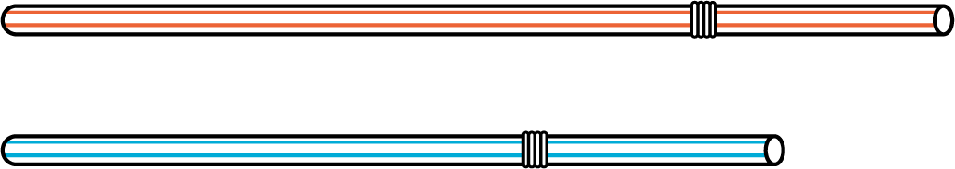

2 Build Shapes from Straws

Student Task Statement

3 Introduce Build Shapes, Match the Flat Shape

Student Task Statement
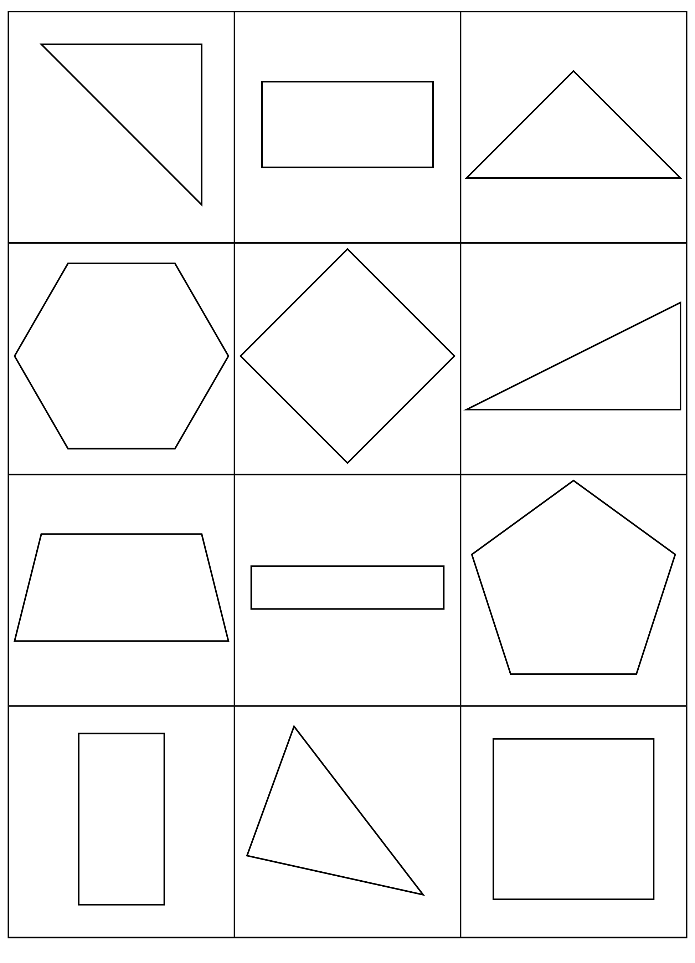
Choose a center.
Build Shapes
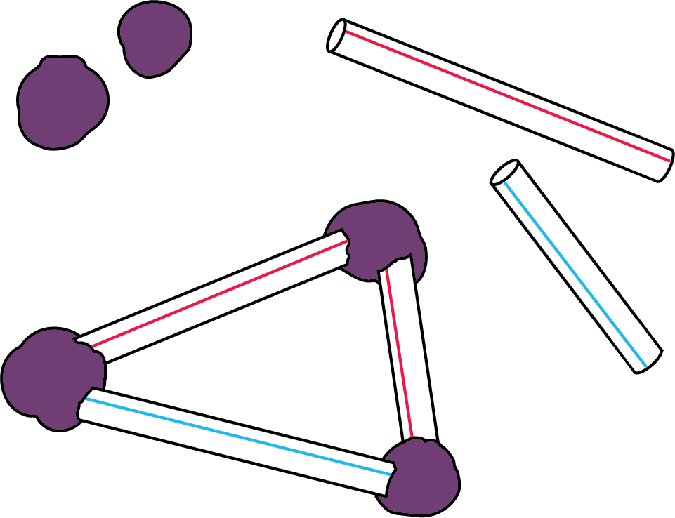
Counting Collections
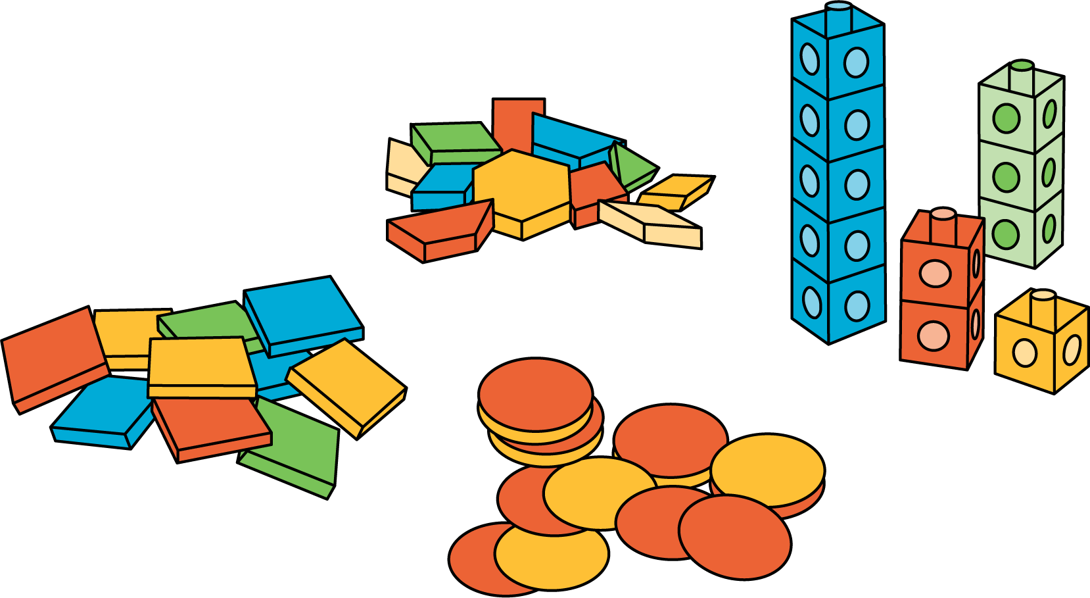
Which One
Picture Books
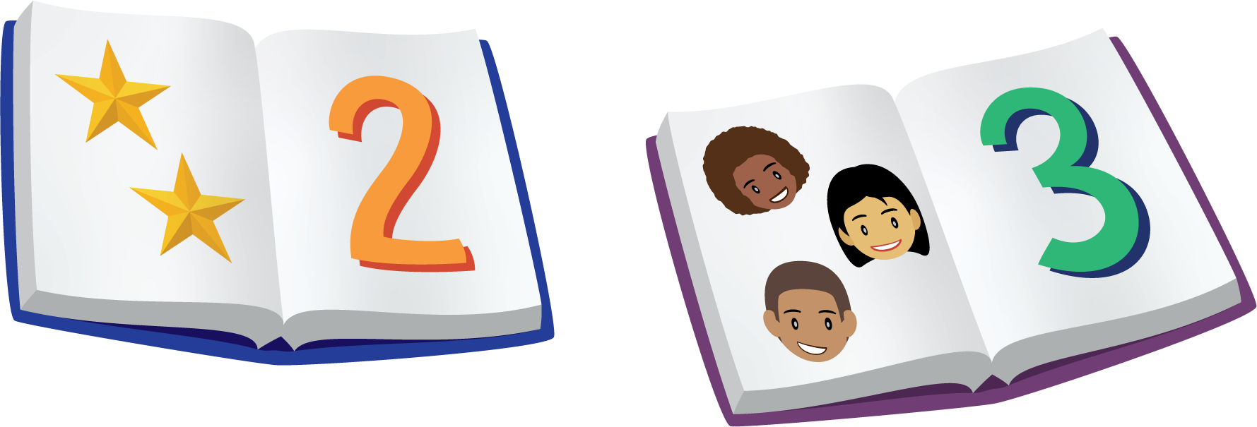
Bingo
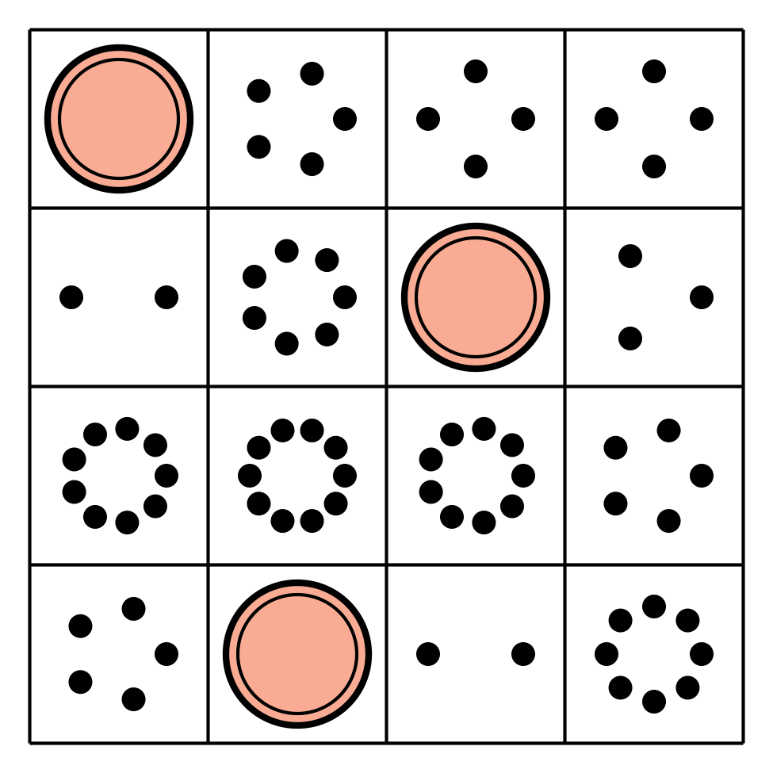
Shake and Spill
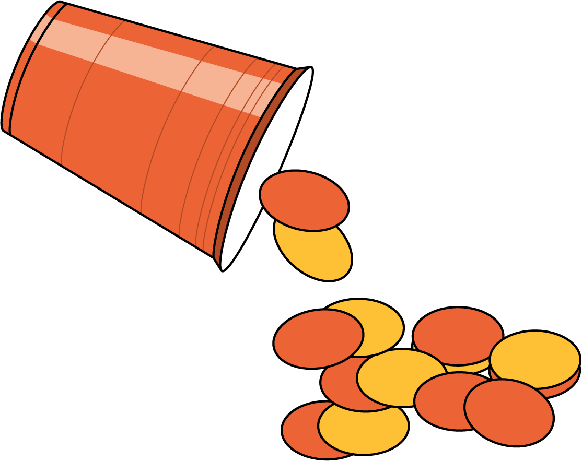
© CC BY 2021 Illustrative Mathematics®

