Unit 8 Lesson 5: More Division

WU Estimation Exploration: Large Quotient (Warm up)

Student Task Statement
$9,​953÷37$
Record an estimate that is:
too low | about right | too high

1 Elena’s Work

Student Task Statement
- Find the value of the quotient.
- 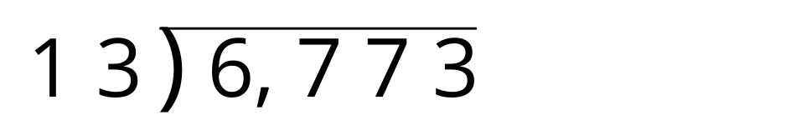
- Here is how Elena found the quotient. Is her answer reasonable?
- Explain or show your reasoning.
- 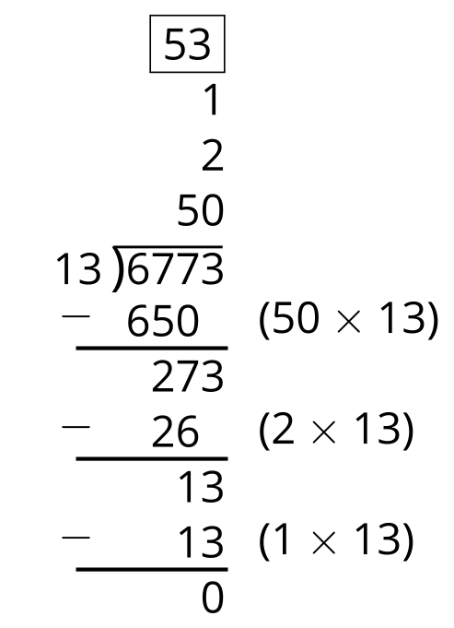
- What parts of the work do you agree with? Be prepared to explain your reasoning.
- What parts of the work do you disagree with? Be prepared to explain your reasoning.
- Look at your solution to problem 1. Is there anything you want to revise? Be prepared to explain.

2 Partial Quotients Practice

Student Task Statement
- Use partial quotients to find the value of one of the quotients. Be prepared to explain how you found the quotient.
- Partner A:
- 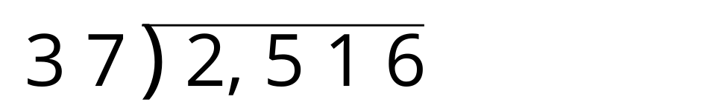
- Partner B:
- 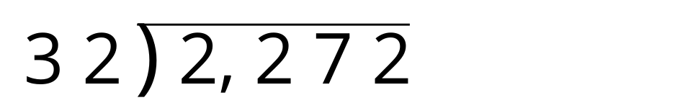
- Explain to your partner how you found the quotient in your problem.

Activity Synthesis
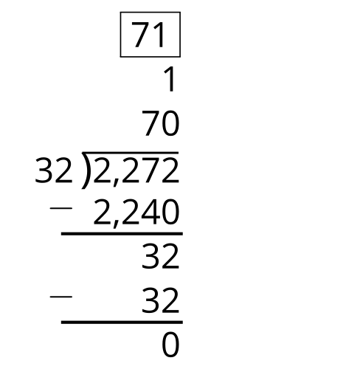
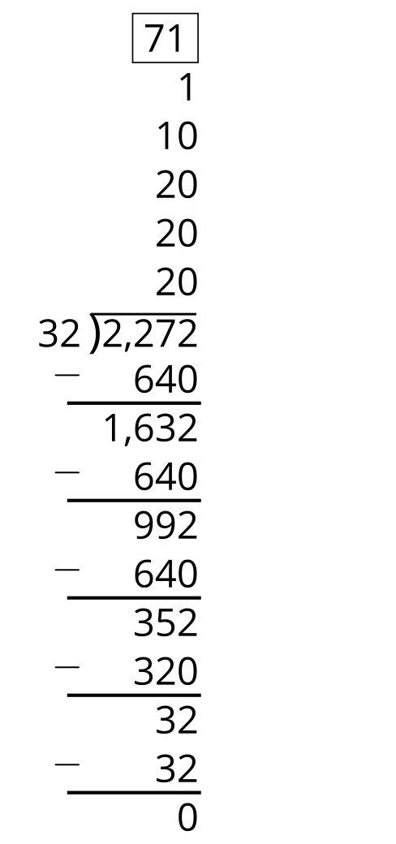
© CC BY 2021 Illustrative Mathematics®

