Unit 5 Lesson 7: Center Day 1

WU True or False: Compare to 100 (Warm up)

Student Task Statement
Decide if each statement is true or false. Be prepared to explain your reasoning.
- $100>99$
- $100<99+1$
- $98+3>100$
- $50+50+50>100$

1 Introduce Mystery Number, Three-digit Numbers

Student Task Statement

2 Centers: Choice Time

Student Task Statement
Choose a center.
Jump the Line
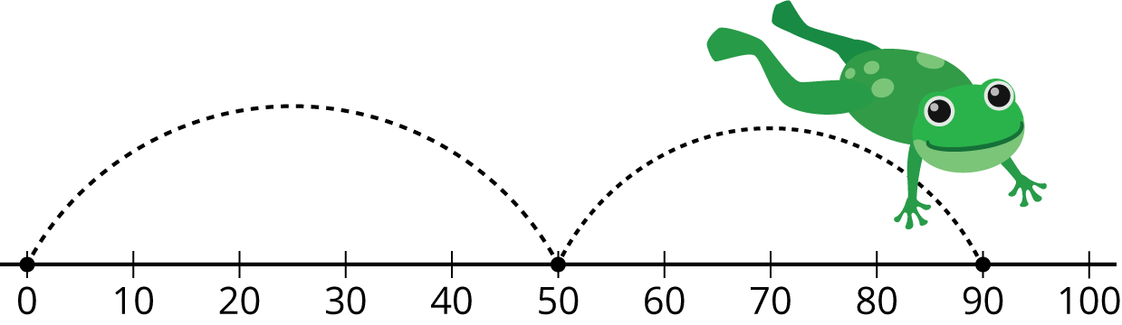
Mystery Number
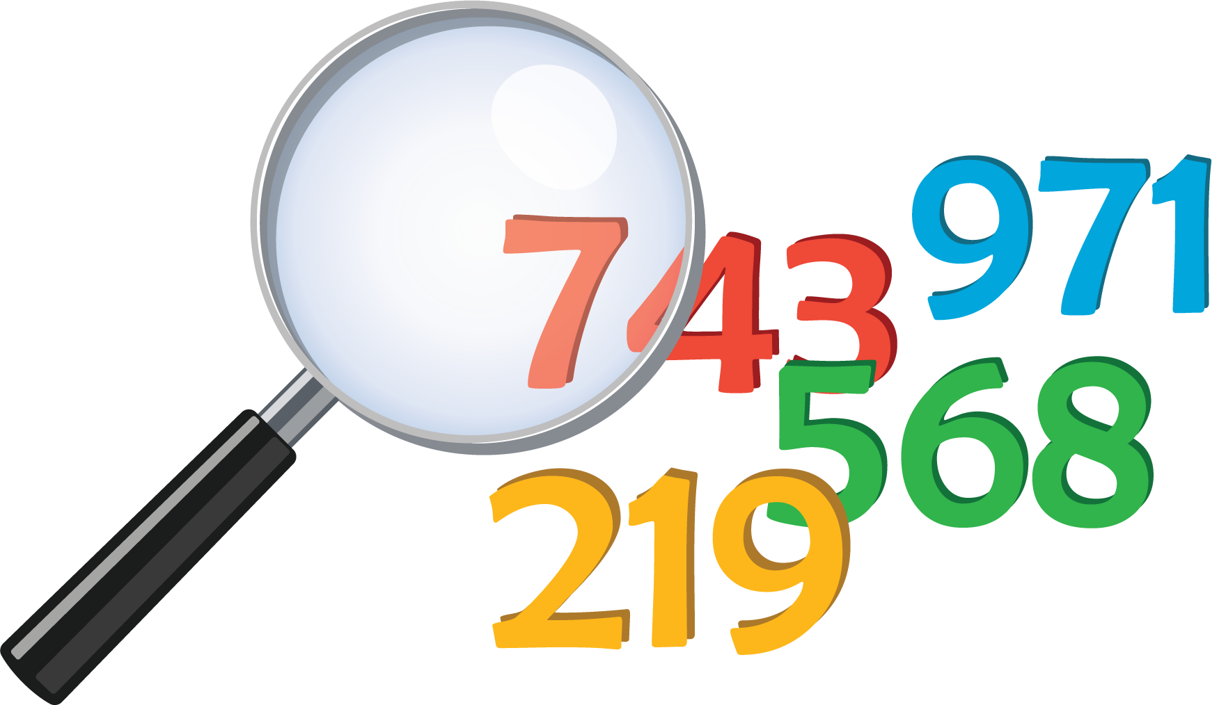
Number Puzzles
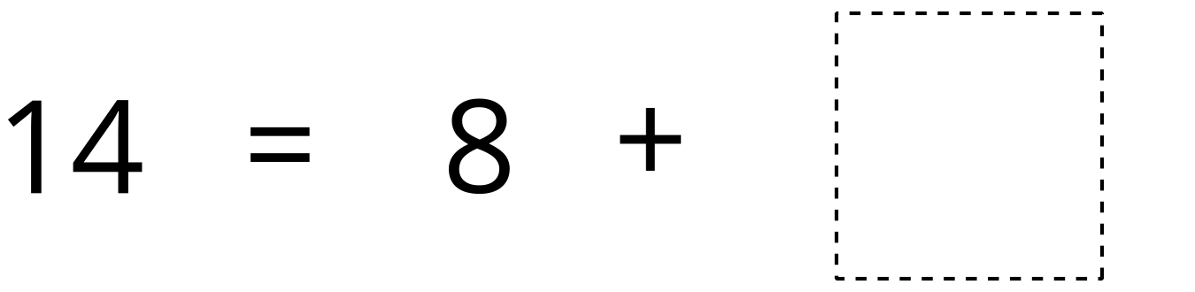
© CC BY 2021 Illustrative Mathematics®

