Unit 6 Lesson 9: Write Numbers to 120

WU Choral Count: Numbers Up to 120 (Warm up)

Student Task Statement

1 Measure Animal Lengths

Student Task Statement
Animal:________________________________
Length: _______________________
Show your thinking using drawings, numbers, or words.

2 Write Numbers to Represent Animal Lengths

Student Task Statement
For each animal, write the number of cubes that represent its length.
- The beaver is ______________________ long.
- The dog is ______________________ long.
- The giant anteater is ______________________ long.
- The raccoon is ______________________ long.
- The red fox is ______________________ long.
- The snake is ______________________ long.
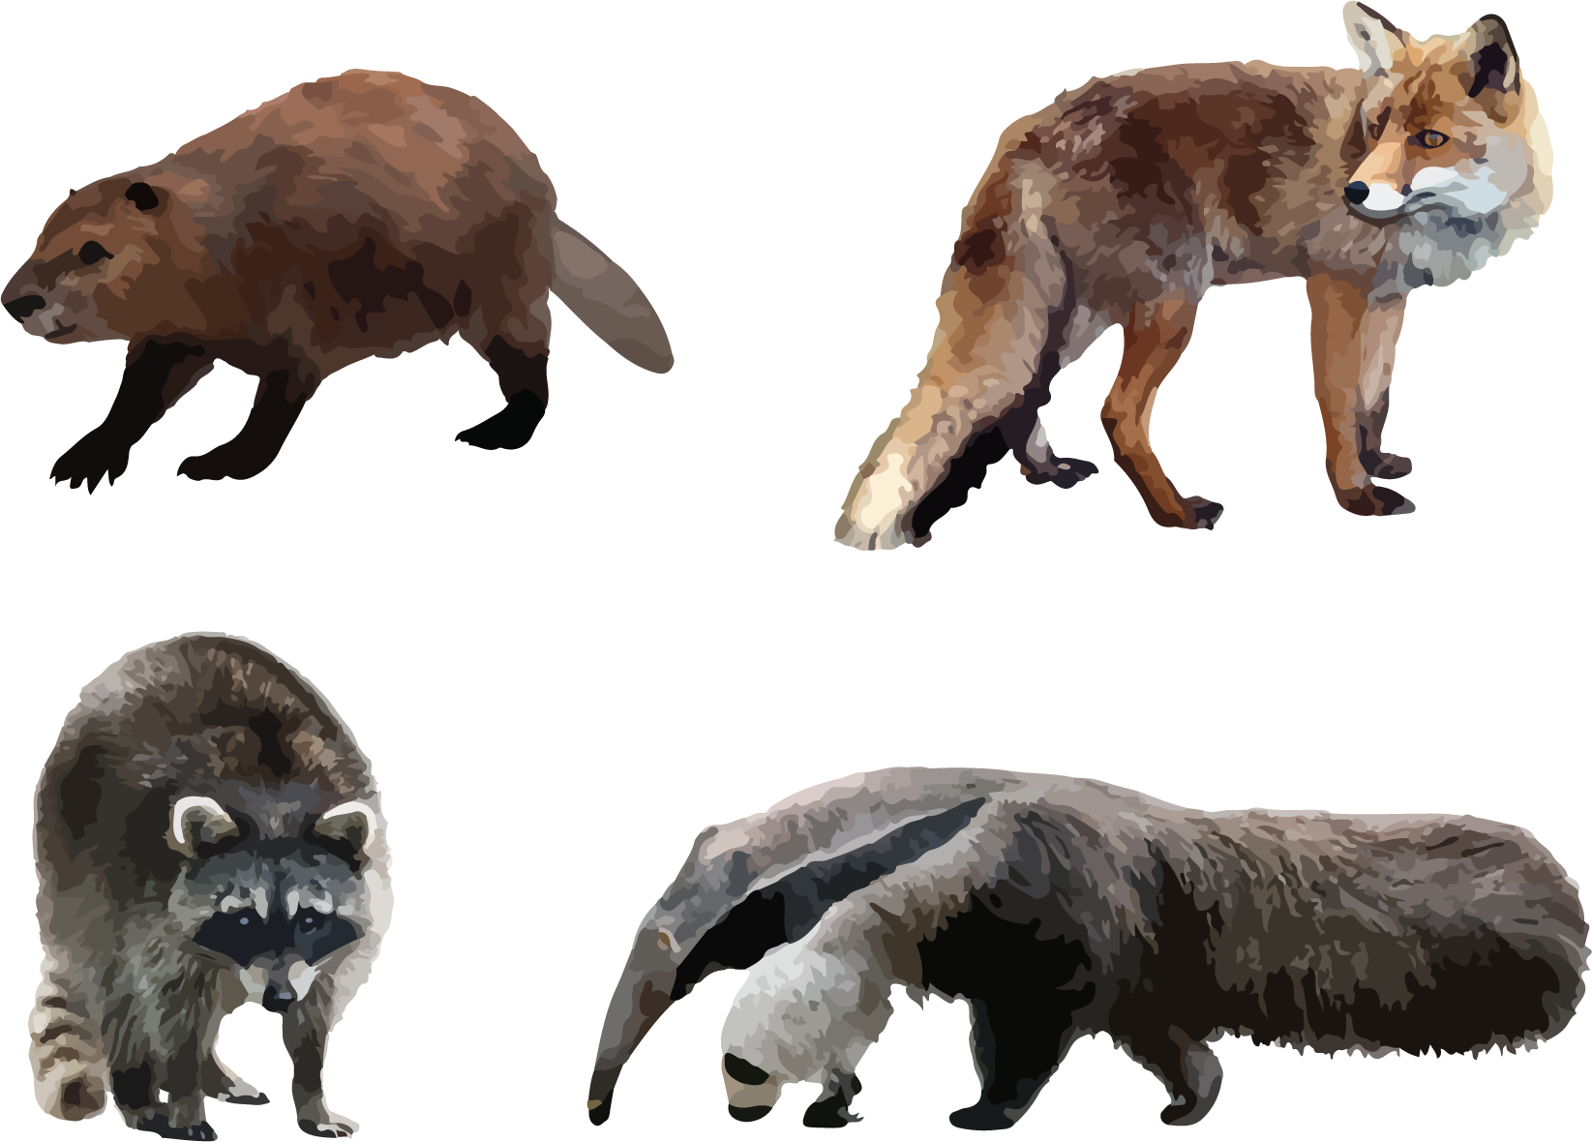
© CC BY 2021 Illustrative Mathematics®

