Lesson 19: Compose and Decompose to Add and Subtract

Standards Alignments
Addressing | 4.NBT.B.4, 4.NF.B.3.c

Teacher-facing Learning Goals
- Add and subtract multi-digit numbers, with composing or decomposing, using the standard algorithm.

Student-facing Learning Goals
- Let’s compose and decompose units to add and subtract.

Lesson Purpose
The purpose of this lesson is for students to review how to add and subtract multi-digit numbers with composition and decomposition.
In earlier grades, students encountered subtraction problems which required decomposing a unit. In this lesson, students review this idea of decomposition and revisit how it is recorded when using the standard algorithm to subtract numbers through the thousands place. Students also use composition to add multi-digit numbers through the hundred-thousands place.

Access for:

Students with Disabilities
- Representation (Activity 2)

Instructional Routines
MLR7 Compare and Connect (Activity 2), Number Talk (Warm-up)

Materials to Gather
- Grid paper: Activity 1

Lesson Timeline
Warm-up | 10 min
Activity 1 | 15 min
Activity 2 | 20 min
Lesson Synthesis | 10 min
Cool-down | 5 min

Teacher Reflection Question
Who got to do math today in class? How do you know? What norms or routines allowed those students to engage? How can you adjust these norms and routines so all students do math tomorrow?

Cool-down
(to be completed at the end of the lesson) 5min
Difference and then Sum

Standards Alignments
Addressing | 4.NBT.B.4

Student-facing Task Statement
- Use the standard algorithm to find the difference.
  - $1,​993−118$
  - $1,​897−116$
- Find the value of the sum.
- 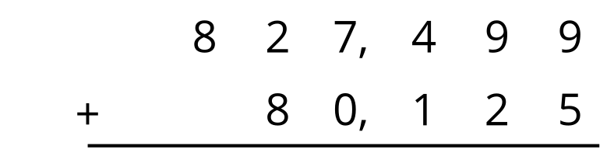

Student Responses

  - 1,875
  - 1,781
- 907,624

