Unit 9 Lesson 6: What’s the Quotient?

WU Number Talk: Divide by 3 and by 6 (Warm up)

Student Task Statement
Find the value of each expression mentally.
- $48÷3$
- $480÷3$
- $528÷3$
- $5,​280÷3$

1 Unfinished Divisions

Student Task Statement
Here are four calculations to find the value of $7,​465÷5$, but each one is unfinished.
Complete at least two of the unfinished calculations. Be prepared to explain how you know what to do to complete the work.
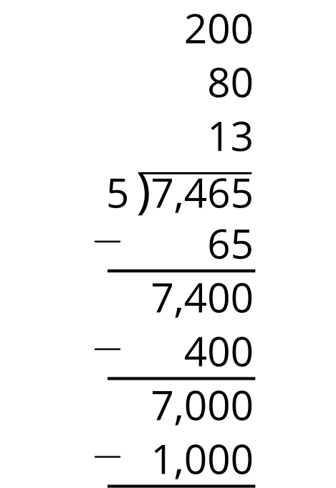
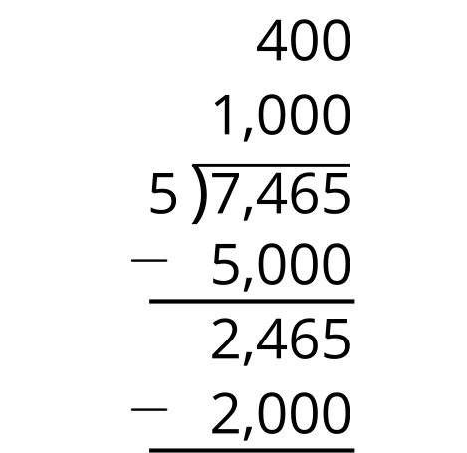
5,​000÷5=1,​00060÷5=0,​0125÷5=0,​001
7,465 is a little less than 7,500.
7,​500÷5=1,​50035÷5=0,​007

2 Where Do We Begin?

Student Task Statement
- Jada and Noah are finding the value of $3,​681÷9$. Jada says to start by dividing 81 by 9. Noah says start by dividing 3,600 by 9.
  - Explain why each suggestion is helpful for finding the quotient.
  - Find the value of $3,​681÷9$. Show your reasoning.
- Find the missing numbers such that each calculation shows a correct division calculation.
- 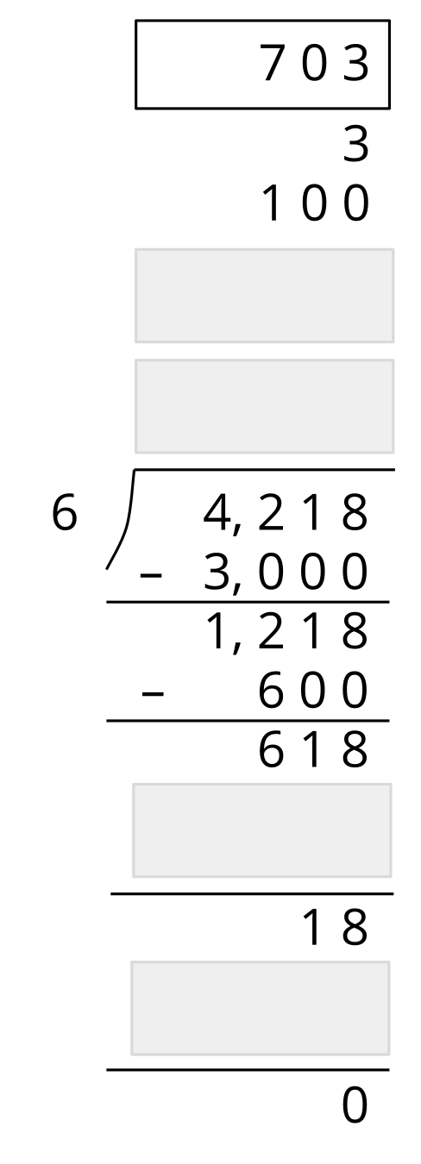
- 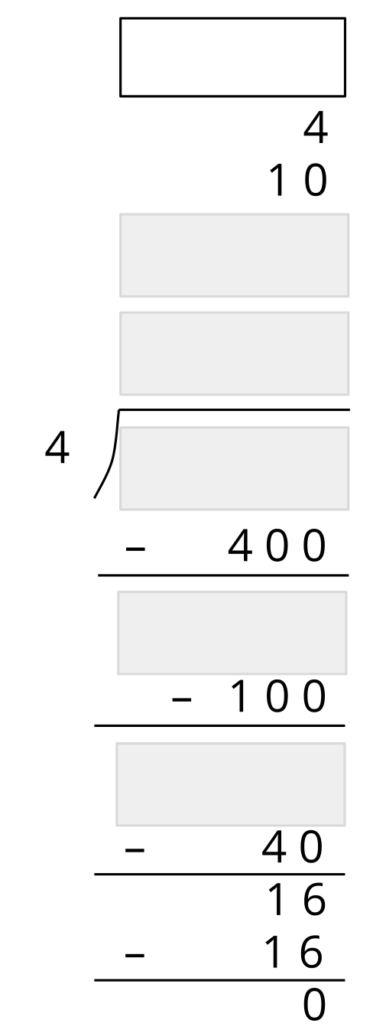
- 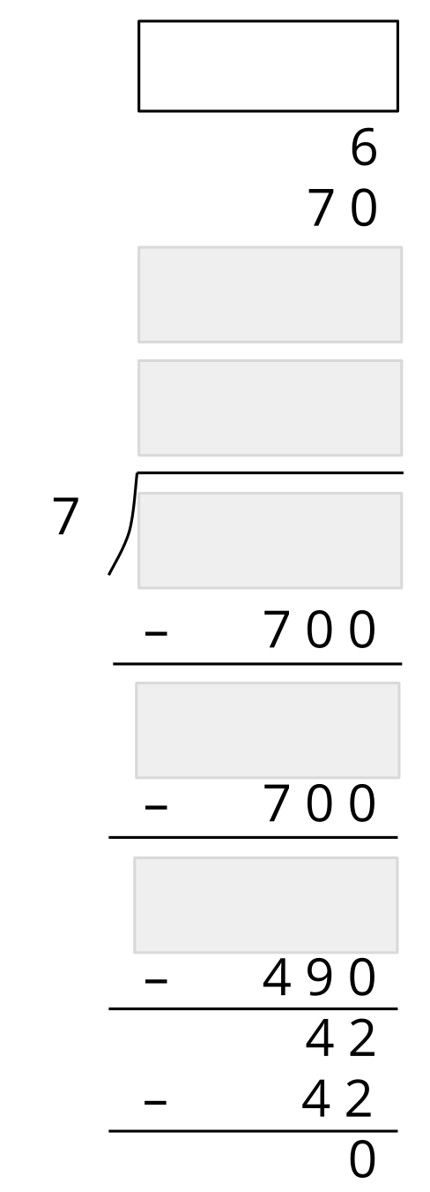
- Consider the expression $5,​016÷8$.
  - What would you do to start finding the value of the quotient?
  - Show how you would find the value with as few steps as possible.
© CC BY 2021 Illustrative Mathematics®

