Unit 8 Lesson 9: Mean

1 Close to Four (Warm up)

Student Task Statement
Use the digits 0–9 to write an expression with a value as close as possible to 4. Each digit can be used only one time in the expression.
TEST+TEST+TEST+TEST÷4

2 Spread Out and Share

Student Task Statement
- The kittens in a room at an animal shelter are placed in 5 crates.
  - The manager of the shelter wants the kittens distributed equally among the crates. How might that be done? How many kittens will end up in each crate?
  - The number of kittens in each crate after they are equally distributed is called the mean number of kittens per crate, or the average number of kittens per crate. Explain how the expression $10÷5$ is related to the average.
  - Another room in the shelter has 6 crates. No two crates has the same number of kittens, and there is an average of 3 kittens per crate. Draw or describe at least two different arrangements of kittens that match this description.
- Five servers were scheduled to work the number of hours shown. They decided to share the workload, so each one would work equal hours.
- server A: 3
- server B: 6
- server C: 11
- server D: 7
- server E: 4
  - On the grid on the left, draw 5 bars whose heights represent the hours worked by servers A, B, C, D, and E.
  - 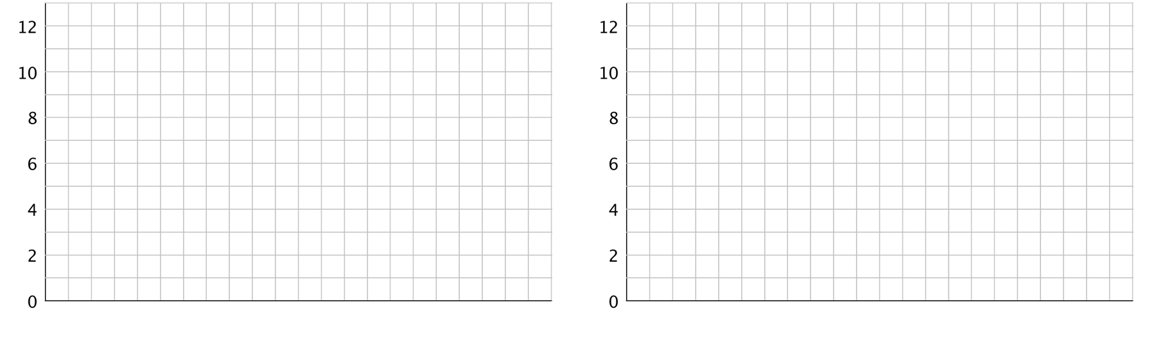
  - Think about how you would rearrange the hours so that each server gets a fair share. Then, on the grid on the right, draw a new graph to represent the rearranged hours. Be prepared to explain your reasoning.
  - Based on your second drawing, what is the average or mean number of hours that the servers will work?
  - Explain why we can also find the mean by finding the value of the expression $31÷5$.
  - Which server will see the biggest change to work hours? Which server will see the least change?

3 Getting to School

Student Task Statement
For the past 12 school days, Mai has recorded how long her bus rides to school take in minutes. The times she recorded are shown in the table.
9
8
6
9
10
7
6
12
9
8
10
8
- Find the mean for Mai’s data. Show your reasoning.
- In this situation, what does the mean tell us about Mai’s trip to school?
- For 5 days, Tyler has recorded how long his walks to school take in minutes. The mean for his data is 11 minutes. Without calculating, predict if each of the data sets shown could be Tyler’s. Explain your reasoning.
  - data set A: 11, 8, 7, 9, 8
  - data set B: 12, 7, 13, 9, 14
  - data set C: 11, 20, 6, 9, 10
  - data set D: 8, 10, 9, 11, 11
- Determine which data set is Tyler’s. Explain how you know.
© CC BY Open Up Resources. Adaptations CC BY IM.

