Unit 3 Lesson 2: Anchoring Units of Measurement

1 Estimating Volume (Warm up)

Student Task Statement
Estimate the volume of the tiny salt shaker.
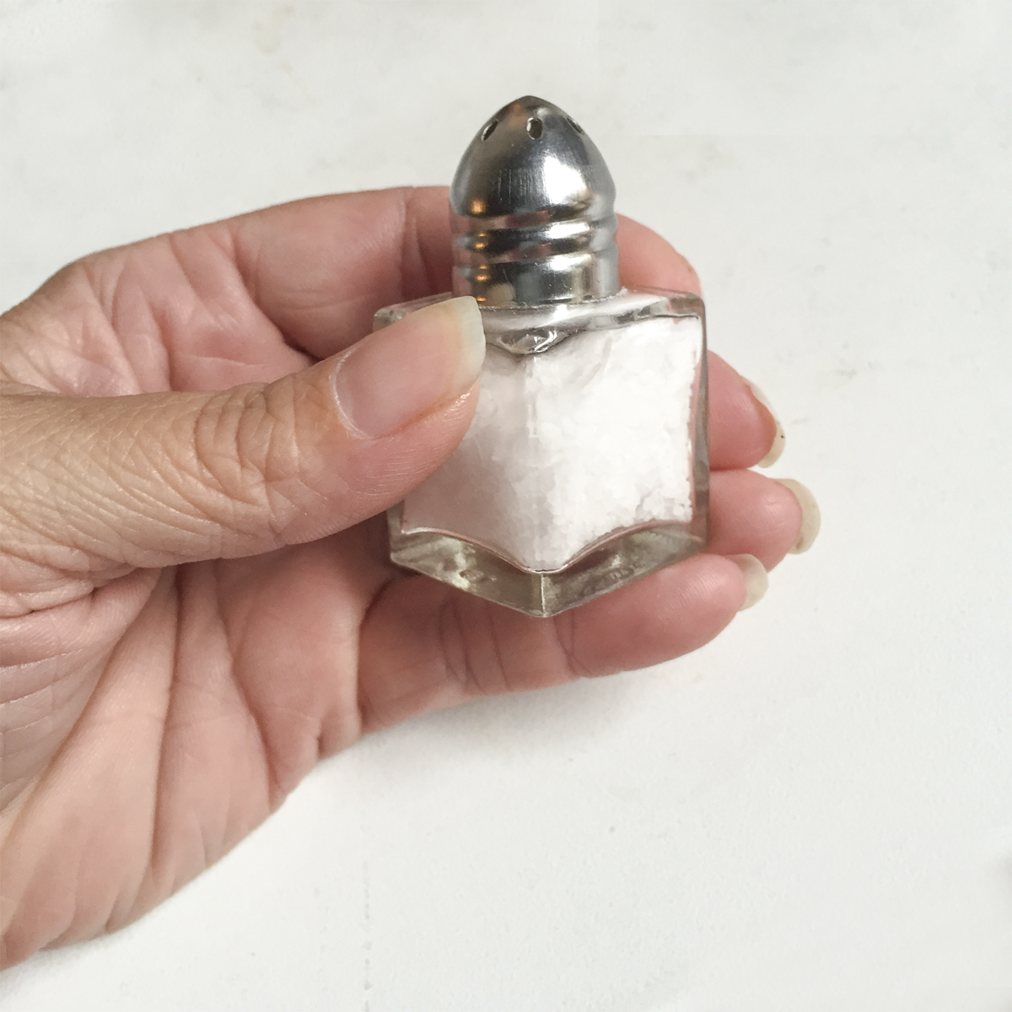

2 Cutting String (Optional)

Student Task Statement
Your teacher will assign you one of the following lengths:
1 centimeter, 1 foot, 1 inch, 1 meter, or 1 yard.
Estimate and cut a piece of string as close to your assigned length as you can without using a measurement tool.

3 Card Sort: Measurements (Optional)

Student Task Statement
Your teacher will give you some cards with the names of different units of measurement and other cards with pictures of objects.
- Sort the units of measurement into groups based on the attribute they measure. Pause here so your teacher can review your groups.
- Match each picture card that has “L” in the top right corner with the closest unit to the length of the object.
- Match each picture card that has “V” in the top right corner with the closest unit to the volume of the object.
- Match each picture card that has “WM” in the top right corner with the closest unit to the weight or mass of the object.
Your teacher will assign you a new group to discuss how you matched the objects. If you disagree, work to reach an agreement.
© CC BY Open Up Resources. Adaptations CC BY IM.

