Lesson 17 Practice Problems
- Describe a situation where each of the following quantities might be useful.
  - -20 gallons per hour
  - -10 feet per minute
  - -0.1 kilograms per second
- A bank charges a service fee of $7.50 per month for a checking account.
- A bank account has $85.00. If no money is deposited or withdrawn except the service charge, how many months until the account balance is negative?
- A submarine is searching for underwater features. It is accompanied by a small aircraft and an underwater robotic vehicle.
- At one time the aircraft is 200 m above the surface, the submarine is 55 m below the surface, and the underwater robotic vehicle is 227 m below the surface.
  - What is the difference in height between the submarine and the aircraft?
  - What is the distance between the underwater robotic vehicle and the submarine?
- (From Unit 7, Lesson 10.)
- Evaluate each expression. When the answer is not a whole number, write your answer as a fraction.
  - $\text{-}4⋅\text{-}6$
  - $\text{-}24⋅\frac{\text{-}7}{6}$
  - $4÷\text{-}6$
  - $\frac{4}{3}÷\text{-}24$
- (From Unit 7, Lesson 16.)

  - A restaurant bill is $21. You leave a 15% tip. How much do you pay including the tip?
  - Which of the following represents the amount a customer pays including the tip of 15% if the bill was $b$ dollars? Select all that apply.
  - $15b$
  - $b+0.15b$
  - $1.15b$
  - $1.015b$
  - $b+\frac{15}{100}b$
  - $b+0.15$
  - $0.15b$
- (From Unit 6, Lesson 7.)
- Consider a rectangular prism with length 4 and width and height $d$.
  - Find an expression for the volume of the prism in terms of $d$.
  - Compute the volume of the prism when $d=1$, when $d=2$, and when $d=\frac{1}{2}$.
- 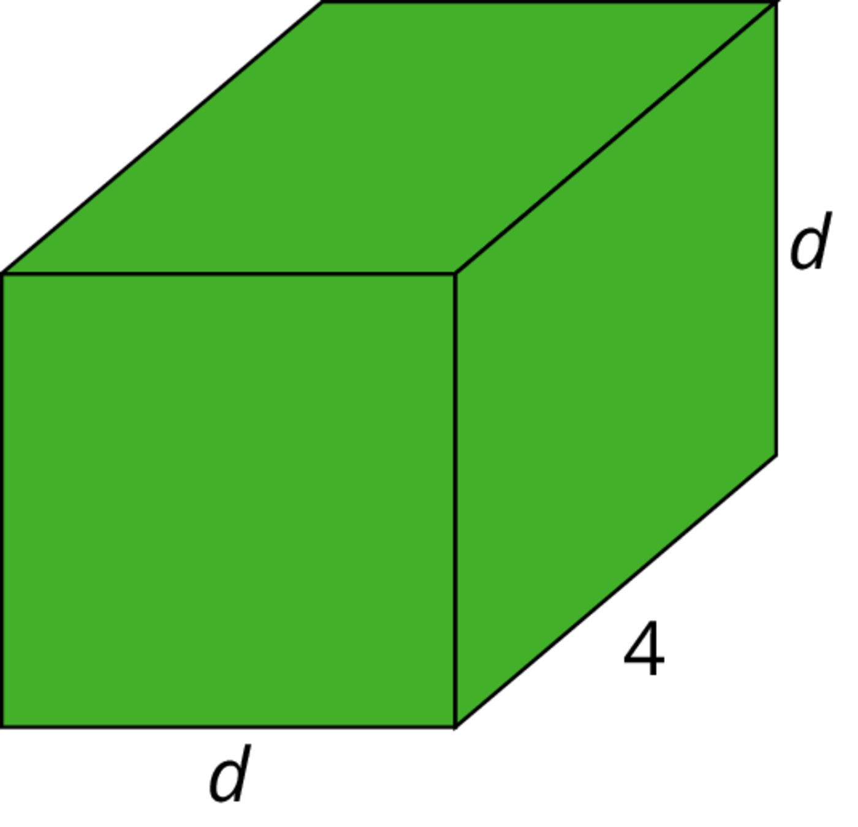
- (From Unit 4, Lesson 15.)
© CC BY Open Up Resources. Adaptations CC BY IM.

