Unit 2 Lesson 12: Similar Polygons

1 All, Some, None: Congruence and Similarity (Warm up)

Student Task Statement
Choose whether each of the statements is true in all cases, in some cases, or in no cases.
- If two figures are congruent, then they are similar.
- If two figures are similar, then they are congruent.
- If an angle is dilated with the center of dilation at its vertex, the angle measure may change.

2 Are They Similar?

Student Task Statement
- 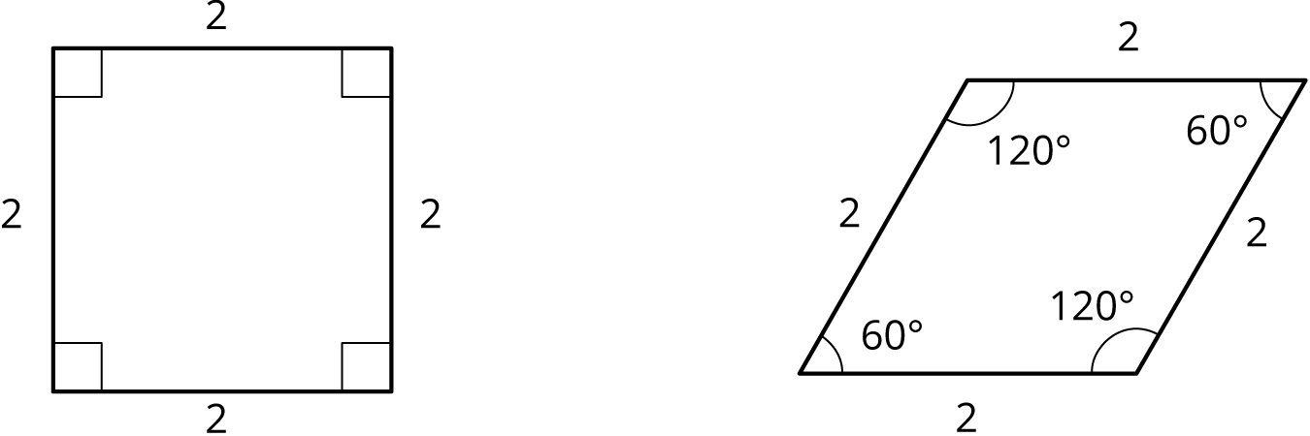
- Let’s look at a square and a rhombus.
Priya says, “These polygons are similar because their side lengths are all the same.” Clare says, “These polygons are not similar because the angles are different.” Do you agree with either Priya or Clare? Explain your reasoning.
- Now, let’s look at rectangles $ABCD$ and $EFGH$.
- 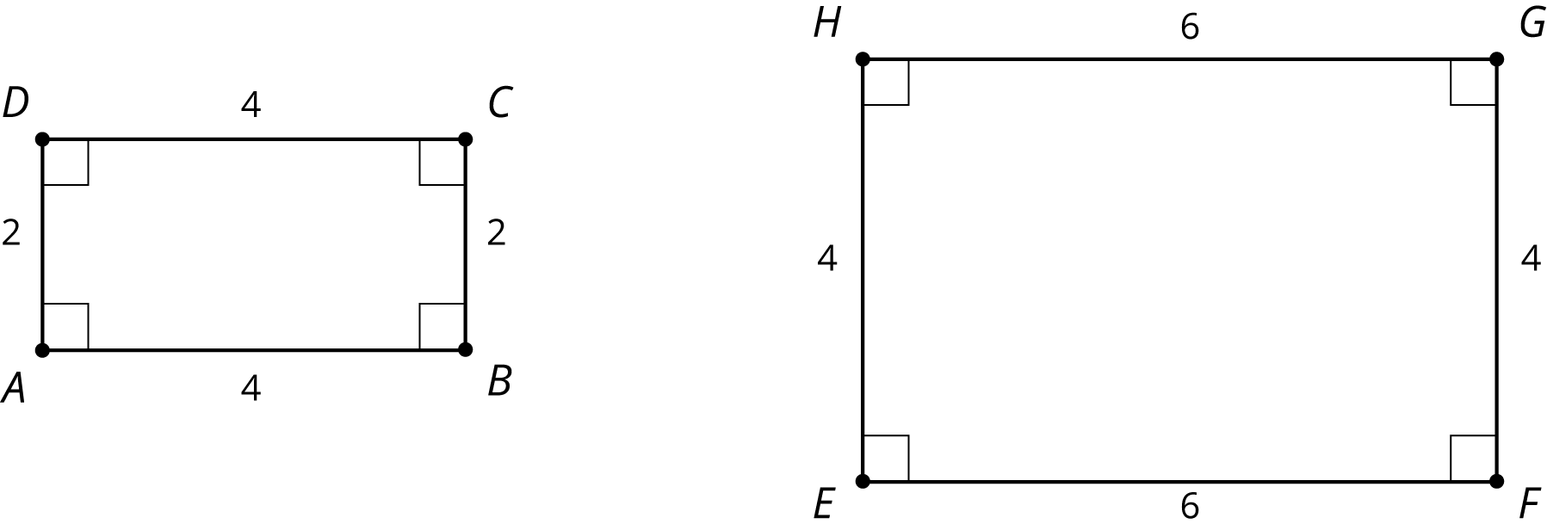
- Jada says, “These rectangles are similar because all of the side lengths differ by 2.” Lin says, “These rectangles are similar. I can dilate $AD$ and $BC$ using a scale factor of 2 and $AB$ and $CD$ using a scale factor of 1.5 to make the rectangles congruent. Then I can use a translation to line up the rectangles.” Do you agree with either Jada or Lin? Explain your reasoning.

3 Find Someone Similar

Student Task Statement
Your teacher will give you a card. Find someone else in the room who has a card with a polygon that is similar but not congruent to yours. When you have found your partner, work with them to explain how you know that the two polygons are similar.
© CC BY Open Up Resources. Adaptations CC BY IM.

