Lesson 18 Practice Problems
- The value of $x$ is $\frac{\text{-}1}{4}$. Order these expressions from least to greatest:
- $x$
- $1−x$
- $x−1$
- $\text{-}1÷x$

- Here are four expressions that have the value $\frac{\text{-}1}{2}$:
- $\frac{\text{-}1}{4}+\left(\frac{\text{-}1}{4}\right)$
- $\frac{1}{2}−1$
- $\text{-}2⋅\frac{1}{4}$
- $\text{-}1÷2$
- Write five expressions: a sum, a difference, a product, a quotient, and one that involves at least two operations that have the value $\frac{\text{-}3}{4}$.
- Find the value of each expression.
  - $\text{-}22+5$
  - $\text{-}22−\left(\text{-}5\right)$
  - $\left(\text{-}22\right)\left(\text{-}5\right)$
  - $\text{-}22÷5$
- The price of an ice cream cone is $3.25, but it costs $3.51 with tax. What is the sales tax rate?
- (From Unit 6, Lesson 7.)
- Here are 4 points on a coordinate plane.
- 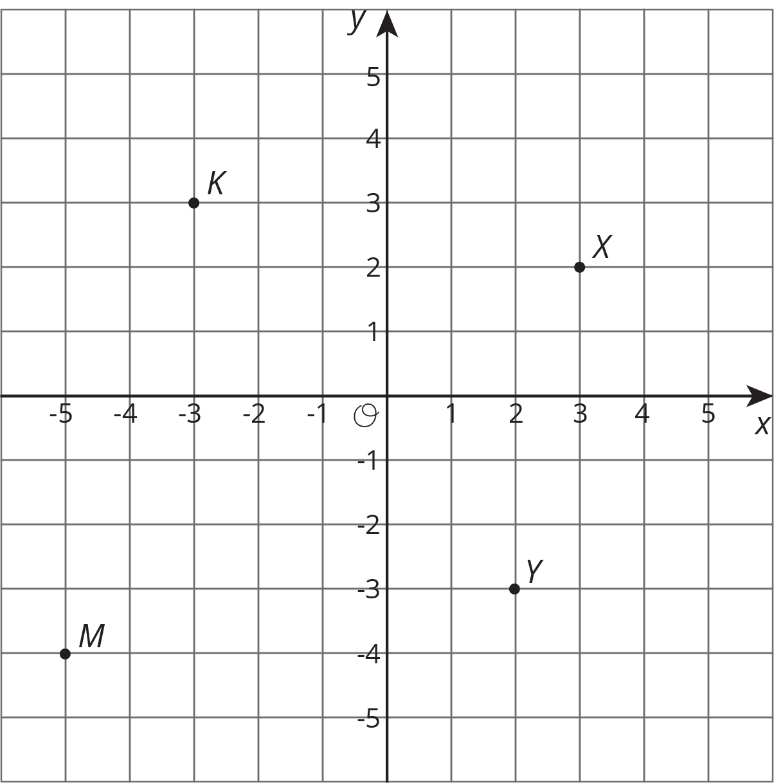
  - Label each point with its coordinates.
  - Plot a point that is 3 units from point $K$. Label it $P$.
  - Plot a point that is 2 units from point $M$. Label it $W$.
- (From Unit 7, Lesson 13.)
- A furniture store pays a wholesale price for a mattress. Then, the store marks up the retail price to 150% of the wholesale price. Later, they put the mattress on sale for 50% off of the retail price. A customer just bought the mattress on sale and paid $1,200.
  - What was the retail price of the mattress, before the discount?
  - What was the wholesale price, before the markup?
- (From Unit 6, Lesson 8.)
© CC BY Open Up Resources. Adaptations CC BY IM.

