Unit 2 Lesson 13: Similar Triangles

1 Equivalent Expressions (Warm up)

Student Task Statement
Create three different expressions that are each equal to 20. Each expression should include only these three numbers: 4, -2, and 10.

2 Making Pasta Angles and Triangles

Images for Launch
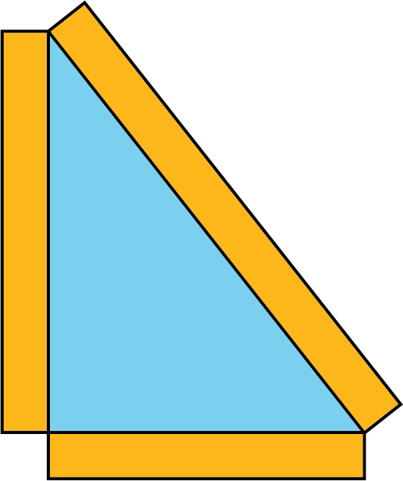

Student Task Statement
Your teacher will give you some dried pasta and a set of angles.
- Create a triangle using three pieces of pasta and angle $A$. Your triangle must include the angle you were given, but you are otherwise free to make any triangle you like. Tape your pasta triangle to a sheet of paper so it won’t move.
  - After you have created your triangle, measure each side length with a ruler and record the length on the paper next to the side. Then measure the angles to the nearest 5 degrees using a protractor and record these measurements on your paper.
  - Find two others in the room who have the same angle $A$ and compare your triangles. What is the same? What is different? Are the triangles congruent? Similar?
  - How did you decide if they were or were not congruent or similar?
- Now use more pasta and angles $A$, $B$, and $C$ to create another triangle. Tape this pasta triangle on a separate sheet of paper.
  - After you have created your triangle, measure each side length with a ruler and record the length on the paper next to the side. Then measure the angles to the nearest 5 degrees using a protractor and record these measurements on your paper.
  - Find two others in the room who used your same angles and compare your triangles. What is the same? What is different? Are the triangles congruent? Similar?
  - How did you decide if they were or were not congruent or similar?
- Here is triangle $PQR$. Break a new piece of pasta, different in length than segment $PQ$.
- 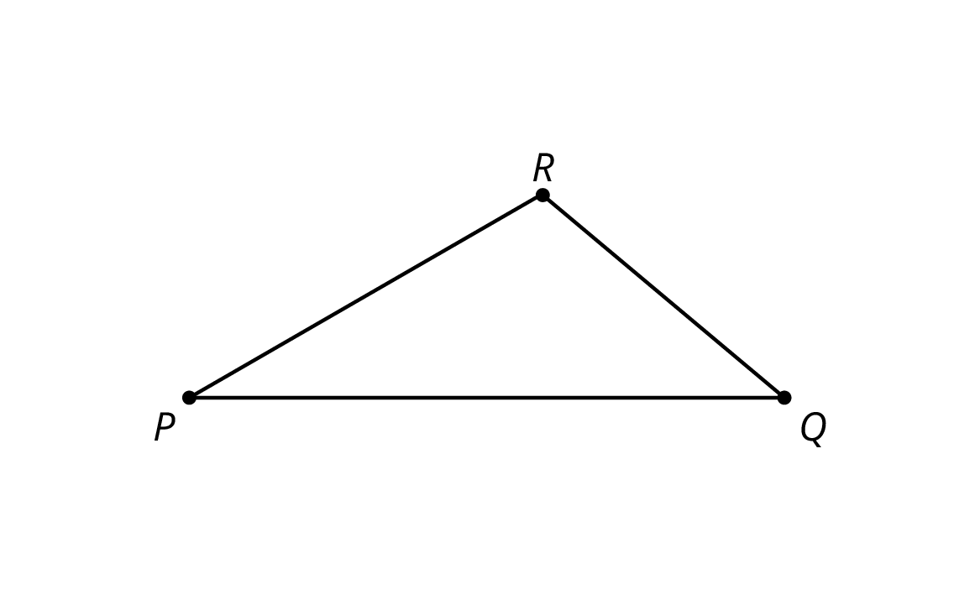
  - Tape the piece of pasta so that it lays on top of line $PQ$ with one end of the pasta at $P$ (if it does not fit on the page, break it further). Label the other end of the piece of pasta $S$.
  - Tape a full piece of pasta, with one end at $S$, making an angle congruent to $∠PQR$.
  - Tape a full piece of pasta on top of line $PR$ with one end of the pasta at $P$. Call the point where the two full pieces of pasta meet $T$.
  - Is your new pasta triangle $PST$ similar to $△PQR$? Explain your reasoning.
  - If your broken piece of pasta were a different length, would the pasta triangle still be similar to $△PQR$? Explain your reasoning.

3 Similar Figures in a Regular Pentagon (Optional)

Student Task Statement
- This diagram has several triangles that are similar to triangle $DJI$.
- 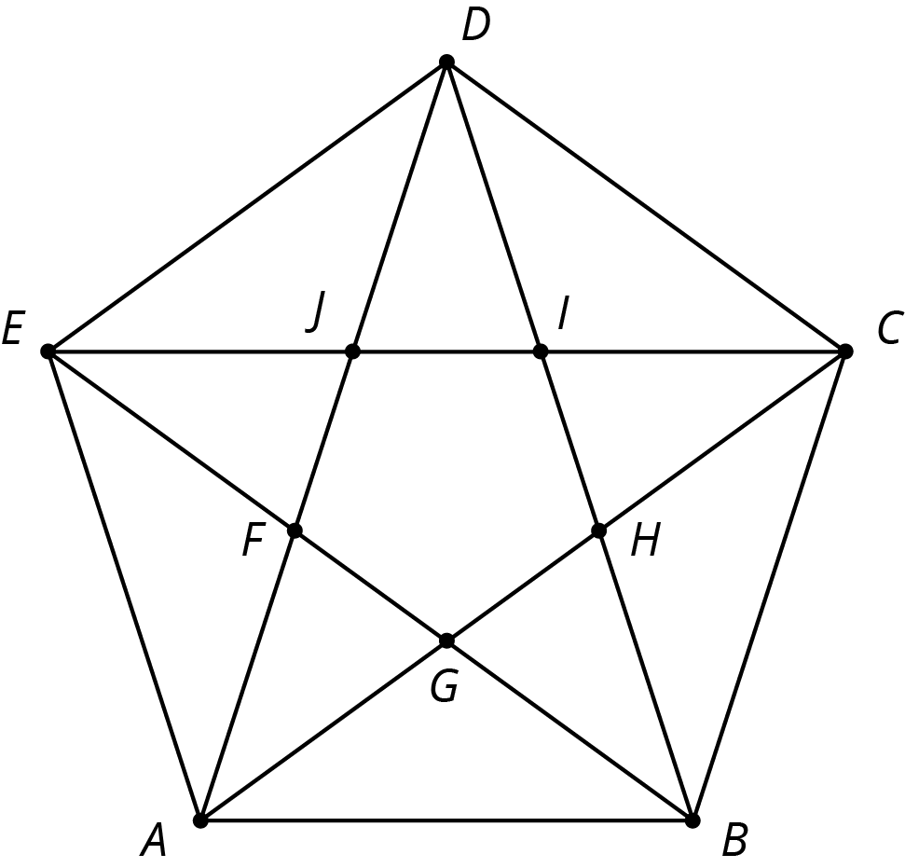
  - Three different scale factors were used to make triangles similar to $DJI$. In the diagram, find at least one triangle of each size that is similar to $DJI$.
  - Explain how you know each of these three triangles is similar to $DJI$.
- Find a triangle in the diagram that is not similar to $DJI$.

Images for Activity Synthesis
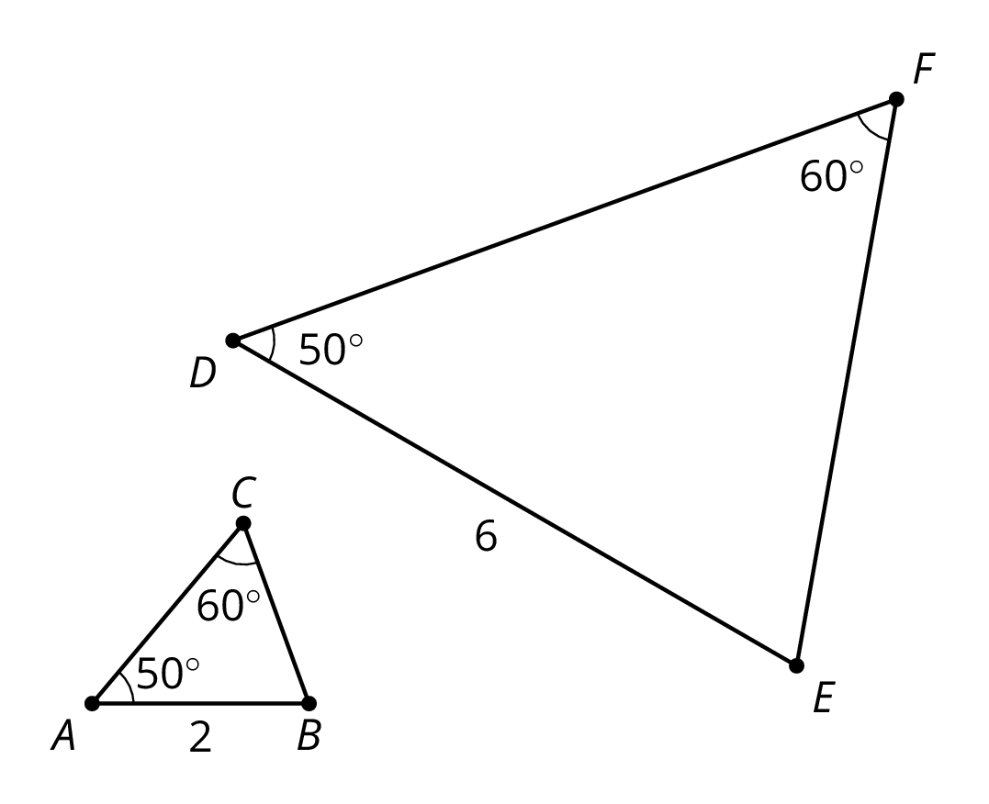
© CC BY Open Up Resources. Adaptations CC BY IM.

