Lesson 1: Fingers as a Math Tool
- Let’s show numbers with our fingers.

1.2: Show Some Fingers
1
3
5
4
6
8
10
9
2
7

1.3: Introduce Math Fingers, Show and Say
Choose a center.
Math Fingers
Pattern Blocks
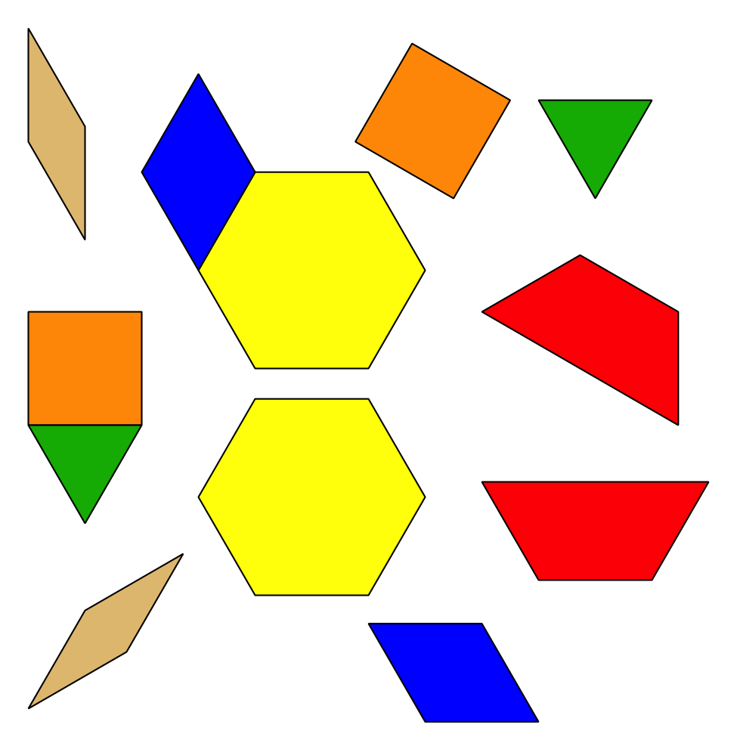
Picture Books
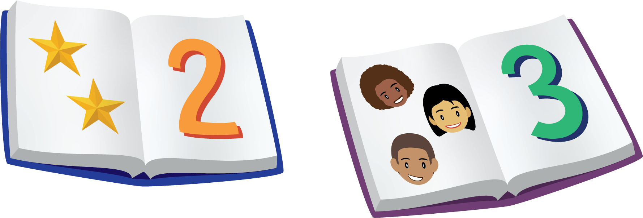
© CC BY 2021 Illustrative Mathematics®

