## Unit 3 Lesson 9: Shapes Are Everywhere

### WU Which One Doesn’t Belong: Rectangles, Squares, and Triangles (Warm up)

#### Student Task Statement

Which one doesn’t belong?

A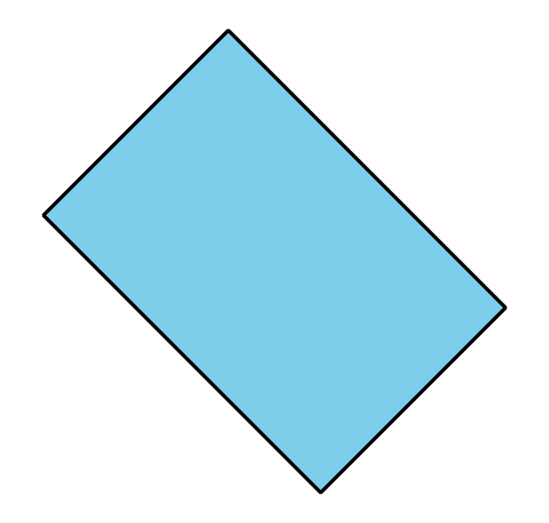

B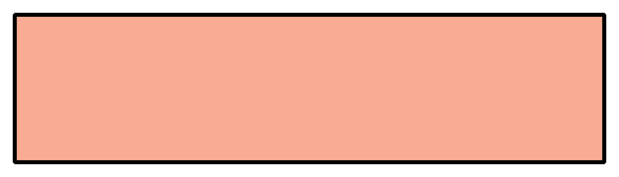

C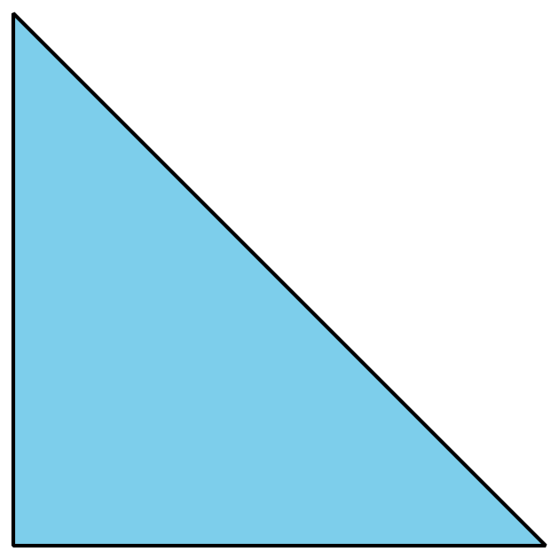

D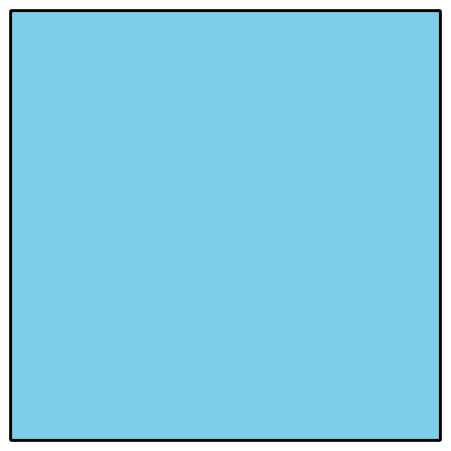

### 1 School Shape Walk

#### Student Task Statement

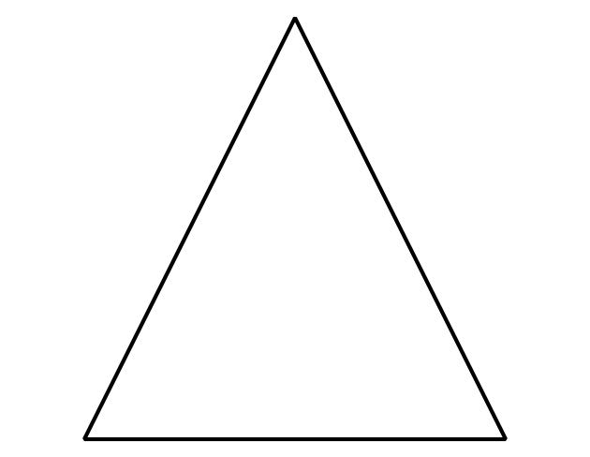

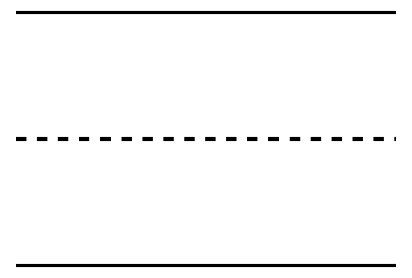

Line to separate the 2 groups.

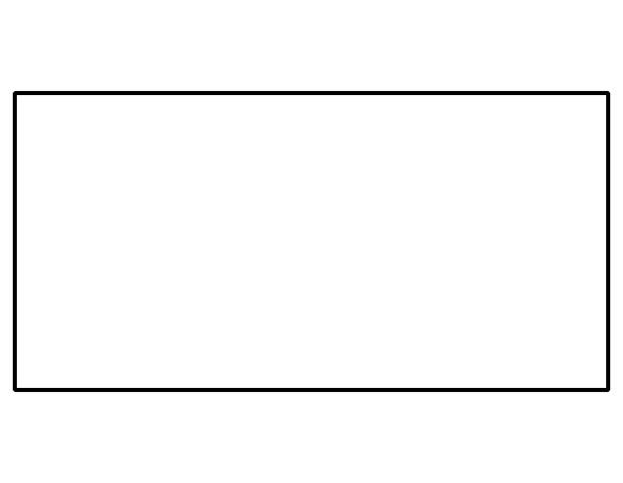



Line to separate the 2 groups.

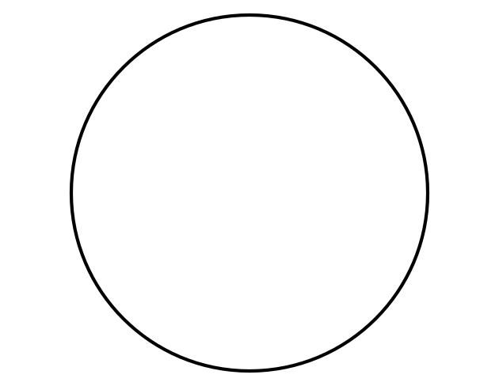



Synthesis:

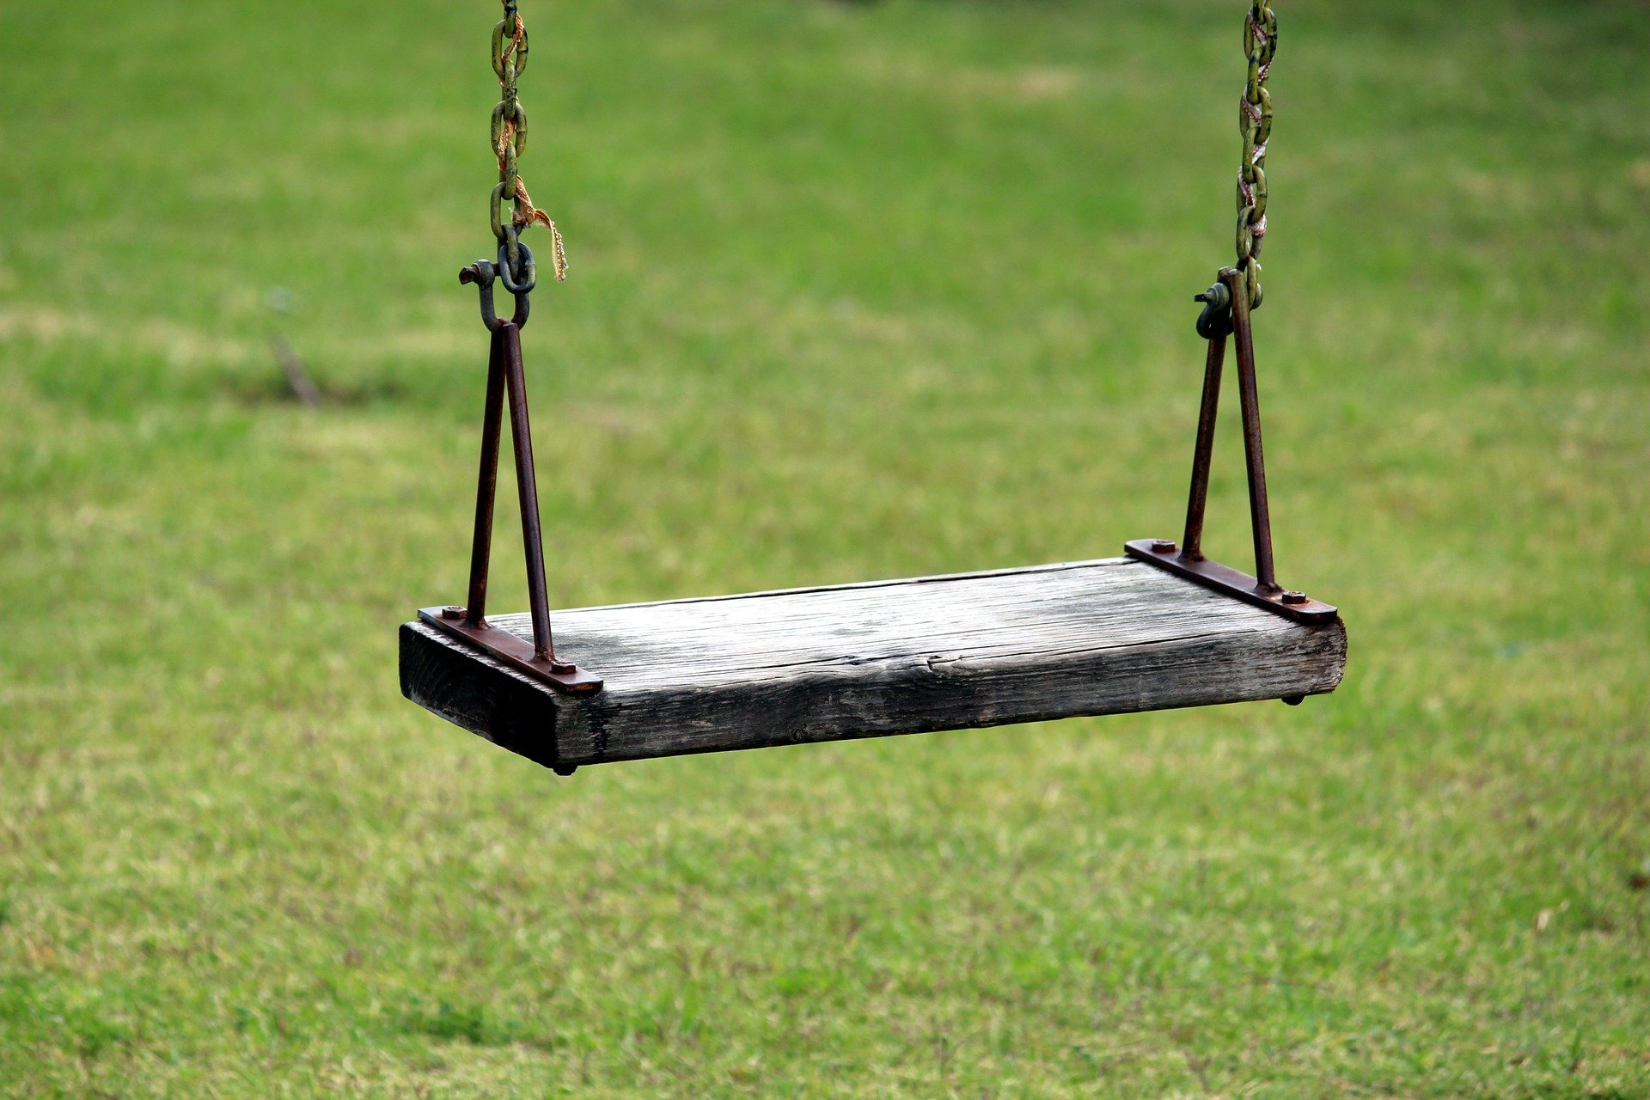

#### Activity Synthesis



### 2 Create the Shape

#### Student Task Statement



### 3 Centers: Choice Time

#### Student Task Statement

Choose a center.

Build Shapes

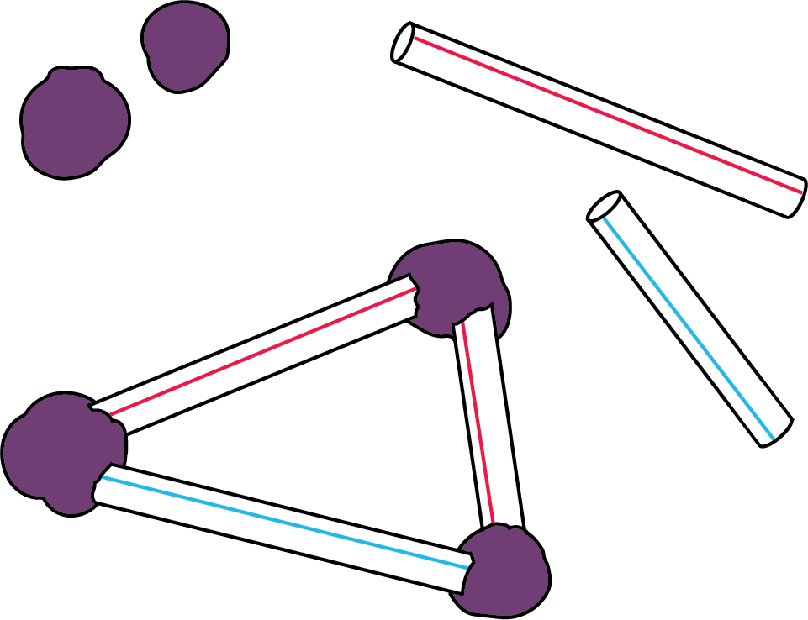

Counting Collections

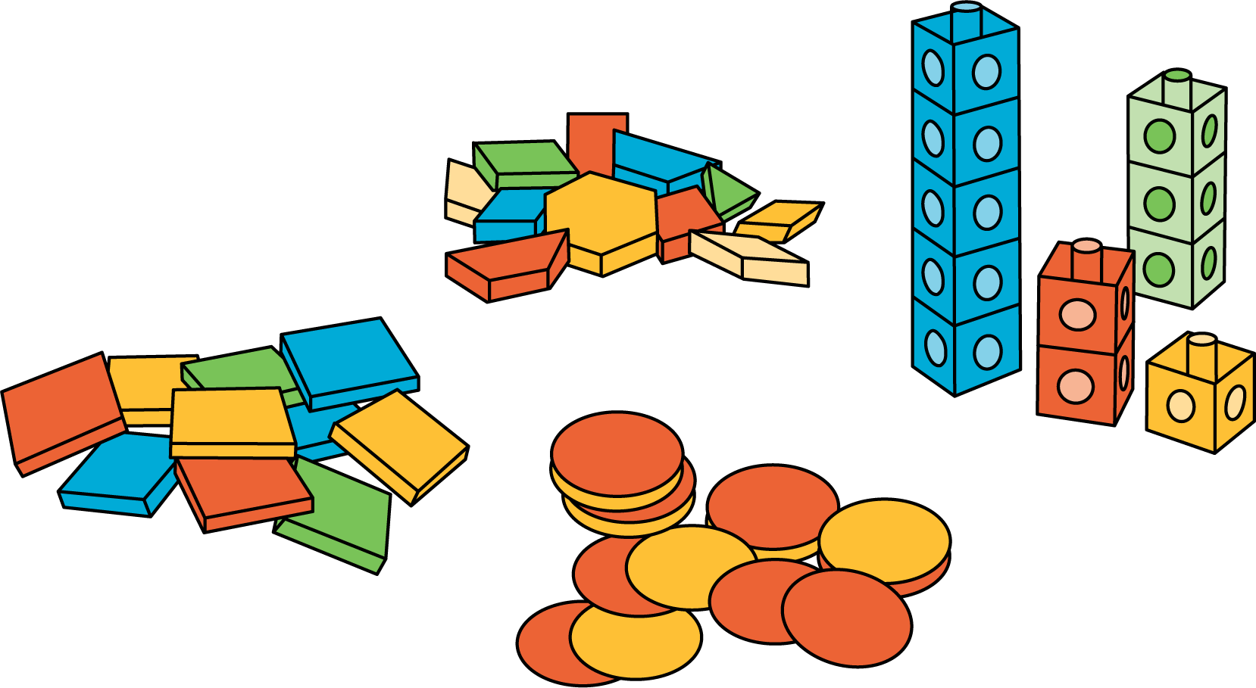

Which One



Picture Books

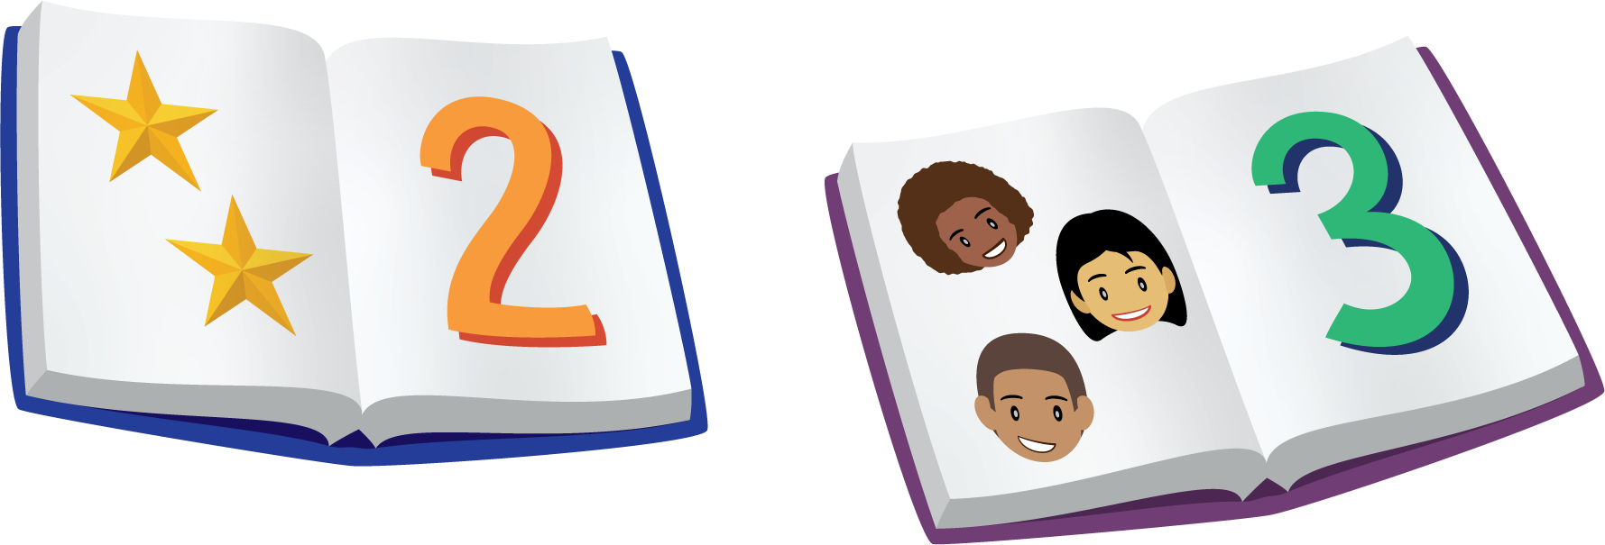

Bingo

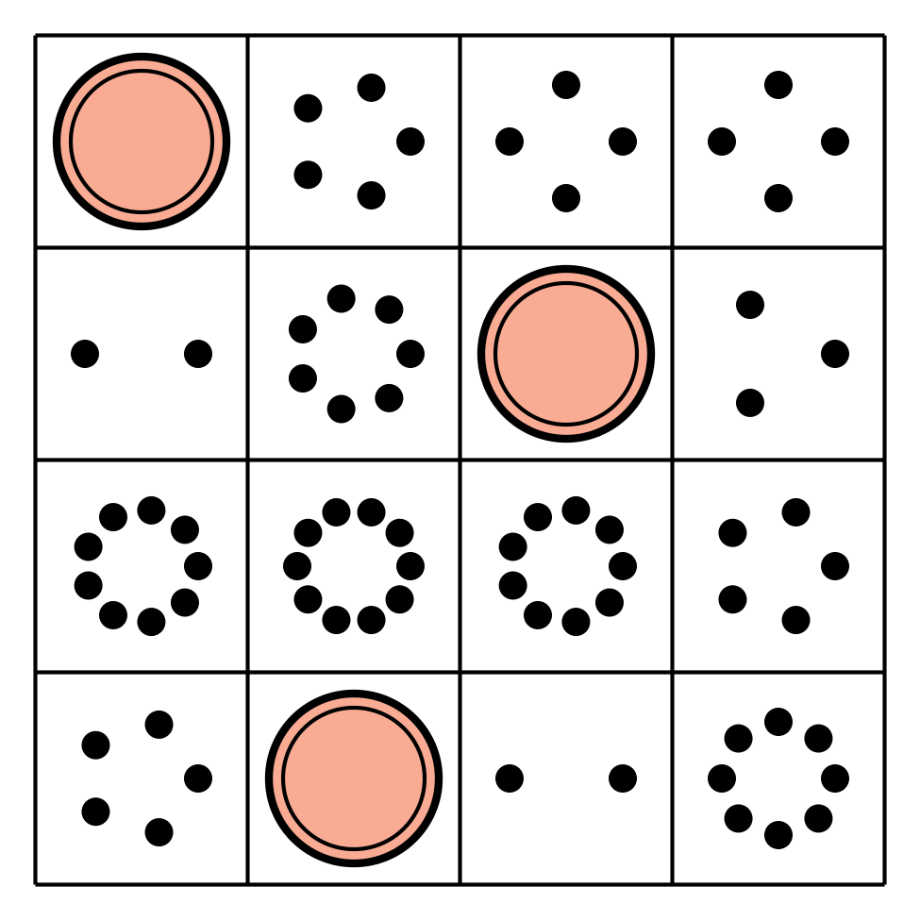

Shake and Spill

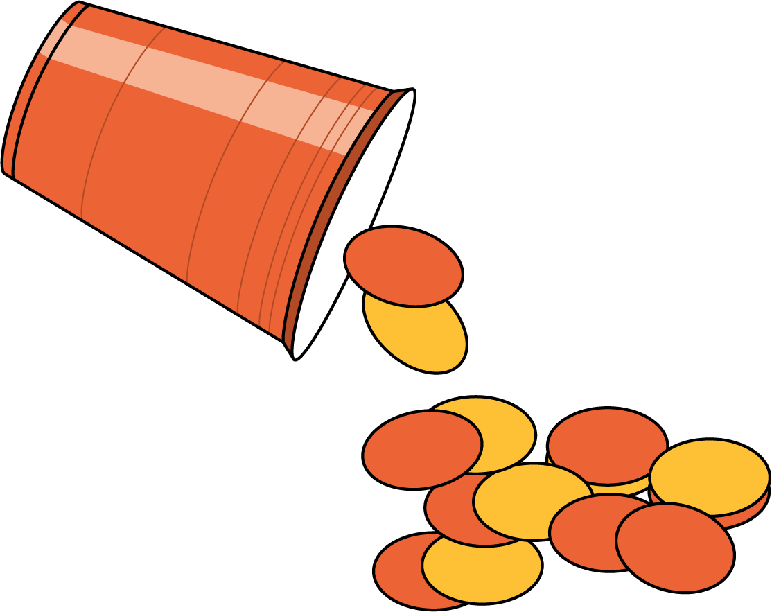



© CC BY 2021 Illustrative Mathematics®