Unit 4 Lesson 6: Finding Interesting Points on a Graph

1 Notice and Wonder: Unemployment Percentage (Warm up)

Student Task Statement
What do you notice? What do you wonder?
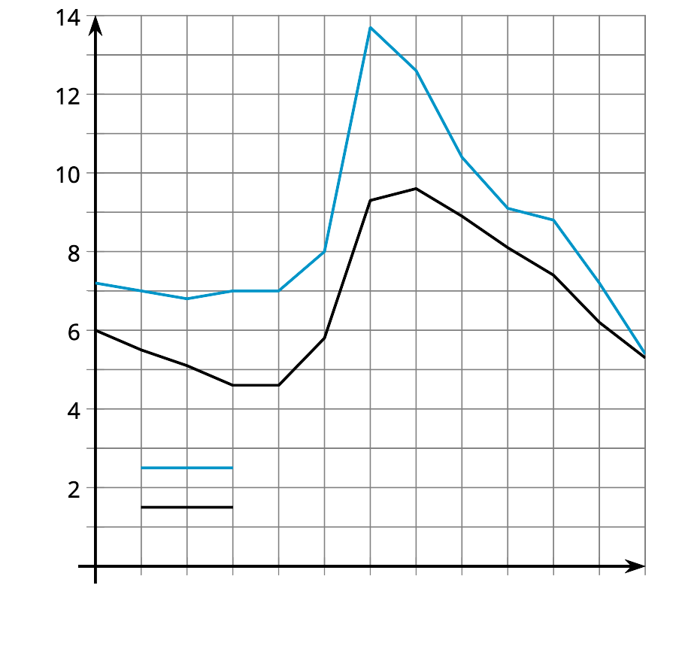

2 Examining Unemployment Percentages

Student Task Statement
This graph shows the percentage of the workforce that is unemployed in the United States and Michigan for several years.
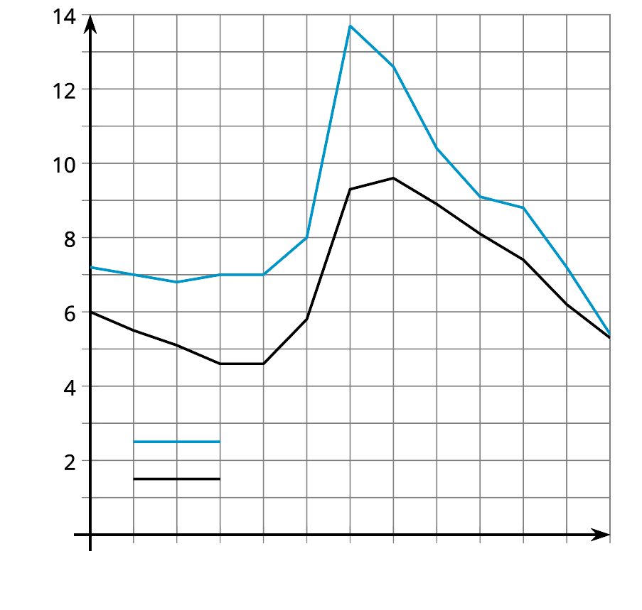
- For the United States, what are the highest and lowest points on the graph? What do the points mean in the situation?
- For Michigan, what are the highest and lowest points on the graph? What do the points mean in the situation?

3 The Wire

Student Task Statement
- Use technology to graph the function $f(x)=x^{4}−16x^{3}+86x^{2}−176x+105$.
- What are some points on the graph that you think are interesting? Explain your reasoning.
- Examine the graph representing electrical voltage in a wire as a function of time. What interesting points do you see? Explain your reasoning.
- 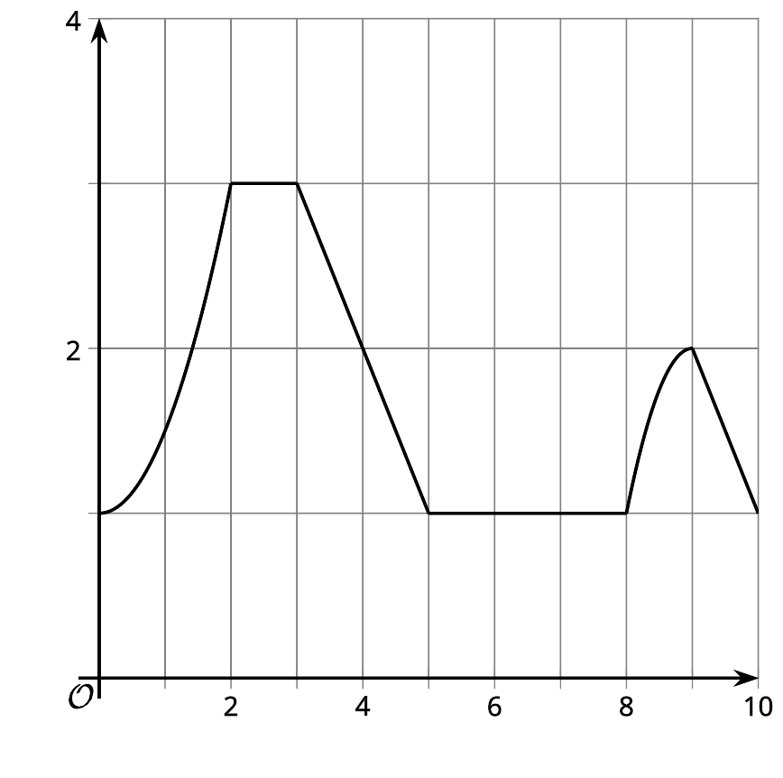
- Use the points you found to describe what is happening to the voltage within the wire.
© CC BY 2019 by Illustrative Mathematics

