Unit 5 Lesson 10: Solve Problems with Decimals

WU Notice and Wonder: The Luge (Warm up)

Student Task Statement
What do you notice? What do you wonder?
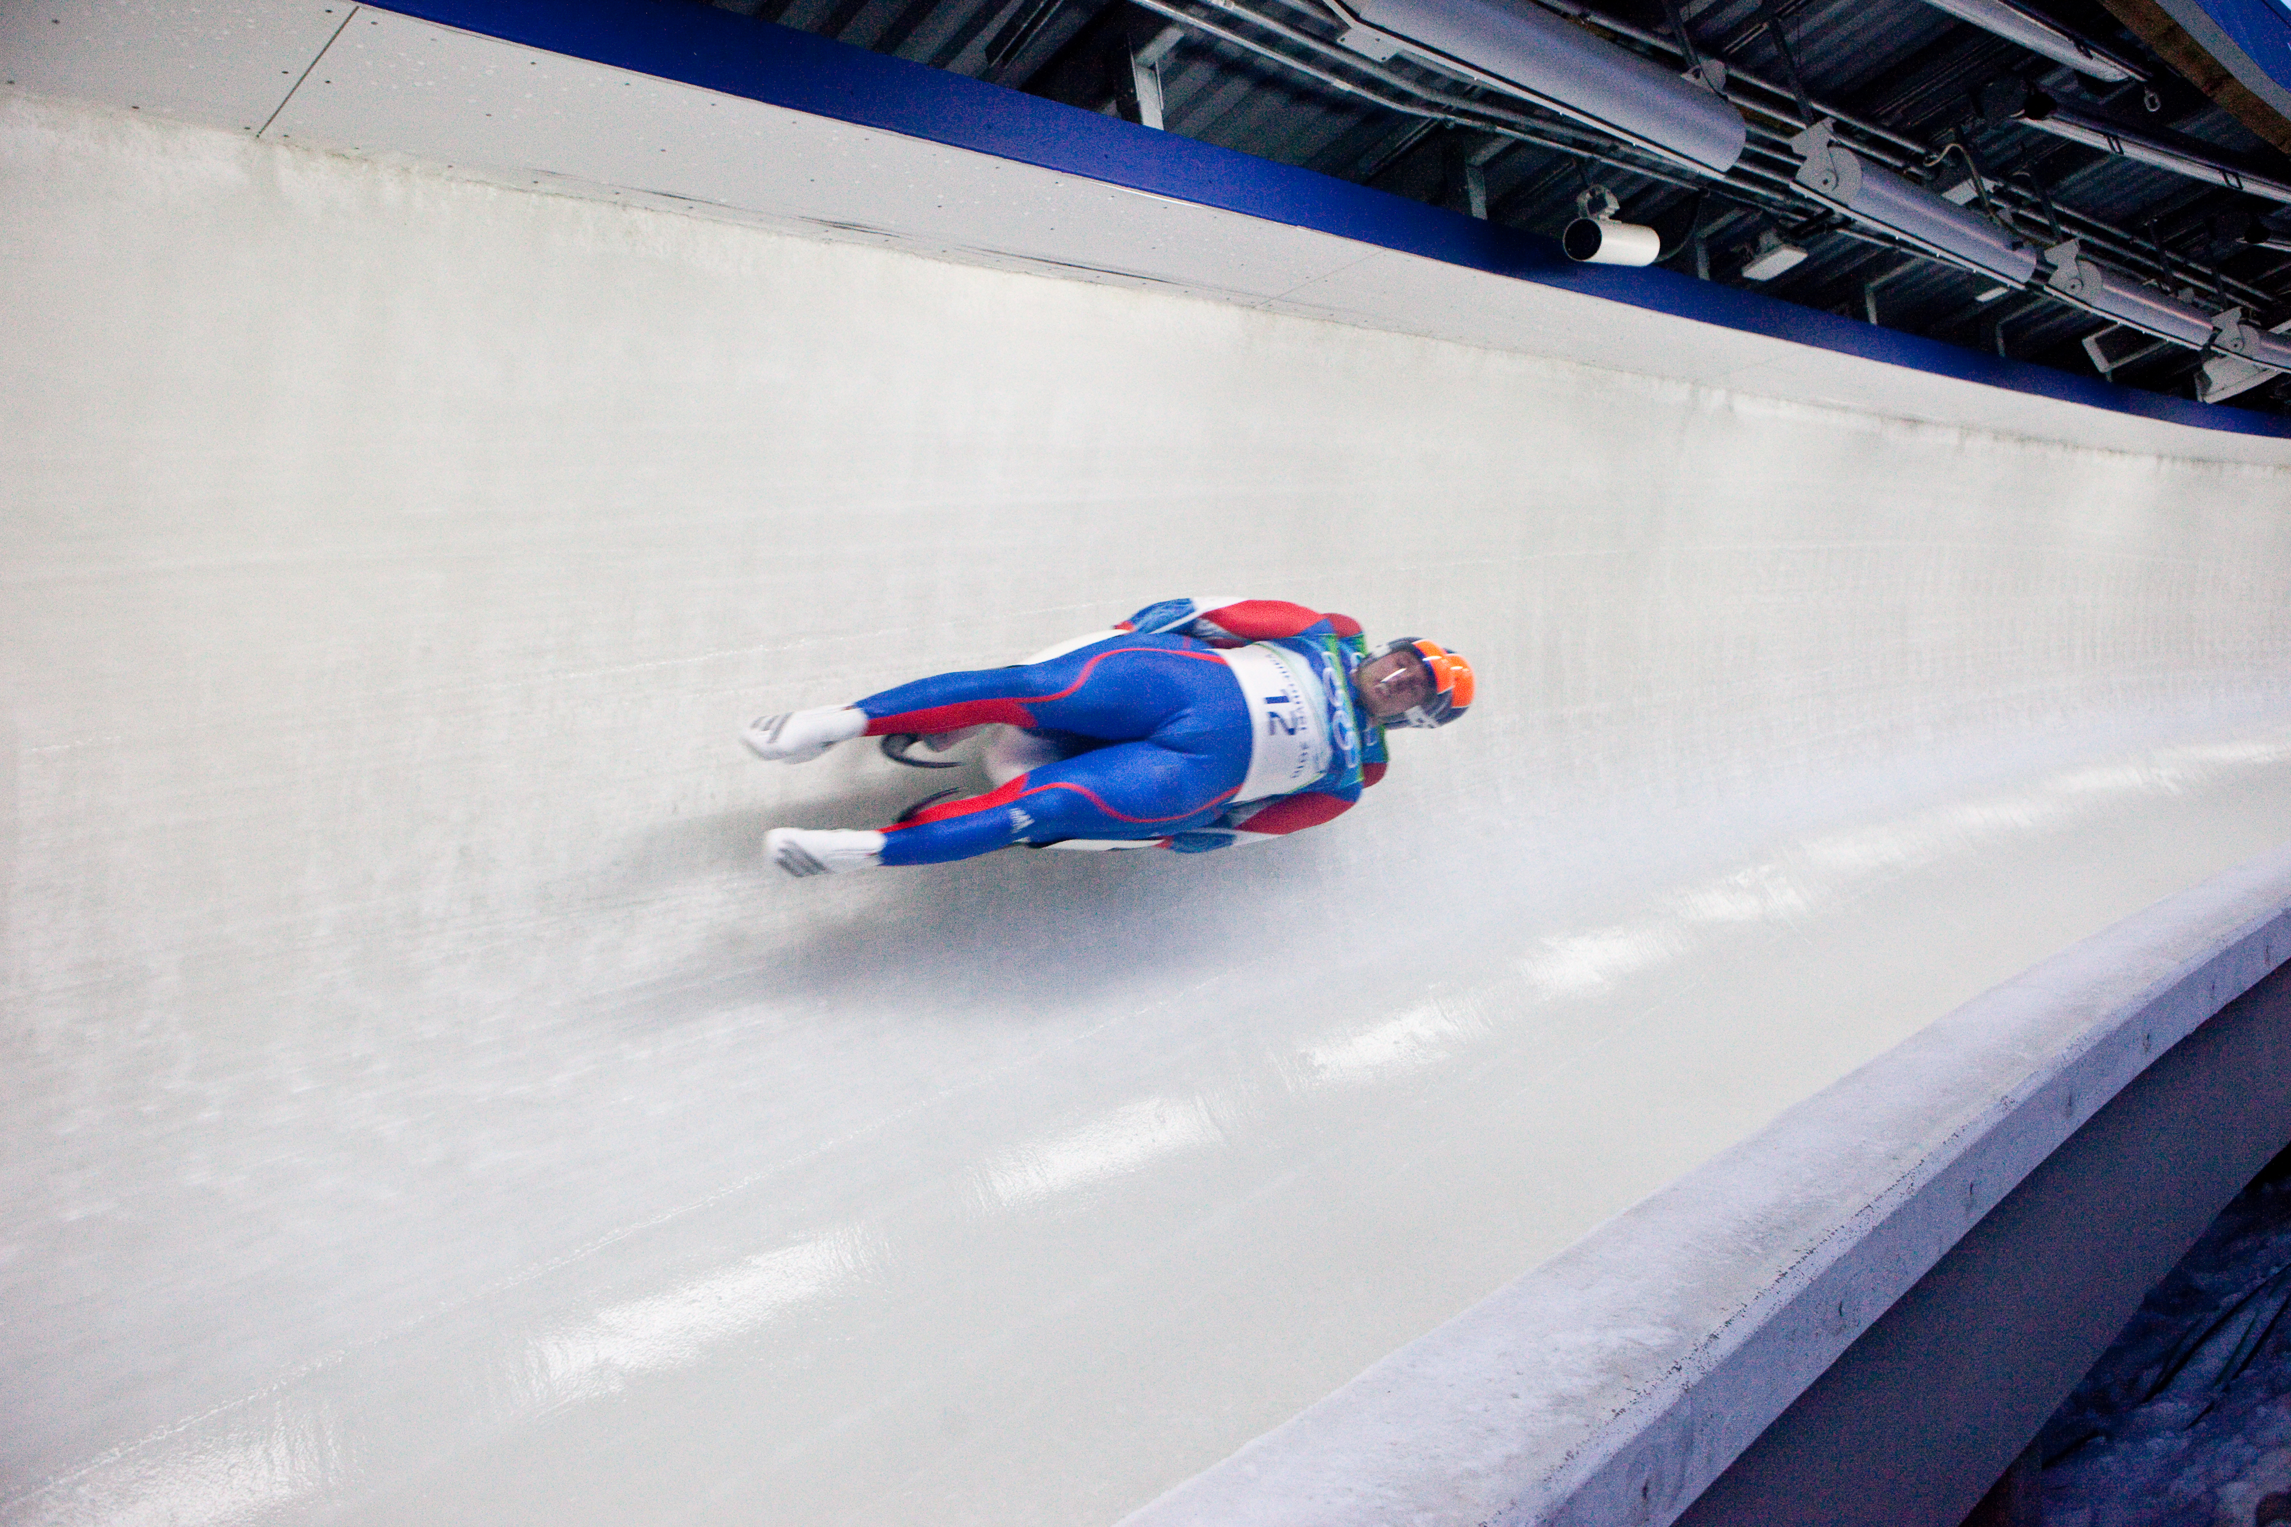
A | B
48.532 | 82.13
48.561 | 82.75
48.626 | 82.81
48.634 | 83.07
48.708 | 82.80

1 How Accurate Is It?

Student Task Statement
athlete | time (seconds) | speed (mph)
Athlete 1 | 48.532 | 82.13
Athlete 2 | 48.561 | 82.75
Athlete 3 | 48.626 | 82.81
Athlete 4 | 48.634 | 83.07
Athlete 5 | 48.708 | 82.80
- How would the results of the race change if the times were recorded to the nearest second?
- How would the results of the race change if the times were recorded to the nearest tenth of a second?
- How would the results of the race change if the times were recorded to the nearest hundredth of a second?
- An athlete recorded a time of 48.85 seconds to the nearest hundredth of a second. What are the possible times of this athlete recorded to the thousandth of a second?
- An athlete recorded a time of 48.615 seconds to the nearest thousandth of a second. What are the possible times that this athlete recorded to the nearest hundredth of a second?

2 Compare Speeds

Student Task Statement
The table shows the top speeds, in miles per hour, of 5 luge athletes:
athlete | speed (miles per hour)
Athlete 1 | 82.13
Athlete 2 | 82.75
Athlete 3 | 82.81
Athlete 4 | 83.07
Athlete 5 | 82.80
- List the top speeds of the athletes in decreasing order.
- Do any of the athletes have the same top speed rounded to the nearest tenth of a mile per hour? What about rounded to the nearest mile per hour?
- There was a sixth athlete who was faster than the rider at 82.80 mph, but slower than the rider at 82.81 mph. What could the speeds of the 3 athletes be if all measured to the nearest thousandth of a mile per hour?
© CC BY 2021 Illustrative Mathematics®

