Unit 8 Lesson 7: Estimating the Volume of the World’s Largest Wagon

WU Notice and Wonder: Radio Flyer (Warm up)

Student Task Statement
What do you notice? What do you wonder?
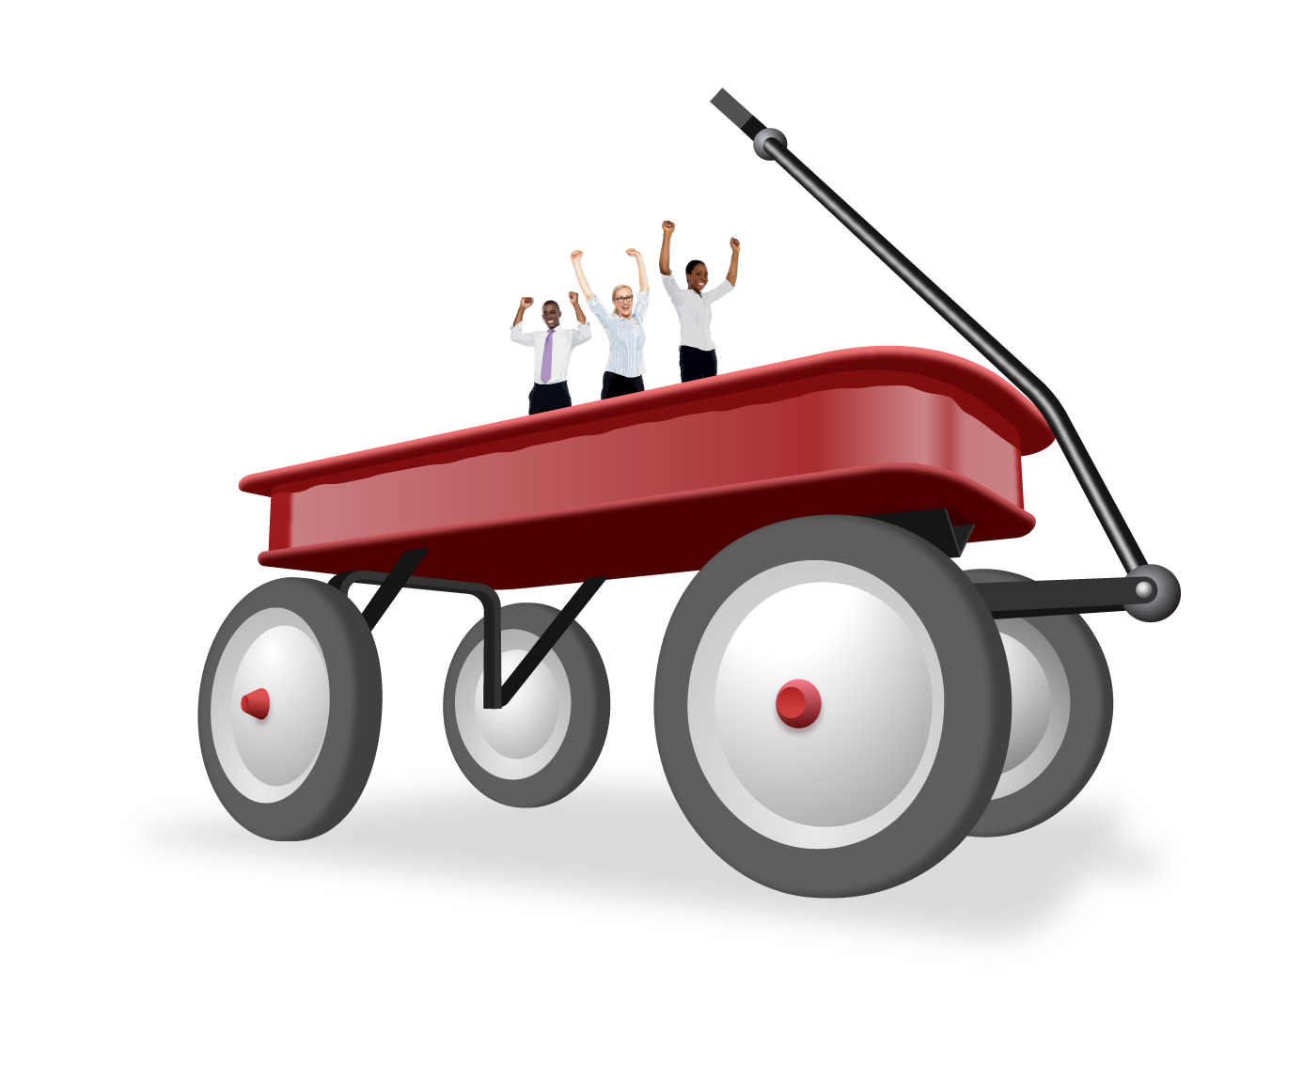

1 Anatomy of an Estimate

Student Task Statement
- What measurements would you take of the wagon to accurately estimate its volume?
- What units would you use to measure the wagon? Explain your reasoning.
- Record an estimate for the volume of the wagon that is:
- too low | - about right | - too high
- What can you use in the picture to refine your estimate?

2 Estimating the Size of the Radio Flyer

Student Task Statement
- Use the picture of the wagon to make a better estimate of the length, width, and height of the wagon bed.
- Make sure to:
  - explain how you estimated each measurement
  - include how accurate you think each estimate is
- 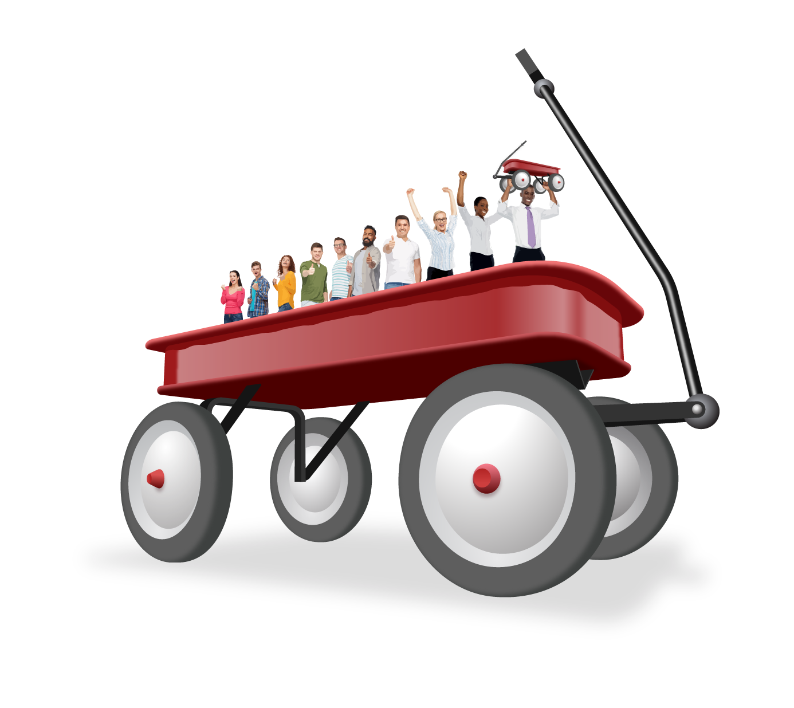
- Then improve your estimate for the volume of the wagon.
© CC BY 2021 Illustrative Mathematics®

