Unit 1 Lesson 11: All Kinds of Prisms

WU Which One Doesn’t Belong: Many Prisms (Warm up)

Student Task Statement
Which one doesn’t belong?
A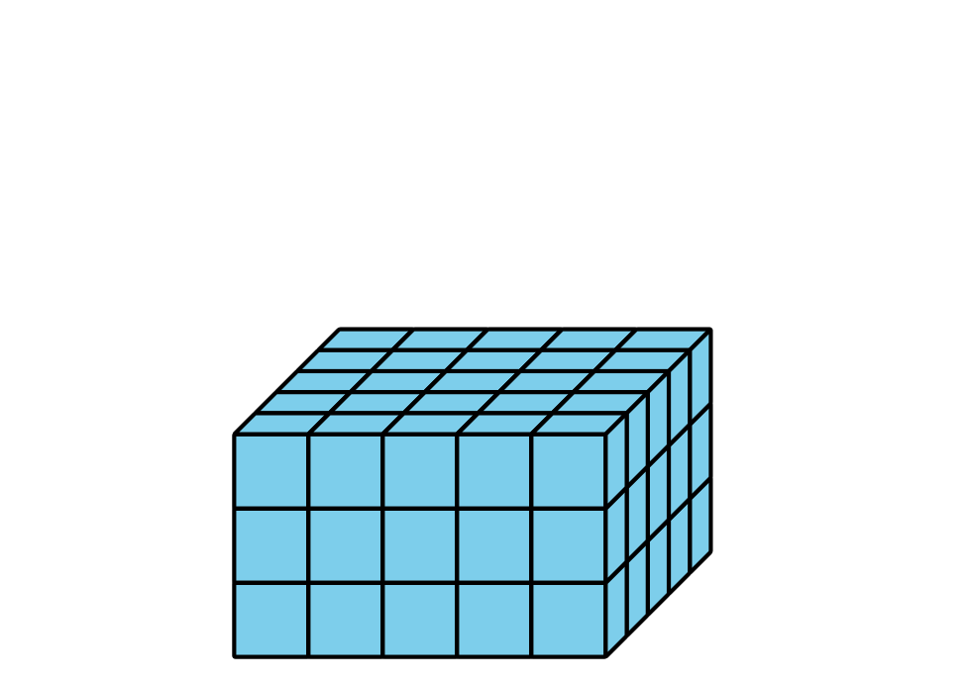
B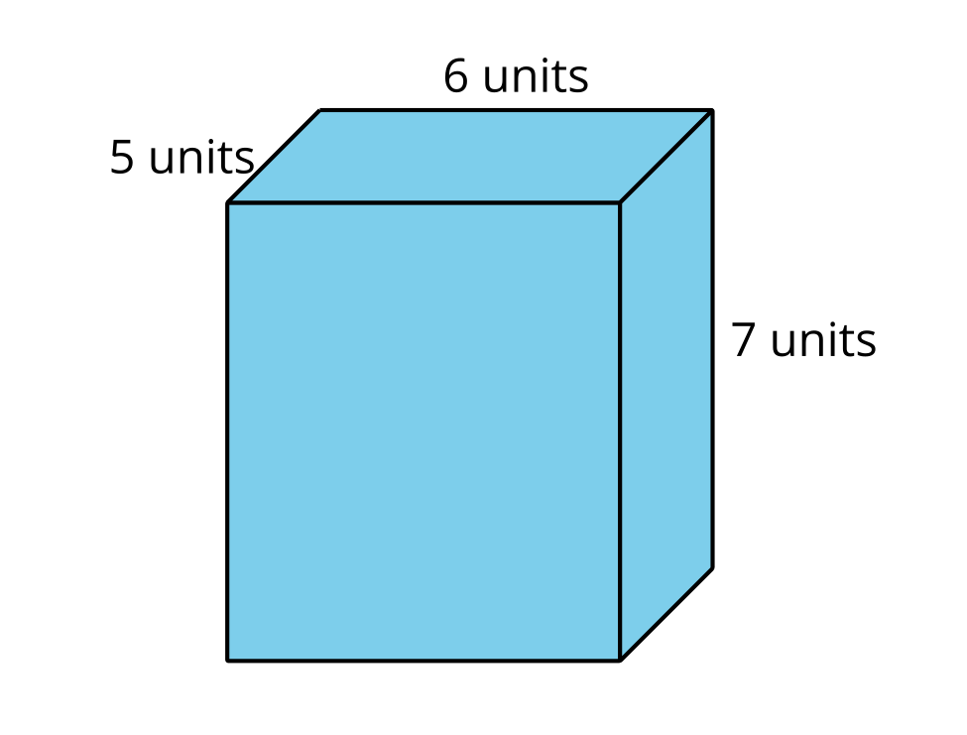
C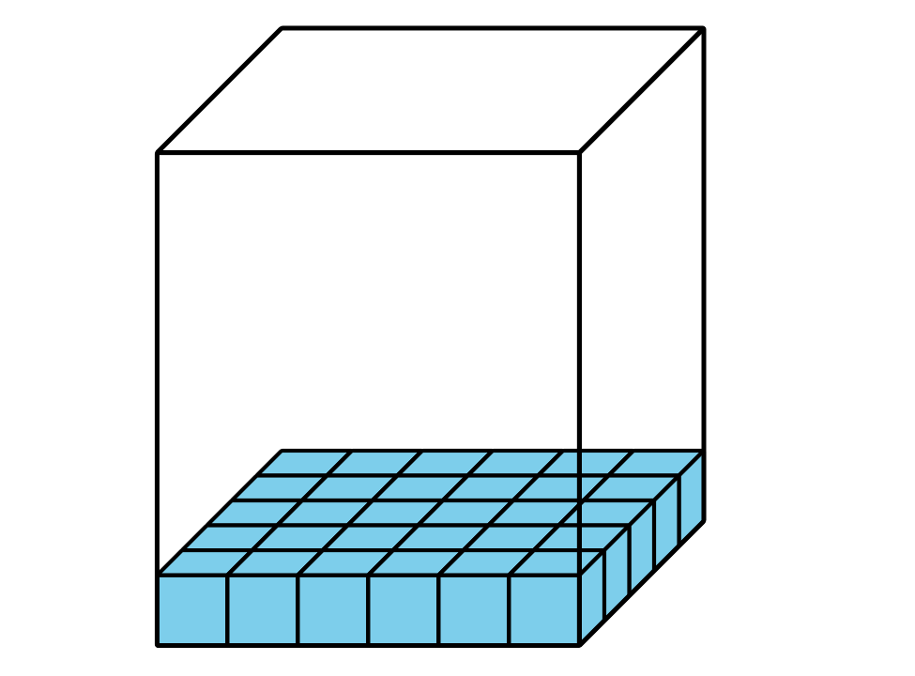
D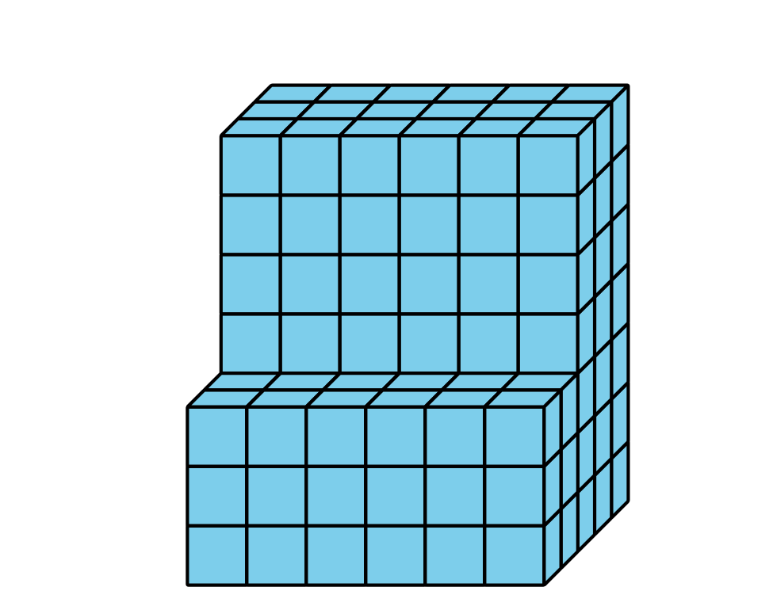

1 Prism Palooza

Student Task Statement
For each problem, explain or show your reasoning.
- Han is filling a box with cubes. Below is a diagram of the box. How many cubes can fit in the box if Han completely packs it, without gaps between cubes?
- 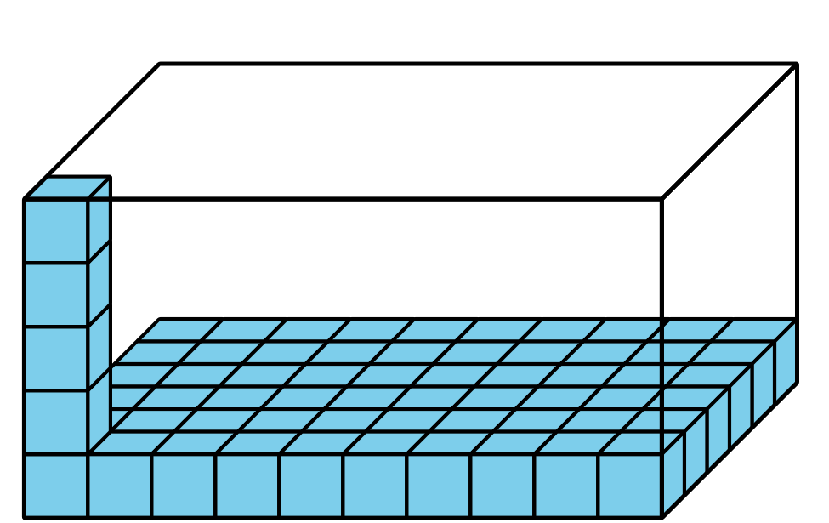
- Clare bought a storage container for her art supplies. The storage container was 4 feet wide, 9 feet long, and 5 feet high. What is the volume of her container?
- Mai’s new bedroom has a walk-in closet with a floor that measures 30 square feet. Her closet ceiling is 9 feet from the floor. What is the volume of her closet?

2 Problem Solving with Figures

Images for Launch
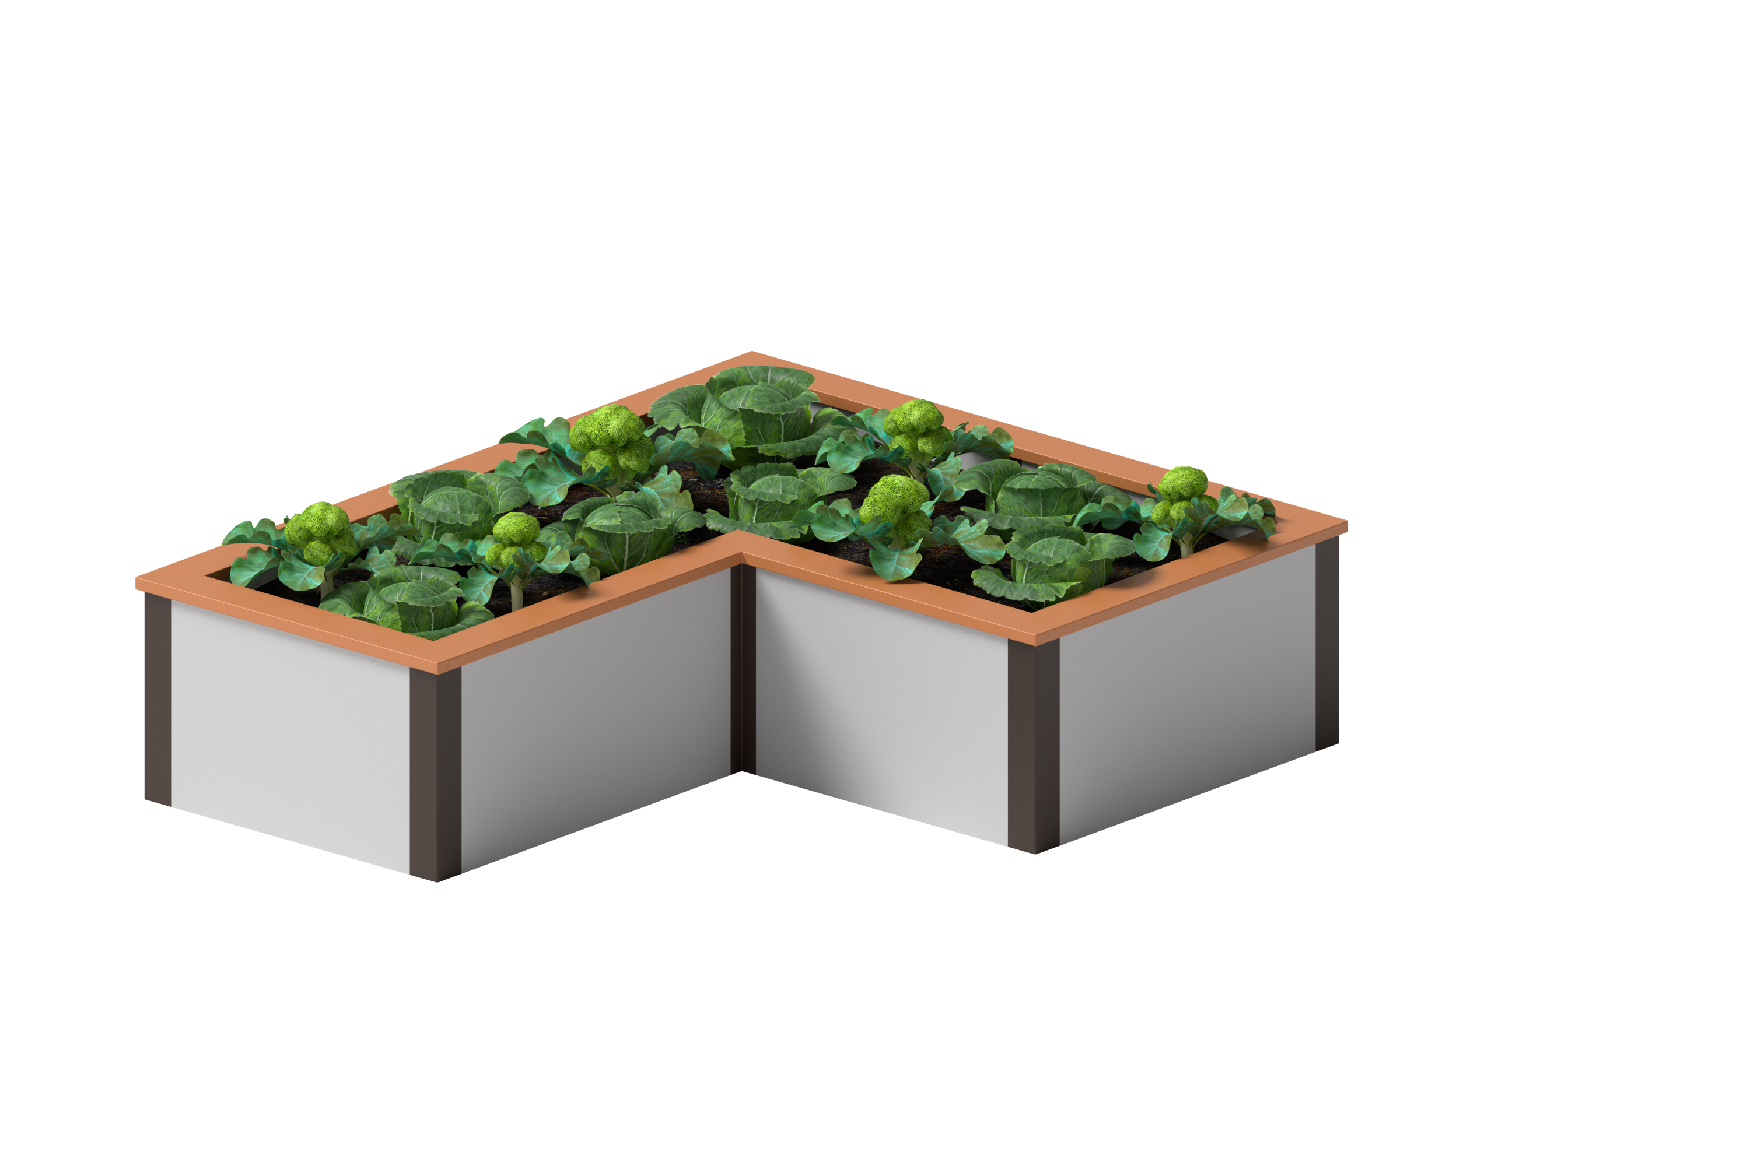

Student Task Statement
The elementary school is going to build a raised bed garden like the one in the picture, but they will use a different design. Here is a diagram that shows the side lengths of the garden the school will build.
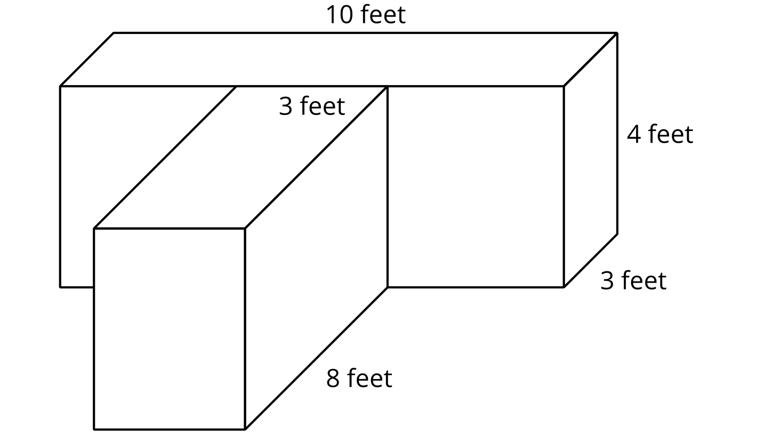
- What is the volume of the garden? Explain or show your reasoning.
- Write an expression to represent the volume of the garden.
- 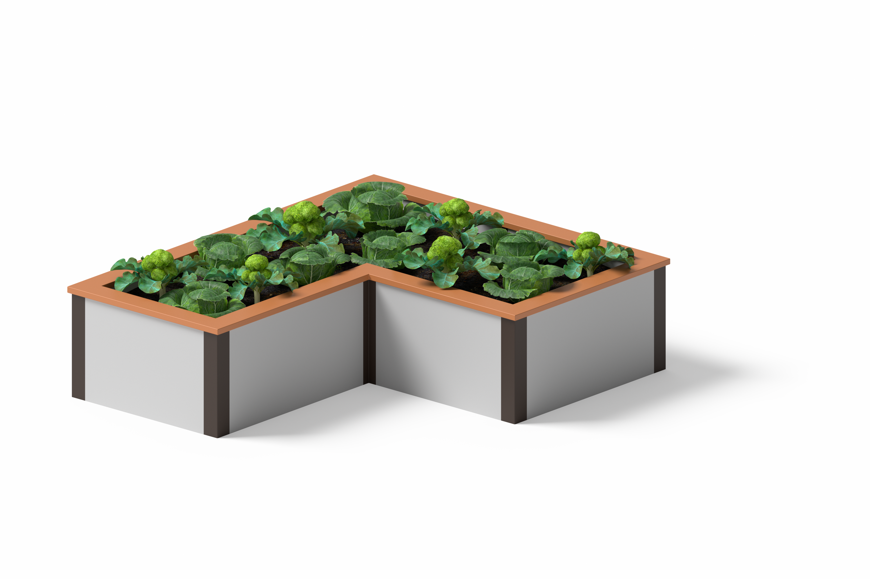
- Noah wants to design a garden with the same volume but different side lengths. What could the side lengths of his garden be?
- Which garden design do you like better? Explain or show your reasoning.

Images for Activity Synthesis
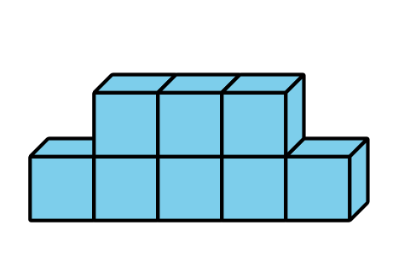
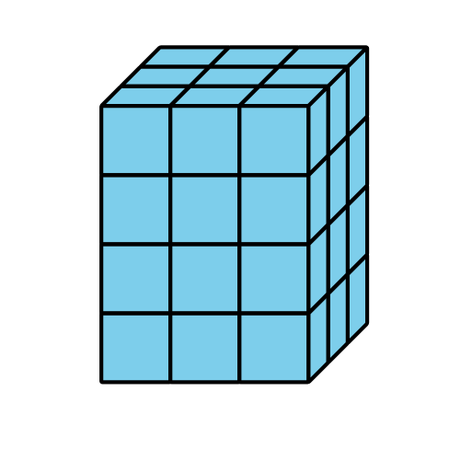
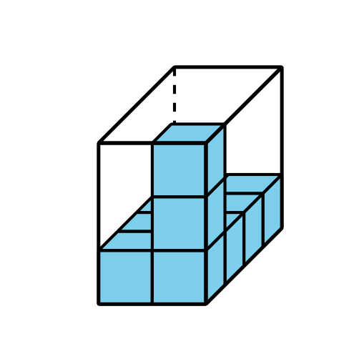
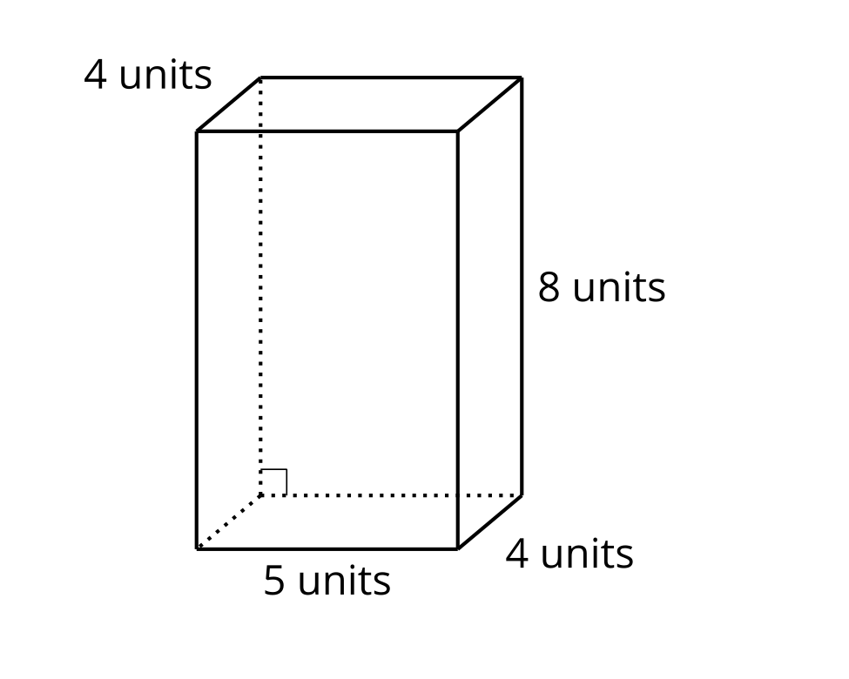
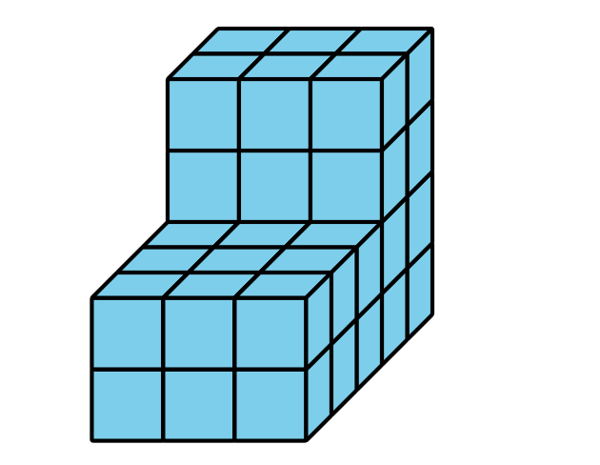
© CC BY 2021 Illustrative Mathematics®

