Lesson 27: Center Day 4
- Let’s play games to practice addition and subtraction.

Warm-up: Number Talk: Subtract 10
Find the value of each expression mentally.
- $20−10$
- $20−10−1$
- $18−10−4$
- $18−14$

27.2: Introduce Compare, Add and Subtract Within 20
Choose a center.
Compare
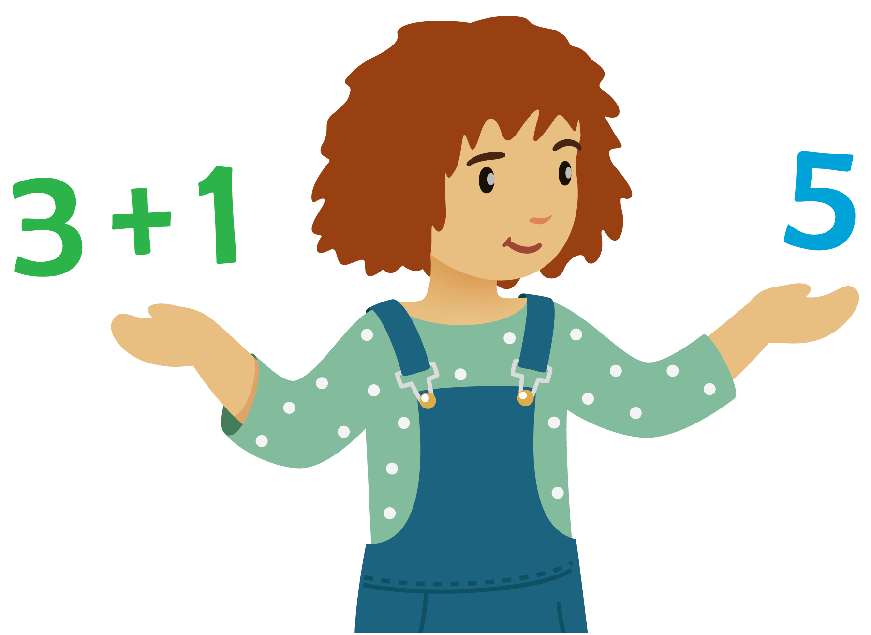
Five in a Row
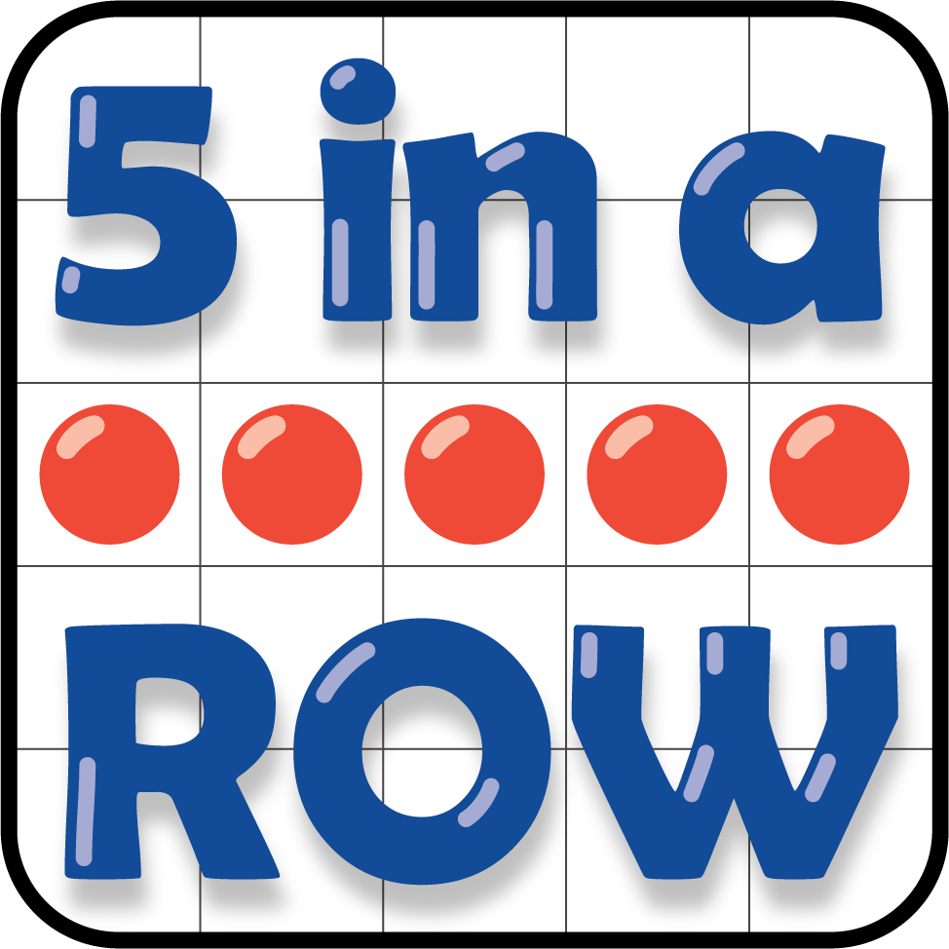
How Close?
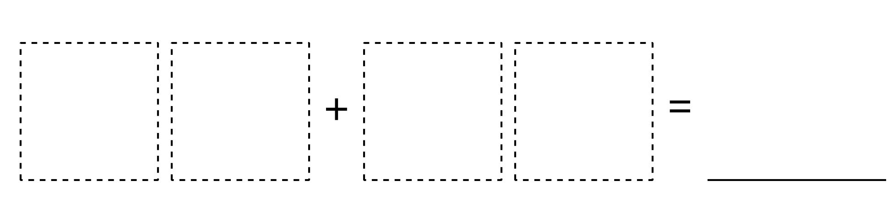
© CC BY 2021 Illustrative Mathematics®

